Survey conducted among the Federal Scientific Institutes staff in April 2016:
“Change of statute for the federal scientific institutes (FSIs): from separately run state services to ... limited companies under public law with a social purpose? "Legal Personality"? How would this affect us?”

What, When, How, Who ?
Survey distributed among all the staff members by their union delegates either by mail or orally (in three language: french, dutch and english). The survey was supposed to be answered online but a paper version was also available for the staff members who do not have access to a computer.
Total number of answers received & encoded by May 3^{d}, 2016: 815

Aim of this survey
Get a picture of what do the staff members think about the announced reform of the FSIs. How informed they are about the goals of this reform. How do they agree with those goals.

Disclaimer
This analysis of the results is not done by professionals, it may contains errors, misinterpretations, in brief it may be not follow the professional standards, best practices, …
In particular, the required conditions for the statistical tests are not always met.

Warning
While analysing the results for your institute, take into account the fact that the repartition of the profiles of the answering persons may not reflect the repartition of profiles in the whole institute.
The chapters per institute do only contain shortened questions and answers, to know what was the original questions and possible answers, please refer to the same subchapter in the first part.
This analysis does not contain the answers to the open question (Q23) nor the open field in Q19 & Q21.

Table of Contents
Global results for all the institutes 3
KB­BR 32
IRSNB­KBIN 53
MRAH­KMKG 74
IASB­BIRA 95
AGR­ARA 116
MRAC­KMMA 137
ORB­KSB 158
MRBAB­KMSKB 179
IRM­KMI 200
BELSPO 221
KIK­IRPA 222
SpacePole 223

Global results for all the institutes

Q1: Which institution do you belong to ? (815 answers)
Q1 | count(*)
AGR­ARA | 117
BELSPO | 4
IASB­BIRA | 97
IRM­KMI | 100
IRSNB­KBIN | 127
KB­BR | 62
KIK­IRPA | 1
MRAC­KMMA | 53
MRAH­KMKG | 108
MRBAB­KMSKB | 59
ORB­KSB | 87

Q2: Are you … (815 answers)
Q2 | count(*)
I don’t know (?) | 24
in the scientific career (SW)? | 333
in the administrative/technical career (A/B/C/D)? | 458

Q3: Please state your current position: (815 answers)
Q3 | count(*)
On a contract | 446
On a mandate | 1
Other (temporary agent, ‘article 60’, … | 8
Permanent (sta) | 360

Position vs Age
↓Q3\Q5→ | NoAnswer | 21­30 | 31­40 | 41­50 | 51­60 | 61­65 | >65
CON | 3 | 60 | 154 | 132 | 82 | 13 | 2
MAN |  |  |  |  | 1
OTH |  | 4 | 1 |  | 1 |  | 2
STA | 7 | 13 | 67 | 137 | 118 | 14 | 4

Based on a simplified table (removing those who haven't answered to the age question, and removing the positions other than contractual and permanent), the statistical test shows no independence between the Age and the Position (as we could have guessed the oldest people are more to have a permanent position than the youngest).
X‐squared = 62.4077, df = 5, p‐value = 3.861e‐12
$observed
21-30 31-40 41-50 51-60 61-65 >65
CON 60 154 132 82 13 2
STA 13 67 137 118 14 4
$expected (in case the variables were independent)
21-30 31-40 41-50 51-60 61-65 >65
CON 40.62688 122.99372 149.7073 111.30653 15.02638 3.339196
STA 32.37312 98.00628 119.2927 88.69347 11.97362 2.660804

Q4: You are… (810 answers)
Q4 | count(*)
No answer | 5
a woman. (F) | 318
a man. (M) | 492

Q5: Which age group do you belong to ? (805 answers)
Q5 | count(*)
No answer | 10
21­30 | 77
31­40 | 222
41­50 | 269
51­60 | 202
61­65 | 27
>65 | 8

Q6: Do you feel concerned by the announced reform? (806 answers)
Q6 | count(*)
No answer | 9
NO, I’m indifferent. | 26
YES, I want to find out about it and express my opinion. | 403
YES, BUT we (the employees) have anyway no influence in the reform process. | 377

Concerned vs Career
↓Q6\Q2→ | ? | Sci | Tech/Admin
NoAnswer | 2 | 2 | 5
NO | 1 | 10 | 15
YES | 3 | 197 | 203
YES, BUT | 18 | 124 | 235

Based on a simplified table (removing the ones who didn't answer Q6, and guessing that the people who doesn't know in which career they are in fact in the Technical/Administrative one), the statistical test shows no independence between the Career and how people feel Concerned: the Admin/Tech people doesn't think they may influence the reform process as much as the Scientific employees. But they feel concerned (YES+YESBUT) or not (NO) independently of the Career (see second statistical test).
X‐squared = 20.6586, df = 2, p‐value = 3.266e‐05
$observed
Sci TA
NO 10 16
YES 197 206
YESBUT 124 253
$expected (if variables were independent)
Sci TA
NO 10.67742 15.32258
YES 165.50000 237.50000
YESBUT 154.82258 222.17742
X‐squared = 0.0052, df = 1, p‐value = 0.9427
$observed
Sci TA
NO 10 16
YES(all) 321 459
$expected (if variables were independent)
Sci TA
NO 10.67742 15.32258
YES(all) 320.32258 459.67742

Concerned vs Position
↓Q6\Q3→ | CON | MAN | OTH | STA
NoAnswer | 9
NO | 16 |  | 1 | 9
YES | 196 | 1 | 4 | 202
YES, BUT | 225 |  | 3 | 149

Based on a simplified table (removing the ones who didn't answer Q6, and removing the positions other than contractual and permanent), the statistical test shows no independence between the Position and how people feel Concerned: the persons in a permanent position do think they may influence the reform process much than persons on a contract.
But they feel concerned (YES+YESBUT) or not (NO) independently of their position (see second statistical test).
X‐squared = 10.1499, df = 2, p‐value = 0.006251
$observed
CON STA
NO 16 9
YES 196 202
YESBUT 225 149
$expected (if variables were independent)
CON STA
NO 13.70765 11.29235
YES 218.22585 179.77415
YESBUT 205.06650 168.93350
X‐squared = 0.5356, df = 1, p‐value = 0.4642
$observed
CON STA
NO 16 9
YES(all) 421 351
$expected (if variables were independent)
CON STA
NO 13.70765 11.29235
YES(all) 423.29235 348.70765

Concerned vs Gender
↓Q6\Q4→ | NoAnswer | F | M
NoAnswer |  | 7 | 2
NO |  | 11 | 15
YES | 2 | 145 | 256
YES, BUT | 3 | 155 | 219

Based on a simplified table (removing those who haven't answered one or the other question), the statistical test shows that people feel concerned independently of their gender.
X‐squared = 2.4122, df = 2, p‐value = 0.2994
$observed
F M
NO 11 15
YES 145 256
YESBUT 155 219
$expected (if variables were independent)
F M
NO 10.09488 15.90512
YES 155.69413 245.30587
YESBUT 145.21099 228.78901

Concerned vs Age
↓Q6\Q5→ | NoAnswer | 21­30 | 31­40 | 41­50 | 51­60 | 61­65 | >65
NoAnswer |  | 3 |  | 3 | 3
NO |  | 6 | 6 | 6 | 6 | 1 | 1
YES | 3 | 25 | 100 | 135 | 112 | 21 | 7
YES, BUT | 7 | 43 | 116 | 125 | 81 | 5

Based on a simplified table (removing those who haven't answered one or the other question, and grouping together the last 2 age categories), the statistical test shows no independence between their age and how they feel concerned: the youngest people doesn't think they may influence the reform process as much as the older employees.
But they feel concerned or not independently of their age (see 2d test).
X‐squared = 32.8392, df = 8, p‐value = 6.583e‐05
$observed
21-30 31-40 41-50 51-60 >60
NO 6 6 6 6 2
YES 25 100 135 112 28
YESBUT 43 116 125 81 5
$expected (in case the variables were independent)
21-30 31-40 41-50 51-60 >60
NO 2.417085 7.251256 8.688442 6.5 1.143216
YES 37.185930 111.557789 133.668342 100.0 17.587940
YESBUT 34.396985 103.190955 123.643216 92.5 16.268844
X‐squared = 7.2771, df = 4, p‐value = 0.1219
$observed
21-30 31-40 41-50 51-60 >60
NO 6 6 6 6 2
YES(all) 68 216 260 193 33
$expected (in case the variables were independent)
21-30 31-40 41-50 51-60 >60
NO 2.417085 7.251256 8.688442 6.5 1.143216
YES(all) 71.582915 214.748744 257.311558 192.5 33.856784

Q7: How informed are you of the contents (goals, as officially stated) of the proposed reform ? (813 answers)
Q7 | count(*)
No answer | 2
I’m not informed at all (0) | 147
I have very little information (1) | 259
I have some information, but not much (2) | 268
I’m well informed (3) | 139

How Informed vs Career
↓Q7\Q2→ | ? | Sci | Tech/Admin
NoAnswer |  |  | 2
0 | 4 | 54 | 89
1 | 13 | 83 | 163
2 | 2 | 115 | 151
3 | 5 | 81 | 53

Based on a simplified table (removing the ones who didn't answer Q7, and guessing that the people who doesn't know in which career they are are in fact in the Technical/Administrative one), the statistical test shows no independance between the Career and how people feel informed: the Admin/Tech people feel to be better informed than the scientific employees.
X‐squared = 27.246, df = 3, p‐value = 5.228e‐06
$observed
Sci TA
0 54 93
1 83 176
2 115 153
3 81 58
$expected (in case the variables were independent)
Sci TA
0 60.21033 86.78967
1 106.08487 152.91513
2 109.77122 158.22878
3 56.93358 82.06642

How Informed vs Position
↓Q7\Q3→ | CON | MAN | OTH | STA
NoAnswer | 2
0 | 90 |  | 2 | 55
1 | 138 |  | 3 | 118
2 | 135 |  | 3 | 130
3 | 81 | 1 |  | 57

Based on a simplified table (removing the ones who didn't answer Q7, and removing the positions other than contractual and permanent), the statistical test shows that the level of information is independent of the position.
X‐squared = 5.5636, df = 3, p‐value = 0.1349
$observed
CON STA
0 90 55
1 138 118
2 135 130
3 81 57
$expected (in case the variables were independent)
CON STA
0 80.07463 64.92537
1 141.37313 114.62687
2 146.34328 118.65672
3 76.20896 61.79104

How Informed vs Age
↓Q7\Q5→ | NoAnswer | 21­30 | 31­40 | 41­50 | 51­60 | 61­65 | >65
NoAnswer |  |  | 1 | 1
0 | 4 | 18 | 28 | 51 | 42 | 3 | 1
1 | 1 | 28 | 70 | 90 | 56 | 10 | 4
2 | 3 | 24 | 71 | 84 | 72 | 11 | 3
3 | 2 | 7 | 52 | 43 | 32 | 3

Based on a simplified table (removing those who haven't answered one or the other question, and grouping together the last 2 age categories), the statistical test does not show an evidence of dependency between the age and the level of information, we could state that it is probably independent.
X‐squared = 20.5707, df = 12, p‐value = 0.05703
$observed
21-30 31-40 41-50 51-60 >60
0 18 28 51 42 4
1 28 70 90 56 14
2 24 71 84 72 14
3 7 52 43 32 3
$expected (in case the variables were independent)
21-30 31-40 41-50 51-60 >60
0 13.71233 39.35616 47.72603 35.97260 6.232877
1 24.73973 71.00623 86.10710 64.90162 11.245330
2 25.41096 72.93275 88.44334 66.66252 11.550436
3 13.13699 37.70486 45.72354 34.46326 5.971357

Q8: As far as you know, do you agree with these objectives? (704 answers)
Q8 | count(*)
No answer | 111
I don’t know (?) | 241
NO | 413
YES | 50

Agree with Objectives vs Career
↓Q8\Q2→ | ? | Sci | Tech/Admin
NoAnswer | 4 | 44 | 63
? | 9 | 106 | 126
NO | 11 | 158 | 244
YES |  | 25 | 25

Based on a simplified table (removing the ones who didn't answer Q8 or do not express an opinion (I don’t know), and guessing that the people who doesn't know in which career they are are in fact in the Technical/Administrative one), the statistical test shows that the agreement with the reform's objectives is independent of the Career.
X‐squared = 2.1054, df = 1, p‐value = 0.1468
$observed
Sci TA
NO 158 255
YES 25 25
$expected (in case the variables were independent)
Sci TA
NO 163.23758 249.76242
YES 19.76242 30.23758

Agree with Objectives vs Position
↓Q8\Q3→ | CON | MAN | OTH | STA
NoAnswer | 71 |  | 1 | 39
? | 150 |  | 3 | 88
NO | 198 |  | 3 | 212
YES | 27 | 1 | 1 | 21

Based on a simplified table (removing the ones who didn't answer Q8 or do not express an opinion, and removing the positions other than contractual and permanent), the statistical test shows that the agreement with the reform's objectives is independent of the position.
X‐squared = 0.7935, df = 1, p‐value = 0.373
$observed
CON STA
NO 198 212
YES 27 21
$expected (in case the variables were independent)
CON STA
NO 201.41921 208.58079
YES 23.58079 24.41921

Agree with Objectives vs Age
↓Q8\Q5→ | NoAnswer | 21­30 | 31­40 | 41­50 | 51­60 | 61­65 | >65
NoAnswer | 1 | 14 | 24 | 37 | 33 | 1 | 1
? | 7 | 22 | 79 | 79 | 44 | 8 | 2
NO | 2 | 30 | 105 | 142 | 113 | 16 | 5
YES |  | 11 | 14 | 11 | 12 | 2

Based on a simplified table (removing those who haven't answered to one or the other question, or do not express an opinion, and grouping together the last 2 age categories), the statistical test shows that the agreement with the reform's objectives depends on the age, but not that much. Only the youngest ones (21­30) seems to agree a bit more with the objectives.
X‐squared = 13.3619, df = 4, p‐value = 0.009636
$observed
21-30 31-40 41-50 51-60 >60
NO 30 105 142 113 21
YES 11 14 11 12 2
$expected (in case the variables were independent)
21-30 31-40 41-50 51-60 >60
NO 36.553145 106.09328 136.40564 111.44252 20.505423
YES 4.446855 12.90672 16.59436 13.55748 2.494577

Q9: As far as you know, do you believe this reform will help to achieve these goals? (702 answers)
Q9 | count(*)
No answer | 113
I don’t know (?) | 261
NO | 401
YES | 40

Q10: Do you think there is a hidden agenda? (700 answers)
Q10 | count(*)
No answer | 115
I don’t know (?) | 223
NO | 34
YES | 443

Hidden Agenda vs Language
↓Q10\Lang→ | EN | FR | NL
NoAnswer | 6 | 56 | 53
? | 9 | 110 | 104
NO | 2 | 12 | 20
YES | 5 | 280 | 158

Based on a simplified table (removing those who haven't answered to Q10, or do not express an opinion), the statistical test shows that the belief in the existence of an hidden agenda depends on the language in which the enquete was filled in. Dutch answering people belief in it less (naivety?) than french answering people (paranoia?).
X‐squared = 13.4187, df = 2, p‐value = 0.001219
$observed
EN FR NL
NO 2 12 20
YES 5 280 158
$expected (in case the variables were independent)
EN FR NL
NO 0.4989518 20.81342 12.68763
YES 6.5010482 271.18658 165.31237

Q11: Do you think the reform entails (699 answers)
Q11 | count(*)
No answer | 116
I don’t know (?) | 87
a CONTINUED existence in the public sector ? | 42
the PRIVATISATION of a public service ? | 266
some RISK of future privatisation ? | 304

Q12: In your opinion, the announced reform (700 answers)
Q12 | count(*)
No answer | 115
will enable institutions to work better. (+) | 34
will result in institutions working less well (­) | 355
will neither improve or worsen the current situation. (=) | 101
I don’t know. (?) | 210

How better will work the institution vs Career
↓Q12\Q2→ | ? | Sci | Tech/Admin
NoAnswer | 5 | 45 | 65
+ |  | 15 | 19
­ | 9 | 146 | 200
= | 4 | 40 | 57
? | 6 | 87 | 117

Based on a simplified table (removing the ones who didn't answer Q12 or do not express an opinion, and guessing that the people who doesn't know in which career they are are in fact in the
Technical/Administrative one), the statistical test shows that the idea on if the institutions will work better or worse after the reform is independent of the Career.
X‐squared = 0.2202, df = 2, p‐value = 0.8957
$observed
Sci TA
- 146 209
= 40 61
+ 15 19
$expected (in case the variables were independent)
Sci TA
‐ 145.62245 209.37755
= 41.43061 59.56939
+ 13.94694 20.05306

Q13: Do you generally agree with the privatisation of public services ? (810 answers)
Q13 | count(*)
No answer | 5
I don’t know (?) | 78
NO | 689
YES | 43

Agree with Privatisation of Public Services vs Age
↓Q13\Q5→ | NoAnswer | 21­30 | 31­40 | 41­50 | 51­60 | 61­65 | >65
NoAnswer |  |  | 1 |  | 4
? | 1 | 8 | 27 | 25 | 15 | 2
NO | 7 | 60 | 182 | 230 | 179 | 24 | 7
YES | 2 | 9 | 12 | 14 | 4 | 1 | 1

Based on a simplified table (removing those who haven't answered one or the other question, or do not express an opinion, and grouping together the last 2 age categories), the statistical test shows that the agreement with the privatisation of public services depends on the age, but not that much. The youngest people (21­30) seems to agree a bit more with the privatisation of public services and the oldest ones (51+) a bit less.
X‐squared = 11.2739, df = 4, p‐value = 0.02365
$observed
21-30 31-40 41-50 51-60 >60
NO 60 182 230 179 31
YES 9 12 14 4 2
$expected (in case the variables were independent)
21-30 31-40 41-50 51-60 >60
NO 65.087137 182.99862 230.16321 172.62241 31.128631
YES 3.912863 11.00138 13.83679 10.37759 1.871369

Agree with Privatisation of Public Services vs Language
↓Q13\Lang→ | EN | FR | NL
NoAnswer |  | 1 | 4
? | 2 | 29 | 47
NO | 16 | 412 | 261
YES | 4 | 16 | 23

Based on a simplified table (removing those who haven't answered to Q13, or do not express an opinion), the statistical test shows that the agreement with the privatisation of public services depends on the language in which the enquete was filled in. Dutch and english answering people show much agreement than french answering ones.
X‐squared = 13.2903, df = 2, p‐value = 0.0013
$observed
EN FR NL
NO 16 412 261
YES 4 16 23
$expected (in case the variables were independent)
EN FR NL
NO 18.825137 402.85792 267.31694
YES 1.174863 25.14208 16.68306

Q14: More in particular, do you agree with the privatisation of the FSIs ? (812 answers)
Q14 | count(*)
No answer | 3
I don’t know (?) | 85
NO | 692
YES | 35

Agree with Privatisation of FSIs vs Agree with Privatisation of Public Services
↓Q14\Q13→ | NoAnswer | ? | NO | YES
NoAnswer |  | 1 | 2
? |  | 56 | 25 | 4
NO | 5 | 20 | 659 | 8
YES |  | 1 | 3 | 31

The statistical test shows that there is no independence at all between the opinion on privatisation of public services against privatisation of scientific institutes, which is what we expected if people were coherent in their opinion.
X‐squared = 481.52, df = 1, p‐value < 2.2e‐16
$observed
NOQ13 YESQ13
NOQ14 659 8
YESQ14 3 31
$expected (in case the variables were independent)
NOQ13 YESQ13
NOQ14 629.89158 37.108417
YESQ14 32.10842 1.891583

Agree with Privatisation of FSIs vs Career
↓Q14\Q2→ | ? | Sci | Tech/Admin
NoAnswer |  | 2 | 1
? | 6 | 32 | 47
NO | 18 | 281 | 393
YES |  | 18 | 17

Based on a simplified table (removing the ones who didn't answer Q14 or do not express an opinion, and guessing that the people who doesn't know in which career they are are in fact in the
Technical/Administrative one), the statistical test shows that the agreement with the privatisation of the FSIs is independent of the Career.
X‐squared = 1.1954, df = 1, p‐value = 0.2742
$observed
Sci TA
NO 281 411
YES 18 17
$expected (in case the variables were independent)
Sci TA
NO 284.60523 407.39477
YES 14.39477 20.60523

Q15: Do you think that the FSIs need major reforms? (814 answers)
Q15 | count(*)
No answer | 1
I don’t know (?) | 188
NO | 233
YES | 393

FSIs need Major Reforms vs Career
↓Q15\Q2→ | ? | Sci | Tech/Admin
NoAnswer |  |  | 1
? | 10 | 67 | 111
NO | 8 | 76 | 149
YES | 6 | 190 | 197

Based on a simplified table (removing the ones who didn't answer Q15 or do not express an opinion, and guessing that the people who doesn't know in which career they are are in fact in the
Technical/Administrative one), the statistical test shows that the need for major FSIs reforms depends on the Career. Scientific people does feel this need much more than Tech/Adm. And Tech/Adm are more uncertain than Scientific.
X‐squared = 17.7781, df = 2, p‐value = 0.0001379
$observed
Sci TA
DontKnow 67 121
NO 76 157
YES 190 203
$expected (in case the variables were independent)
Sci TA
DontKnow 76.90909 111.0909
NO 95.31818 137.6818
YES 160.77273 232.2273

FSIs need Major Reforms vs Position
↓Q15\Q3→ | CON | MAN | OTH | STA
NoAnswer |  |  |  | 1
? | 127 |  | 6 | 55
NO | 104 |  | 1 | 128
YES | 215 | 1 | 1 | 176

Based on a simplified table (removing the ones who didn't answer Q15 or do not express an opinion, and removing the positions other than contractual and permanent), the statistical test shows that need for major FSIs reforms depends on the position. But this is mainly because the uncertain people are much more contractual than permanent. If we remove the persons that do not express an opinion (see 2d test) then the dependency is much less obvious; contractuals are a bit more in need of major reforms.
X‐squared = 25.7546, df = 2, p‐value = 2.555e‐06
$observed
CON STA
DontKnow 127 55
NO 104 128
YES 215 176
$expected (in case the variables were independent)
CON STA
DontKnow 100.8348 81.16522
NO 128.5366 103.46335
YES 216.6286 174.37143
X‐squared = 5.6154, df = 1, p‐value = 0.0178
$observed
CON STA
NO 104 128
YES 215 176
$expected (in case the variables were independent)
CON STA
NO 118.7929 113.2071
YES 200.2071 190.7929

FSIs need Major Reforms vs Age
↓Q15\Q5→ | NoAnswer | 21­30 | 31­40 | 41­50 | 51­60 | 61­65 | >65
NoAnswer |  |  |  |  | 1
? | 1 | 29 | 48 | 60 | 45 | 3 | 2
NO | 4 | 11 | 52 | 84 | 73 | 5 | 4
YES | 5 | 37 | 122 | 125 | 83 | 19 | 2

Based on a simplified table (removing those who haven't answered to one or the other question, or do not express an opinion, and grouping together the last 2 age categories), the statistical test shows that the need for major reform depends on the age. The youngest ones (21­30) are more to not express an opinion, and also more to express a need for major reforms (see also the 2d test where the uncertain people are removed).
X‐squared = 26.351, df = 8, p‐value = 0.0009144
$observed
21-30 31-40 41-50 51-60 >60
DontKnow 29 48 60 45 5
NO 11 52 84 73 9
YES 37 122 125 83 21
$expected (in case the variables were independent)
21-30 31-40 41-50 51-60 >60
DontKnow 17.90920 51.63433 62.56592 46.75 8.140547
NO 21.93159 63.23134 76.61816 57.25 9.968905
YES 37.15920 107.13433 129.81592 97.00 16.890547

X‐squared = 15.8038, df = 4, p‐value = 0.003294
$observed
21-30 31-40 41-50 51-60 >60
NO 11 52 84 73 9
YES 37 122 125 83 21
$expected (in case the variables were independent)
21-30 31-40 41-50 51-60 >60
NO 17.81524 64.58023 77.5705 57.89951 11.13452
YES 30.18476 109.41977 131.4295 98.10049 18.86548

Q16: If so (Q15), do the reforms you have in mind require a change of status of the FSIs? (572 answers)
Q16 | count(*)
No answer | 243
I don’t know (?) | 173
NO | 330
YES | 69

Q17: Do you fear for your job and/or status because of the reform announced by E. Sleurs? (799 answers)
Q17 | count(*)
No answer | 16
NO | 270
YES | 529

Fear for Job vs Position
↓Q17\Q3→ | CON | MAN | OTH | STA
NoAnswer | 13 |  | 1 | 2
NO | 130 | 1 | 6 | 133
YES | 303 |  | 1 | 225

Based on a simplified table (removing the ones who didn't answer Q17, and removing the positions other than contractual and permanent), the statistical test tends to show that there is a slight influence of the position on the fear. The contractuals have a bit more fear than the permanents, but not that much.
X‐squared = 4.1706, df = 1, p‐value = 0.04113
$observed
CON STA
NO 130 133
YES 303 225
$expected (in case the variables were independent)
CON STA
NO 143.9684 119.0316
YES 289.0316 238.9684

Fear for Job vs Age
↓Q17\Q5→ | NoAnswer | 21­30 | 31­40 | 41­50 | 51­60 | 61­65 | >65
NoAnswer |  | 1 | 6 | 4 | 5
NO | 3 | 28 | 80 | 72 | 70 | 12 | 5
YES | 7 | 48 | 136 | 193 | 127 | 15 | 3

Based on a simplified table (removing those who haven't answered to one or the other question, and grouping together the last 2 age categories), the statistical test tends to show that there is a slight influence of the age on the fear. The people aged from 41 to 50 years show more fear than the other age categories (as well younger than older). This might be explained because they are already a bit old to change job, but will still have to work for quite some years.
X‐squared = 10.203, df = 4, p‐value = 0.03714
$observed
21-30 31-40 41-50 51-60 >60
NO 28 80 72 70 17
YES 48 136 193 127 18
$expected (in case the variables were independent)
21-30 31-40 41-50 51-60 >60
NO 25.71863 73.09506 89.67681 66.6654 11.84411
YES 50.28137 142.90494 175.32319 130.3346 23.15589

Fear for Job vs Career
↓Q17\Q2→ | ? | Sci | Tech/Admin
NoAnswer | 2 | 8 | 6
NO | 5 | 122 | 143
YES | 17 | 203 | 309

Based on a simplified table (removing the ones who didn't answer Q17, and guessing that the people who doesn't know in which career they are are in fact in the Technical/Administrative one), the statistical test shows that the fear for their job is independent of the Career.
X‐squared = 3.16, df = 1, p‐value = 0.07546
$observed
Sci TA
NO 122 148
YES 203 326
$expected (in case the variables were independent)
Sci TA
NO 109.8248 160.1752
YES 215.1752 313.8248

Q18: Do you believe that some employment conditions could IMPROVE as a result of this reform? (810 answers)
Q18 | count(*)
No answer | 5
I don’t know (?) | 191
NO | 509
YES | 110

Reform will improve some employment conditions vs Position
↓Q18\Q3→ | CON | MAN | OTH | STA
NoAnswer | 5
? | 127 |  | 6 | 58
NO | 243 |  | 1 | 265
YES | 71 | 1 | 1 | 37

Based on a simplified table (removing the ones who didn't answer Q18, and removing the positions other than contractual and permanent), the statistical test shows that expecting improvements due to the reform is strongly dependent on the position. The contractuals are more to expect improvements than permanents.
X‐squared = 29.5023, df = 2, p‐value = 3.923e‐07
$observed
CON STA
DontKnow 127 58
NO 243 265
YES 71 37
$expected (in case the variables were independent)
CON STA
DontKnow 101.85393 83.14607
NO 279.68539 228.31461
YES 59.46067 48.53933

Reform will improve some employment conditions vs Age
↓Q18\Q5→ | NoAnswer | 21­30 | 31­40 | 41­50 | 51­60 | 61­65 | >65
NoAnswer |  |  | 1 | 2 | 2
? | 4 | 25 | 58 | 66 | 31 | 5 | 2
NO | 6 | 32 | 130 | 163 | 153 | 20 | 5
YES |  | 20 | 33 | 38 | 16 | 2 | 1

Based on a simplified table (removing those who haven't answered to one or the other question, and grouping together the last 2 age categories), the statistical test shows that there is an influence of the age on the expectation of improvements. People aged 51+ are not expecting improvements as much as the younger ones.
X‐squared = 35.9099, df = 8, p‐value = 1.824e‐05
$observed
21-30 31-40 41-50 51-60 >60
DontKnow 25 58 66 31 7
NO 32 130 163 153 25
YES 20 33 38 16 3
$expected (in case the variables were independent)
21-30 31-40 41-50 51-60 >60
DontKnow 17.99875 51.65875 62.41125 46.75 8.18125
NO 48.41375 138.95375 167.87625 125.75 22.00625
YES 10.58750 30.38750 36.71250 27.50 4.81250

Reform will improve some employment conditions vs Career
↓Q18\Q2→ | ? | Sci | Tech/Admin
NoAnswer | 2 | 1 | 2
? | 8 | 92 | 91
NO | 13 | 180 | 316
YES | 1 | 60 | 49

Based on a simplified table (removing the ones who didn't answer Q18, and guessing that the people who doesn't know in which career they are are in fact in the Technical/Administrative one), the statistical test shows that expecting improvements due to the reform is strongly dependent on the Career. Tech/Admin are less optimistic than Scientifics.
X‐squared = 19.0866, df = 2, p‐value = 7.168e‐05
$observed
Sci TA
DontKnow 92 99
NO 180 329
YES 60 50
$expected (in case the variables were independent)
Sci TA
DontKnow 78.28642 112.71358
NO 208.62716 300.37284
YES 45.08642 64.91358

Q20: Do you think that some employments conditions could DETERIORATE as a result of this reform?
Q20 | count(*)
No answer | 6
I don’t know (?) | 100
NO | 26
YES | 683

Reform will deteriorate some employment conditions vs Position
↓Q20\Q3→ | CON | MAN | OTH | STA
NoAnswer | 6
? | 70 |  | 4 | 26
NO | 16 | 1 |  | 9
YES | 354 |  | 4 | 325

Based on a simplified table (removing the ones who didn't answer Q20, and removing the positions other than contractual and permanent), the statistical test shows that expecting deteriorations due to the reform is dependent on the position. The permanents are more to expect deteriorations than contractuals.
X‐squared = 15.5205, df = 2, p‐value = 0.0004264
$observed
CON STA
DontKnow 70 26
NO 16 9
YES 354 325
$expected (in case the variables were independent)
CON STA
DontKnow 52.80 43.20
NO 13.75 11.25
YES 373.45 305.55

Reform will deteriorate some employment conditions vs Age
↓Q20\Q5→ | NoAnswer | 21­30 | 31­40 | 41­50 | 51­60 | 61­65 | >65
NoAnswer |  | 1 | 1 | 1 | 2 | 1
? | 3 | 16 | 34 | 26 | 17 | 3 | 1
NO |  | 6 | 6 | 6 | 7 | 1
YES | 7 | 54 | 181 | 236 | 176 | 22 | 7

Based on a simplified table (removing those who haven't answered to one or the other question, and grouping together the last 2 age categories), the statistical test shows that if there is an influence of the age on the expectation of deteriorations it is small.
X‐squared = 19.0055, df = 8, p‐value = 0.01483
$observed
21-30 31-40 41-50 51-60 >60
DontKnow 16 34 26 17 4
NO 6 6 6 7 1
YES 54 181 236 176 29
$expected (in case the variables were independent)
21-30 31-40 41-50 51-60 >60
DontKnow 9.226533 26.829787 32.535670 24.280350 4.127660
NO 2.473091 7.191489 8.720901 6.508135 1.106383
YES 64.300375 186.978723 226.743429 169.211514 28.765957

Reform will deteriorate some employment conditions vs Career
↓Q20\Q2→ | ? | Sci | Tech/Admin
NoAnswer | 1 | 3 | 2
? | 1 | 53 | 46
NO |  | 13 | 13
YES | 22 | 264 | 397

Based on a simplified table (removing the ones who didn't answer Q20, and guessing that the people who doesn't know in which career they are are in fact in the Technical/Administrative one), the statistical test shows that expecting deteriorations due to the reform might be dependent on the Career. Tech/Admin are more to expect deteriorations and scientific are more uncertain.
X‐squared = 8.3773, df = 2, p‐value = 0.01517
$observed
Sci TA
DontKnow 53 47
NO 13 13
YES 264 419
$expected (in case the variables were independent)
Sci TA
DontKnow 40.79110 59.20890
NO 10.60569 15.39431
YES 278.60321 404.39679

Q22: Do you think that BELSPO's reform will impact the functioning of the FSIs? (652 answers)
Q22 | count(*)
No answer | 163
I don’t know (?) | 271
No. | 32
Yes, positively. (YES+) | 55
Yes, negatively. (YES­) | 294

Impact of BELSPO's reform on the FSIs vs Career
↓Q22\Q2→ | ? | Sci | Tech/Admin
NoAnswer | 7 | 95 | 61
? | 10 | 96 | 165
NO |  | 14 | 18
YES+ | 2 | 29 | 24
YES­ | 5 | 99 | 190

Based on a simplified table (removing the ones who didn't answer Q22 or do not expressed an opinion, and guessing that the people who doesn't know in which career they are are in fact in the Technical/Administrative one), the statistical test shows that the career might have a small impact on how people feel BELSPO's reform will impact the functionning of the FSIs. Scientifics are a bit more to think there will be NO or a positive impact than Tech/Adm.
X‐squared = 7.822, df = 2, p‐value = 0.02002
$observed
Sci TA
YES‐ 99 195
NO 14 18
YES+ 29 26
$expected (in case the variables were independent)
Sci TA
YES‐ 109.57480 184.42520
NO 11.92651 20.07349
YES+ 20.49869 34.50131

Impact of BELSPO's reform on the FSIs vs Position
↓Q22\Q3→ | CON | MAN | OTH | STA
NoAnswer | 91 |  | 2 | 70
? | 168 |  | 3 | 100
NO | 17 |  |  | 15
YES+ | 23 | 1 |  | 31
YES­ | 147 |  | 3 | 144

Based on a simplified table (removing the ones who didn't answer Q22 or do not expressed an opinion, and removing the positions other than contractual and permanent), the statistical test shows that the opinion on how BELSPO's reform will impact (or not) the functioning of the FSIs is independent of the position.
X‐squared = 1.3173, df = 2, p‐value = 0.5175
$observed
CON STA
YES‐ 147 144
NO 17 15
YES+ 23 31
$expected (in case the variables were independent)
CON STA
YES‐ 144.34218 146.65782
NO 15.87268 16.12732
YES+ 26.78515 27.21485

Language in which the survey was answered
 | count(*)
EN | 22
FR | 458
NL | 335

Language vs Age
↓Lang\Q5→ | NoAnswer | 21­30 | 31­40 | 41­50 | 51­60 | 61­65 | >65
EN |  | 2 | 7 | 12 |  |  | 1
FR | 4 | 46 | 122 | 160 | 105 | 17 | 4
NL | 6 | 29 | 93 | 97 | 97 | 10 | 3

Language vs Position
↓Lang\Q3→ | CON | MAN | OTH | STA
EN | 20 |  |  | 2
FR | 245 |  | 4 | 209
NL | 181 | 1 | 4 | 149

Q19: If so (Q18), what improvements do you expect?
#answers Q19 | 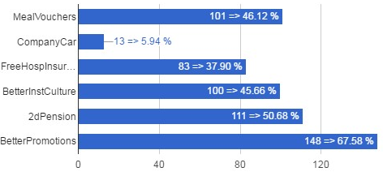  219
Meal Vouchers | 101
Company Car | 13
Free Hospitalisation Insurance | 83
Better Institutional Culture | 100
An employer pension scheme (2dPension) | 111
Better career prospects (Promotions) | 148

Which Improvements vs Career
↓Q19\Q2→ | ? | Sci | Tech/Admin
MealVouchers | 4 | 34 | 63
CompanyCar |  | 6 | 7
FreeHospInsurance | 2 | 26 | 55
BetterInstCulture | 1 | 52 | 47
2dPension | 3 | 49 | 59
BetterPromotions | 3 | 67 | 78

Which Improvements vs Position
↓Q19\Q3→ | CON | MAN | OTH | STA
MealVouchers | 64 | 1 | 2 | 34
CompanyCar | 6 |  | 1 | 6
FreeHospInsurance | 55 | 1 | 1 | 26
BetterInstCulture | 55 | 1 | 3 | 41
2dPension | 70 | 1 | 2 | 38
BetterPromotions | 100 | 1 | 3 | 44

Which Improvements vs Age
↓Q19\Q5→ | NoAnswer | 21­30 | 31­40 | 41­50 | 51­60 | 61­65 | >65
MealVouchers | 3 | 13 | 29 | 29 | 22 | 4 | 1
CompanyCar |  | 4 | 3 | 5 |  | 1
FreeHospInsurance | 2 | 7 | 22 | 29 | 18 | 4 | 1
BetterInstCulture | 2 | 13 | 28 | 37 | 14 | 5 | 1
2dPension | 3 | 12 | 35 | 34 | 21 | 5 | 1
BetterPromotions | 2 | 19 | 47 | 46 | 28 | 5 | 1

Q21: If so (Q20), which specific deterioration do you fear?
#answers Q21 | 702
Job Insecurity | 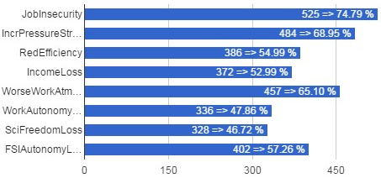  525
Increased Pressure and excessive Stress | 484
Reduced Efficiency | 386
Loss of Income | 372
Deterioration of the atmosphere at work (WorseWorkAtmos) | 457
Loss of Autonomy in my Work | 336
Loss of Scientific Freedom | 328
Loss of Autonomy for my FSI | 402

Which Deteriorations vs Career
↓Q21\Q2→ | ? | Sci | Tech/Admin
JobInsecurity | 18 | 202 | 305
IncrPressureStress | 20 | 173 | 291
RedEfficiency | 13 | 135 | 238
IncomeLoss | 8 | 113 | 251
WorseWorkAtmos | 15 | 179 | 263
WorkAutonomyLoss | 11 | 143 | 182
SciFreedomLoss | 2 | 208 | 118
FSIAutonomyLoss | 9 | 189 | 204

Which Deteriorations vs Position
↓Q21\Q3→ | CON | MAN | OTH | STA
JobInsecurity | 280 |  | 2 | 243
IncrPressureStress | 245 |  | 1 | 238
RedEfficiency | 187 |  |  | 199
IncomeLoss | 184 |  |  | 188
WorseWorkAtmos | 232 |  | 3 | 222
WorkAutonomyLoss | 160 |  | 2 | 174
SciFreedomLoss | 173 |  | 4 | 151
FSIAutonomyLoss | 187 |  | 3 | 212

Which Deteriorations vs Age
↓Q21\Q5→ | NoAnswer | 21­30 | 31­40 | 41­50 | 51­60 | 61­65 | >65
JobInsecurity | 5 | 38 | 136 | 186 | 134 | 20 | 6
IncrPressureStress | 8 | 40 | 120 | 170 | 125 | 17 | 4
RedEfficiency | 6 | 23 | 98 | 144 | 99 | 14 | 2
IncomeLoss | 3 | 25 | 88 | 136 | 105 | 12 | 3
WorseWorkAtmos | 5 | 31 | 118 | 163 | 120 | 15 | 5
WorkAutonomyLoss | 1 | 19 | 89 | 117 | 94 | 10 | 6
SciFreedomLoss | 4 | 27 | 85 | 112 | 82 | 13 | 5
FSIAutonomyLoss | 5 | 26 | 103 | 147 | 103 | 15 | 3

Additional Contingency Tables (Comparison of several questions per Institute Types)
Institutes were grouped by main domain of activity:
Papers = KB­BR + AGR­ARA
Museums = IRSNB­KBIN + MRAC­KMMA + MRAH­KMKG + MRBAB­KMSKB
SpaceScience = IASB­BIRA + IRM­KMI + ORB­KSB
BELSPO & KIK­IRPA have been ignored here because of the very few answers we receive from there.

Feel Concerned by the Reform vs Institute Type
↓InstType\\Q6→ | NoAnswer | NO | YES, BUT | YES
Papers | 2 | 7 | 79 | 91
Museums | 6 | 13 | 163 | 165
SpaceScience | 1 | 6 | 134 | 143

Agree with Reform Objectives vs Institute Type
↓InstType\\Q8→ | NoAnswer | ? | NO | YES
Papers | 34 | 35 | 100 | 10
Museums | 44 | 102 | 181 | 20
SpaceScience | 32 | 102 | 131 | 19

How better will work the institution vs Institute Type
↓InstType\\Q12→ | NoAnswer | + | ­ | = | ?
Papers | 35 | 6 | 83 | 19 | 36
Museums | 46 | 15 | 147 | 42 | 97
SpaceScience | 33 | 12 | 123 | 40 | 76

FSIs need Major Reform vs Institute Type
↓InstType\\Q15→ | NoAnswer | ? | NO | YES
Papers | 1 | 33 | 59 | 86
Museums | 0 | 87 | 89 | 171
SpaceScience | 0 | 67 | 84 | 133

Fear for Job vs Institute Type
↓InstType\\Q17→ | NoAnswer | NO | YES
Papers | 1 | 61 | 117
Museums | 8 | 107 | 232
SpaceScience | 7 | 101 | 176

Impact of BELSPO's reform on the FSIs vs Institute Type
↓InstType\\Q17→ | NoAnswer | ? | NO | YES+ | YES­
Papers | 4 | 62 | 9 | 13 | 91
Museums | 7 | 144 | 13 | 27 | 156
SpaceScience | 152 | 64 | 10 | 13 | 45

KB­BR

Total number of answers (KB­BR)
Q1 | count(*)
KB­BR | 62

Scientific or Administrative/Technical Career? (KB­BR)
Q2 | count(*)
? | 2
Sci | 8
Tech/Admin | 52
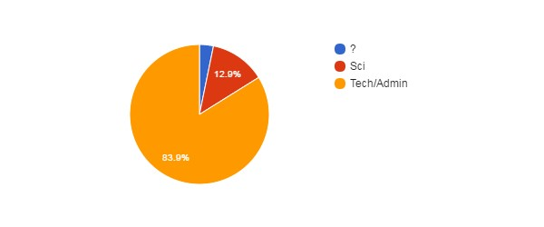

Position (KB­BR)
Q3 | count(*)
CON | 16
STA | 46
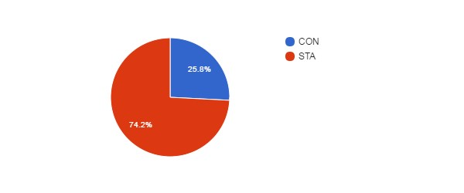

Position vs Age (KB­BR)
↓Q3\Q5→ | NoAnswer | 21­30 | 31­40 | 41­50 | 51­60 | 61­65 | >65
CON |  | 4 | 2 | 5 | 3 | 1 | 1
MAN
OTH
STA | 1 | 3 | 7 | 21 | 14

Gender (KB­BR)
Q4 | count(*)
F | 35
M | 27
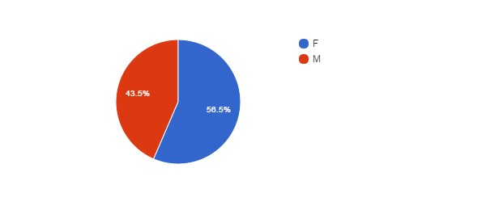

Age (KB­BR)
Q5 | count(*)
No answer | 1
21­30 | 7
31­40 | 9
41­50 | 26
51­60 | 17
61­65 | 1
>65 | 1
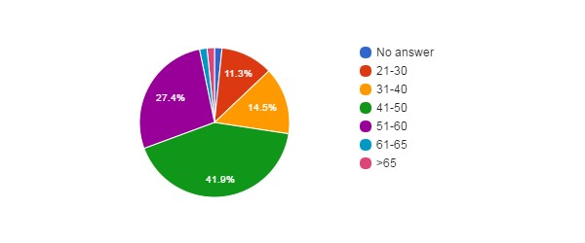

Feel Concerned by the Reform ? (KB­BR)
Q6 | count(*)
NO | 3
YES | 34
YES, BUT | 25
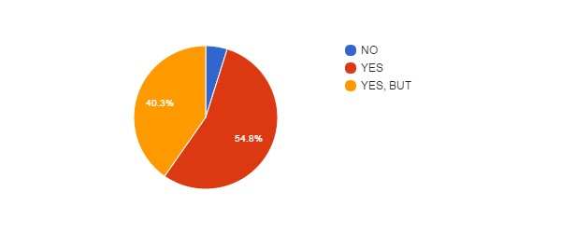

Concerned vs Career (KB­BR)
↓Q6\Q2→ | ? | Sci | Tech/Admin
NoAnswer
NO |  | 1 | 2
YES | 1 | 5 | 28
YES, BUT | 1 | 2 | 22

Concerned vs Position (KB­BR)
↓Q6\Q3→ | CON | MAN | OTH | STA
NoAnswer
NO | 1 |  |  | 2
YES | 5 |  |  | 29
YES, BUT | 10 |  |  | 15

Concerned vs Gender (KB­BR)
↓Q6\Q4→ | NoAnswer | F | M
NoAnswer
NO |  | 1 | 2
YES |  | 19 | 15
YES, BUT |  | 15 | 10

Concerned vs Age (KB­BR)
↓Q6\Q5→ | NoAnswer | 21­30 | 31­40 | 41­50 | 51­60 | 61­65 | >65
NoAnswer
NO |  | 2 |  | 1
YES | 1 | 2 | 5 | 13 | 11 | 1 | 1
YES, BUT |  | 3 | 4 | 12 | 6

How Informed ? (KB­BR)
Q7 | count(*)
0 | 7
1 | 26
2 | 25
3 | 4
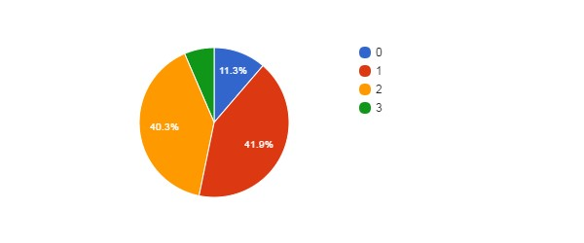

How Informed vs Career (KB­BR)
↓Q7\Q2→ | ? | Sci | Tech/Admin
NoAnswer
0 |  | 1 | 6
1 | 2 | 1 | 23
2 |  | 5 | 20
3 |  | 1 | 3

How Informed vs Position (KB­BR)
↓Q7\Q3→ | CON | MAN | OTH | STA
NoAnswer
0 | 2 |  |  | 5
1 | 7 |  |  | 19
2 | 7 |  |  | 18
3 |  |  |  | 4

How Informed vs Age (KB­BR)
↓Q7\Q5→ | NoAnswer | 21­30 | 31­40 | 41­50 | 51­60 | 61­65 | >65
NoAnswer
0 |  |  |  | 5 | 1 | 1
1 |  | 1 | 3 | 14 | 7 |  | 1
2 | 1 | 5 | 5 | 6 | 8
3 |  | 1 | 1 | 1 | 1

Agree with Objectives ? (KB­BR)
Q8 | count(*)
No answer | 4
? | 14
NO | 43
YES | 1
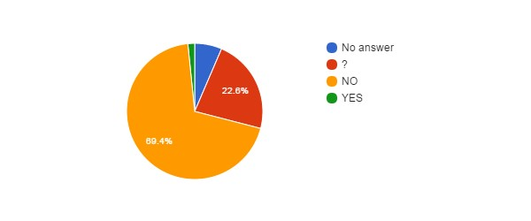

Agree with Objectives vs Career (KB­BR)
↓Q8\Q2→ | ? | Sci | Tech/Admin
NoAnswer |  |  | 4
? |  | 1 | 13
NO | 2 | 7 | 34
YES |  |  | 1

Agree with Objectives vs Position (KB­BR)
↓Q8\Q3→ | CON | MAN | OTH | STA
NoAnswer | 1 |  |  | 3
? | 2 |  |  | 12
NO | 13 |  |  | 30
YES |  |  |  | 1

Agree with Objectives vs Age (KB­BR)
↓Q8\Q5→ | NoAnswer | 21­30 | 31­40 | 41­50 | 51­60 | 61­65 | >65
NoAnswer |  |  |  | 3 |  | 1
? | 1 |  | 2 | 8 | 3
NO |  | 6 | 7 | 15 | 14 |  | 1
YES |  | 1

Reform will Achieve Objectives ? (KB­BR)
Q9 | count(*)
No answer | 6
? | 22
NO | 30
YES | 4
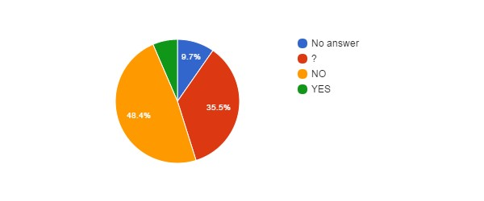

Hidden Agenda ? (KB­BR)
Q10 | count(*)
No answer | 7
? | 18
NO | 1
YES | 36
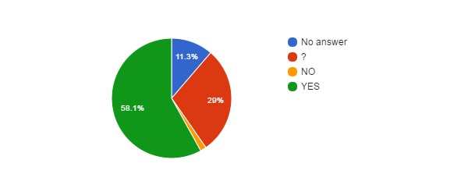

Hidden Agenda vs Language (KB­BR)
↓Q10\Lang→ | EN | FR | NL
NoAnswer |  | 3 | 4
? |  | 9 | 9
NO |  | 1
YES |  | 29 | 7

Reform entails... (KB­BR)
Q11 | count(*)
No answer | 6
? | 6
CONT | 5
PRIV | 23
RISK | 22
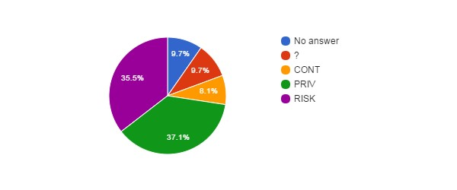

How better will work the institution after the reform ? (KB­BR)
Q12 | count(*)
No answer | 6
+ | 1
­ | 31
= | 8
? | 16
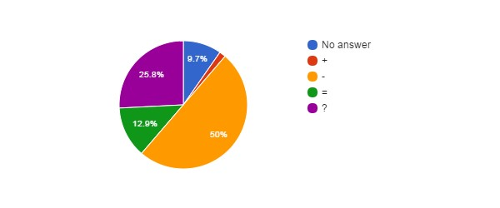

How better will work the institution vs Career (KB­BR)
↓Q12\Q2→ | ? | Sci | Tech/Admin
NoAnswer |  | 1 | 5
+ |  |  | 1
­ | 2 | 5 | 24
= |  |  | 8
? |  | 2 | 14

Agree with Privatisation of Public Services ? (KB­BR)
Q13 | count(*)
No answer | 1
? | 1
NO | 59
YES | 1
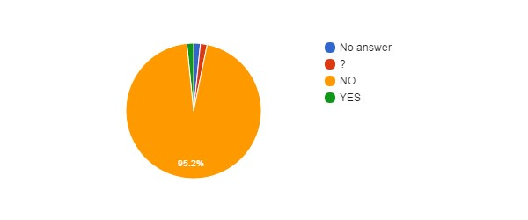

Agree with Privatisation of Public Services vs Age (KB­BR)
↓Q13\Q5→ | NoAnswer | 21­30 | 31­40 | 41­50 | 51­60 | 61­65 | >65
NoAnswer |  |  |  |  | 1
? |  |  |  | 1
NO | 1 | 6 | 9 | 25 | 16 | 1 | 1
YES |  | 1

Agree with Privatisation of Public Services vs Language (KB­BR)
↓Q13\Lang→ | EN | FR | NL
NoAnswer |  |  | 1
? |  | 1
NO |  | 40 | 19
YES |  | 1

Agree with Privatisation of the FSIs ? (KB­BR)
Q14 | count(*)
? | 3
NO | 59
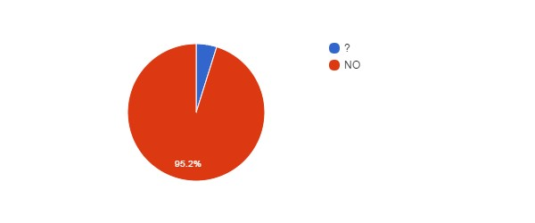

Agree with Privatisation of FSIs vs Agree with Privatisation of Public Services (KB­BR)
↓Q14\Q13→ | NoAnswer | ? | NO | YES
NoAnswer
? |  | 1 | 2
NO | 1 |  | 57 | 1
YES

Agree with Privatisation of FSIs vs Career (KB­BR)
↓Q14\Q2→ | ? | Sci | Tech/Admin
NoAnswer
? |  |  | 3
NO | 2 | 8 | 49
YES

FSIs need Major Reforms ? (KB­BR)
Q15 | count(*)
No answer | 1
? | 10
NO | 23
YES | 28
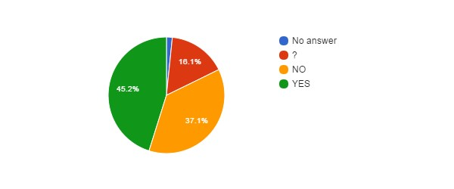

FSIs need Major Reforms vs Career (KB­BR)
↓Q15\Q2→ | ? | Sci | Tech/Admin
NoAnswer |  |  | 1
? |  |  | 10
NO | 2 | 3 | 18
YES |  | 5 | 23

FSIs need Major Reforms vs Position (KB­BR)
↓Q15\Q3→ | CON | MAN | OTH | STA
NoAnswer |  |  |  | 1
? | 3 |  |  | 7
NO | 8 |  |  | 15
YES | 5 |  |  | 23

FSIs need Major Reforms vs Age (KB­BR)
↓Q15\Q5→ | NoAnswer | 21­30 | 31­40 | 41­50 | 51­60 | 61­65 | >65
NoAnswer |  |  |  |  | 1
? |  | 1 | 2 | 7
NO |  | 2 | 2 | 11 | 7 |  | 1
YES | 1 | 4 | 5 | 8 | 9 | 1

FSIs Reforms need status change ? (KB­BR)
Q16 | count(*)
No answer | 23
? | 10
NO | 28
YES | 1
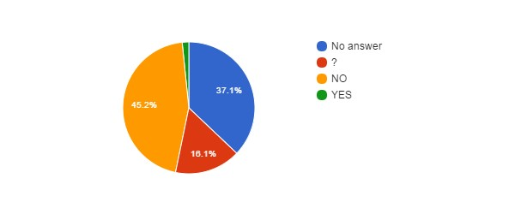

Fear for your Job ? (KB­BR)
Q17 | count(*)
NO | 19
YES | 43
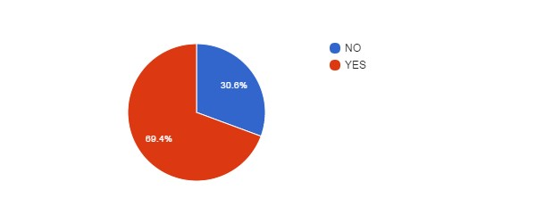

Fear for Job vs Position (KB­BR)
↓Q17\Q3→ | CON | MAN | OTH | STA
NoAnswer
NO | 3 |  |  | 16
YES | 13 |  |  | 30

Fear for Job vs Age (KB­BR)
↓Q17\Q5→ | NoAnswer | 21­30 | 31­40 | 41­50 | 51­60 | 61­65 | >65
NoAnswer
NO |  | 2 | 2 | 7 | 8
YES | 1 | 5 | 7 | 19 | 9 | 1 | 1

Fear for Job vs Career (KB­BR)
↓Q17\Q2→ | ? | Sci | Tech/Admin
NoAnswer
NO | 1 | 1 | 17
YES | 1 | 7 | 35

Reform will improve some employment conditions ? (KB­BR)
Q18 | count(*)
? | 12
NO | 48
YES | 2
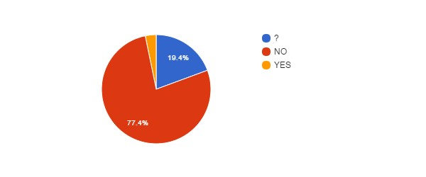

Reform will improve some employment conditions vs Position (KB­BR)
↓Q18\Q3→ | CON | MAN | OTH | STA
NoAnswer
? | 3 |  |  | 9
NO | 12 |  |  | 36
YES | 1 |  |  | 1

Reform will improve some employment conditions vs Age (KB-BR)
↓Q18\Q5→ | NoAnswer | 21­30 | 31­40 | 41­50 | 51­60 | 61­65 | >65
NoAnswer
? |  | 1 |  | 10 | 1
NO | 1 | 4 | 9 | 16 | 16 | 1 | 1
YES |  | 2

Reform will improve some employment conditions vs Career (KB­BR)
↓Q18\Q2→ | ? | Sci | Tech/Admin
NoAnswer
? |  | 1 | 11
NO | 2 | 7 | 39
YES |  |  | 2

Reform will deteriorate some employment conditions ? (KB­BR)
Q20 | count(*)
? | 4
NO | 2
YES | 56

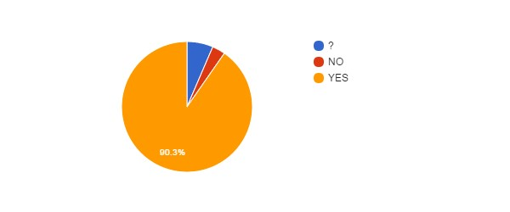

Reform will deteriorate some employment conditions vs Position (KB­BR)
↓Q20\Q3→ | CON | MAN | OTH | STA
NoAnswer
? | 1 |  |  | 3
NO |  |  |  | 2
YES | 15 |  |  | 41

Reform will deteriorate some employment conditions vs Age (KB­BR)
↓Q20\Q5→ | NoAnswer | 21­30 | 31­40 | 41­50 | 51­60 | 61­65 | >65
NoAnswer
? |  | 1 |  | 3
NO |  | 1 | 1
YES | 1 | 5 | 8 | 23 | 17 | 1 | 1

Reform will deteriorate some employment conditions vs Career (KB­BR)
↓Q20\Q2→ | ? | Sci | Tech/Admin
NoAnswer
? |  |  | 4
NO |  |  | 2
YES | 2 | 8 | 46

Impact of BELSPO's reform on the FSIs (KB­BR)
Q22 | count(*)
No answer | 1
? | 17
NO | 3
YES+ | 4
YES­ | 37
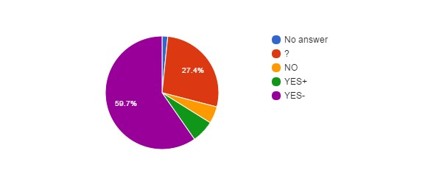

Impact of BELSPO's reform on the FSIs vs Career (KB­BR)
↓Q22\Q2→ | ? | Sci | Tech/Admin
NoAnswer |  |  | 1
? |  | 1 | 16
NO |  |  | 3
YES+ | 1 | 1 | 2
YES­ | 1 | 6 | 30

Impact of BELSPO's reform on the FSIs vs Position (KB­BR)
↓Q22\Q3→ | CON | MAN | OTH | STA
NoAnswer | 1
? | 2 |  |  | 15
NO |  |  |  | 3
YES+ | 1 |  |  | 3
YES­ | 12 |  |  | 25

Language (KB­BR)
Lang | count(*)
FR | 42
NL | 20
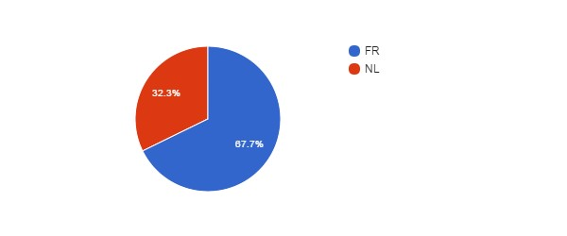

Language vs Age (KB­BR)
↓Lang\Q5→ | NoAnswer | 21­30 | 31­40 | 41­50 | 51­60 | 61­65 | >65
EN
FR | 1 | 6 | 8 | 17 | 8 | 1 | 1
NL |  | 1 | 1 | 9 | 9

Language vs Position (KB­BR)
↓Lang\Q3→ | CON | MAN | OTH | STA
EN
FR | 13 |  |  | 29
NL | 3 |  |  | 17

Which improvements do you expect ? (KB­BR)
#answers Q19 | 8
MealVouchers | 4
CompanyCar | 0
FreeHospInsurance | 4
BetterInstCulture | 4
2dPension | 4
BetterPromotions | 6
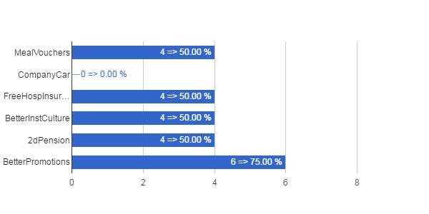

Which Improvements vs Career (KB­BR)
↓Q19\Q2→ | ? | Sci | Tech/Admin
MealVouchers |  |  | 4
CompanyCar
FreeHospInsurance |  |  | 4
BetterInstCulture |  |  | 4
2dPension |  |  | 4
BetterPromotions |  |  | 6

Which Improvements vs Position (KB­BR)
↓Q19\Q3→ | CON | MAN | OTH | STA
MealVouchers | 2 |  |  | 2
CompanyCar
FreeHospInsurance | 2 |  |  | 2
BetterInstCulture | 1 |  |  | 3
2dPension | 1 |  |  | 3
BetterPromotions | 1 |  |  | 5

Which Improvements vs Age (KB­BR)
↓Q19\Q5→ | NoAnswer | 21­30 | 31­40 | 41­50 | 51­60 | 61­65 | >65
MealVouchers |  | 1 |  | 3
CompanyCar
FreeHospInsurance |  | 1 |  | 1 | 2
BetterInstCulture |  | 1 |  | 2 | 1
2dPension |  | 1 |  | 1 | 2
BetterPromotions |  | 1 |  | 2 | 3

Which deteriorations do you expect ? (KB­BR)
#answers Q21 | 56
JobInsecurity | 40
IncrPressureStress | 48
RedEfficiency | 35
IncomeLoss | 39
WorseWorkAtmos | 40
WorkAutonomyLoss | 26
SciFreedomLoss | 16
FSIAutonomyLoss | 32
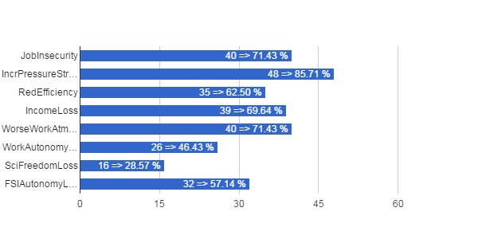

Which Deteriorations vs Career (KB­BR)
↓Q21\Q2→ | ? | Sci | Tech/Admin
JobInsecurity | 2 | 7 | 31
IncrPressureStress | 2 | 7 | 39
RedEfficiency | 1 | 5 | 29
IncomeLoss | 2 | 5 | 32
WorseWorkAtmos | 2 | 7 | 31
WorkAutonomyLoss | 2 | 4 | 20
SciFreedomLoss | 1 | 7 | 8
FSIAutonomyLoss | 1 | 6 | 25

Which Deteriorations vs Position (KB­BR)
↓Q21\Q3→ | CON | MAN | OTH | STA
JobInsecurity | 12 |  |  | 28
IncrPressureStress | 15 |  |  | 33
RedEfficiency | 11 |  |  | 24
IncomeLoss | 11 |  |  | 28
WorseWorkAtmos | 12 |  |  | 28
WorkAutonomyLoss | 8 |  |  | 18
SciFreedomLoss | 9 |  |  | 7
FSIAutonomyLoss | 9 |  |  | 23

Which Deteriorations vs Age (KB­BR)
↓Q21\Q5→ | NoAnswer | 21­30 | 31­40 | 41­50 | 51­60 | 61­65 | >65
JobInsecurity | 1 | 4 | 7 | 17 | 9 | 1 | 1
IncrPressureStress | 1 | 5 | 8 | 18 | 14 | 1 | 1
RedEfficiency |  | 3 | 7 | 15 | 9 | 1
IncomeLoss |  | 3 | 6 | 17 | 12 |  | 1
WorseWorkAtmos |  | 4 | 7 | 15 | 12 | 1 | 1
WorkAutonomyLoss |  |  | 7 | 9 | 8 | 1 | 1
SciFreedomLoss |  | 3 | 2 | 4 | 6 | 1
FSIAutonomyLoss |  | 3 | 6 | 11 | 11 | 1

IRSNB­KBIN

Total number of answers (IRSNB­KBIN)
Q1 | count(*)
IRSNB­KBIN | 127

Scientific or Administrative/Technical Career? (IRSNB­KBIN)
Q2 | count(*)
? | 2
Sci | 54
Tech/Admin | 71

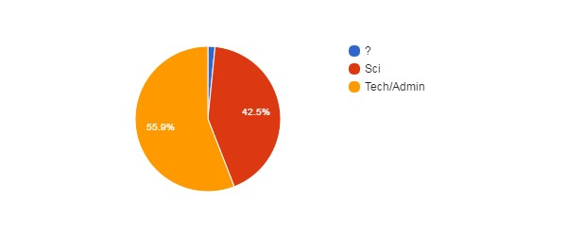

Position (IRSNB­KBIN)
Q3 | count(*)
CON | 67
OTH | 2
STA | 58

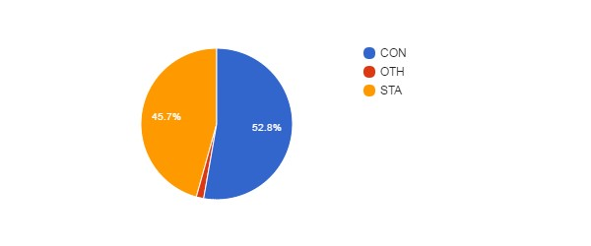

Position vs Age (IRSNB­KBIN)
↓Q3\Q5→ | NoAnswer | 21­30 | 31­40 | 41­50 | 51­60 | 61­65 | >65
CON | 1 | 11 | 19 | 25 | 10 | 1
MAN
OTH |  |  |  |  | 1 |  | 1
STA | 1 | 1 | 11 | 25 | 18 | 2

Gender (IRSNB­KBIN)
Q4 | count(*)
F | 47
M | 80

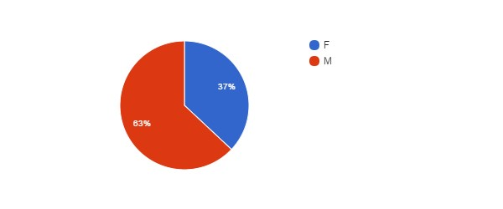

Age (IRSNB­KBIN)
Q5 | count(*)
No answer | 2
21-30 | 12
31-40 | 30
41-50 | 50
51-60 | 29
61-65 | 3
>65 | 1

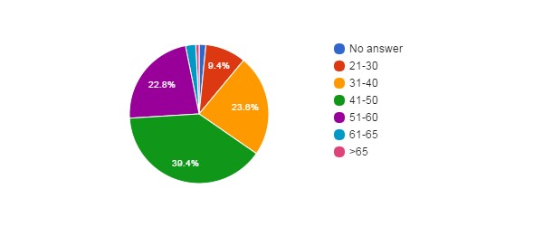

Feel Concerned by the Reform ? (IRSNB­KBIN)
Q6 | count(*)
No answer | 1
NO | 4
YES | 60
YES, BUT | 62

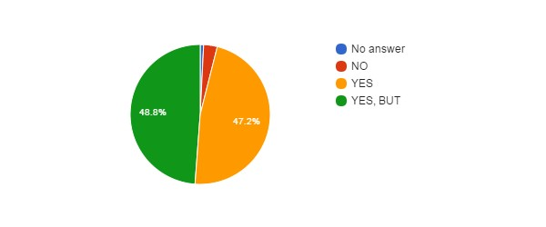

Concerned vs Career (IRSNB­KBIN)
↓Q6\Q2→ | ? | Sci | Tech/Admin
NoAnswer |  | 1
NO |  | 2 | 2
YES | 1 | 30 | 29
YES, BUT | 1 | 21 | 40

Concerned vs Position (IRSNB­KBIN)
↓Q6\Q3→ | CON | MAN | OTH | STA
NoAnswer | 1
NO | 3 |  |  | 1
YES | 33 |  | 1 | 26
YES, BUT | 30 |  | 1 | 31

Concerned vs Gender (IRSNB­KBIN)
↓Q6\Q4→ | NoAnswer | F | M
NoAnswer |  | 1
NO |  | 3 | 1
YES |  | 19 | 41
YES, BUT |  | 24 | 38

Concerned vs Age (IRSNB­KBIN)
↓Q6\Q5→ | NoAnswer | 21­30 | 31­40 | 41­50 | 51­60 | 61­65 | >65
NoAnswer |  | 1
NO |  | 1 | 1 | 1 |  | 1
YES | 2 | 3 | 11 | 26 | 15 | 2 | 1
YES, BUT |  | 7 | 18 | 23 | 14

How Informed ? (IRSNB­KBIN)
Q7 | count(*)
0 | 9
1 | 38
2 | 46
3 | 34
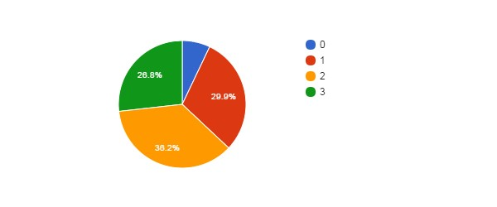

How Informed vs Career (IRSNB­KBIN)
↓Q7\Q2→ | ? | Sci | Tech/Admin
NoAnswer
0 |  | 4 | 5
1 | 1 | 14 | 23
2 |  | 21 | 25
3 | 1 | 15 | 18

How Informed vs Position (IRSNB­KBIN)
↓Q7\Q3→ | CON | MAN | OTH | STA
NoAnswer
0 | 7 |  |  | 2
1 | 19 |  | 1 | 18
2 | 22 |  | 1 | 23
3 | 19 |  |  | 15

How Informed vs Age (IRSNB­KBIN)
↓Q7\Q5→ | NoAnswer | 21­30 | 31­40 | 41­50 | 51­60 | 61­65 | >65
NoAnswer
0 | 1 | 3 | 2 | 2 |  | 1
1 |  | 4 | 16 | 12 | 5 |  | 1
2 | 1 | 4 | 6 | 20 | 14 | 1
3 |  | 1 | 6 | 16 | 10 | 1

Agree with Objectives ? (IRSNB­KBIN)
Q8 | count(*)
No answer | 5
? | 36
NO | 82
YES | 4
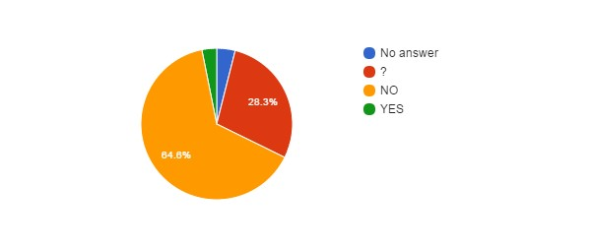

Agree with Objectives vs Career (IRSNB­KBIN)
↓Q8\Q2→ | ? | Sci | Tech/Admin
NoAnswer |  | 1 | 4
? | 2 | 13 | 21
NO |  | 37 | 45
YES |  | 3 | 1

Agree with Objectives vs Position (IRSNB­KBIN)
↓Q8\Q3→ | CON | MAN | OTH | STA
NoAnswer | 4 |  |  | 1
? | 21 |  |  | 15
NO | 40 |  | 2 | 40
YES | 2 |  |  | 2

Agree with Objectives vs Age (IRSNB­KBIN)
↓Q8\Q5→ | NoAnswer | 21­30 | 31­40 | 41­50 | 51­60 | 61­65 | >65
NoAnswer | 1 | 1 | 1 | 2
? |  | 5 | 7 | 15 | 7 | 2
NO | 1 | 6 | 20 | 33 | 21 |  | 1
YES |  |  | 2 |  | 1 | 1

Reform will Achieve Objectives ? (IRSNB­KBIN)
Q9 | count(*)
No answer | 5
? | 44
NO | 75
YES | 3
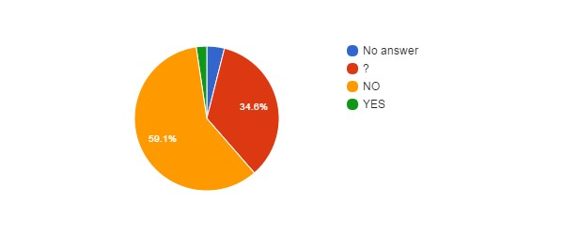

Hidden Agenda ? (IRSNB­KBIN)
Q10 | count(*)
No answer | 5
? | 33
NO | 5
YES | 84
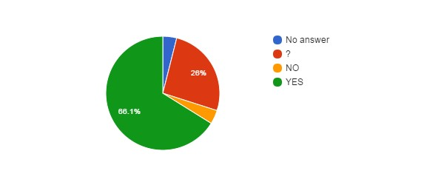

Hidden Agenda vs Language (IRSNB­KBIN)
↓Q10\Lang→ | EN | FR | NL
NoAnswer | 1 | 3 | 1
? |  | 22 | 11
NO |  | 1 | 4
YES |  | 50 | 34

Reform entails... (IRSNB­KBIN)
Q11 | count(*)
No answer | 5
? | 13
CONT | 4
PRIV | 64
RISK | 41
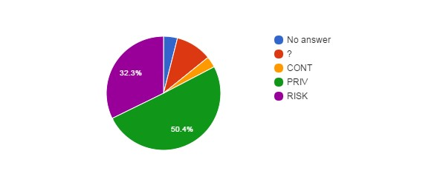

How better will work the institution after the reform ? (IRSNB­KBIN)
Q12 | count(*)
No answer | 5
+ | 3
­ | 72
= | 15
? | 32
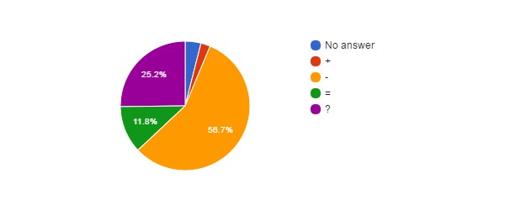

How better will work the institution vs Career (IRSNB­KBIN)
↓Q12\Q2→ | ? | Sci | Tech/Admin
NoAnswer |  | 1 | 4
+ |  | 2 | 1
­ | 1 | 35 | 36
= |  | 5 | 10
? | 1 | 11 | 20

Agree with Privatisation of Public Services ? (IRSNB­KBIN)
Q13 | count(*)
No answer | 2
? | 10
NO | 110
YES | 5
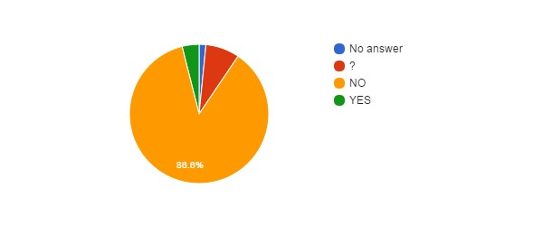

Agree with Privatisation of Public Services vs Age (IRSNB­KBIN)
↓Q13\Q5→ | NoAnswer | 21­30 | 31­40 | 41­50 | 51­60 | 61­65 | >65
NoAnswer |  |  |  |  | 2
? |  |  | 4 | 2 | 3 | 1
NO | 2 | 12 | 25 | 45 | 24 | 1 | 1
YES |  |  | 1 | 3 |  | 1

Agree with Privatisation of Public Services vs Language (IRSNB-KBIN)
↓Q13\Lang→ | EN | FR | NL
NoAnswer |  | 1 | 1
? |  | 4 | 6
NO | 1 | 68 | 41
YES |  | 3 | 2

Agree with Privatisation of the FSIs ? (IRSNB­KBIN)
Q14 | count(*)
No answer | 1
? | 9
NO | 112
YES | 5
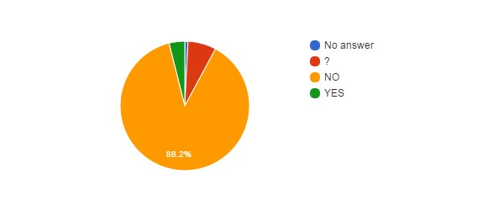

Agree with Privatisation of FSIs vs Agree with Privatisation of Public Services (IRSNB­KBIN)
↓Q14\Q13→ | NoAnswer | ? | NO | YES
NoAnswer |  |  | 1
? |  | 6 | 3
NO | 2 | 4 | 106
YES |  |  |  | 5

Agree with Privatisation of FSIs vs Career (IRSNB­KBIN)
↓Q14\Q2→ | ? | Sci | Tech/Admin
NoAnswer |  |  | 1
? |  | 2 | 7
NO | 2 | 50 | 60
YES |  | 2 | 3

FSIs need Major Reforms ? (IRSNB­KBIN)
Q15 | count(*)
? | 29
NO | 40
YES | 58
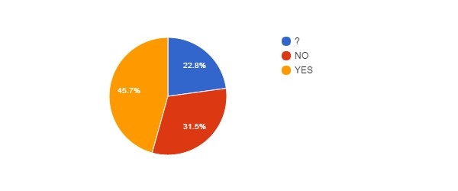

FSIs need Major Reforms vs Career (IRSNB­KBIN)
↓Q15\Q2→ | ? | Sci | Tech/Admin
NoAnswer
? |  | 12 | 17
NO | 1 | 16 | 23
YES | 1 | 26 | 31

FSIs need Major Reforms vs Position (IRSNB­KBIN)
↓Q15\Q3→ | CON | MAN | OTH | STA
NoAnswer
? | 21 |  | 2 | 6
NO | 19 |  |  | 21
YES | 27 |  |  | 31

FSIs need Major Reforms vs Age (IRSNB­KBIN)
↓Q15\Q5→ | NoAnswer | 21­30 | 31­40 | 41­50 | 51­60 | 61­65 | >65
NoAnswer
? |  | 7 | 4 | 8 | 8 | 1 | 1
NO | 2 | 2 | 7 | 20 | 9
YES |  | 3 | 19 | 22 | 12 | 2

FSIs Reforms need status change ? (IRSNB­KBIN)
Q16 | count(*)
No answer | 40
? | 32
NO | 49
YES | 6
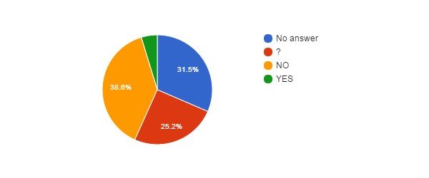

Fear for your Job ? (IRSNB­KBIN)
Q17 | count(*)
No answer | 1
NO | 41
YES | 85
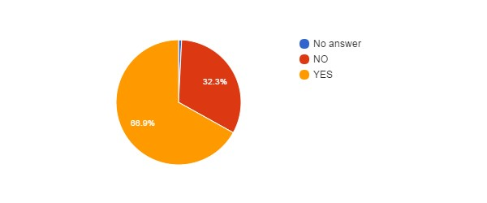

Fear for Job vs Position (IRSNB­KBIN)
↓Q17\Q3→ | CON | MAN | OTH | STA
NoAnswer | 1
NO | 16 |  | 1 | 24
YES | 50 |  | 1 | 34

Fear for Job vs Age (IRSNB­KBIN)
↓Q17\Q5→ | NoAnswer | 21­30 | 31­40 | 41­50 | 51­60 | 61­65 | >65
NoAnswer |  | 1
NO |  | 2 | 11 | 14 | 11 | 2 | 1
YES | 2 | 9 | 19 | 36 | 18 | 1

Fear for Job vs Career (IRSNB­KBIN)
↓Q17\Q2→ | ? | Sci | Tech/Admin
NoAnswer |  | 1
NO |  | 18 | 23
YES | 2 | 35 | 48

Reform will improve some employment conditions ? (IRSNB­KBIN)
Q18 | count(*)
? | 26
NO | 80
YES | 21
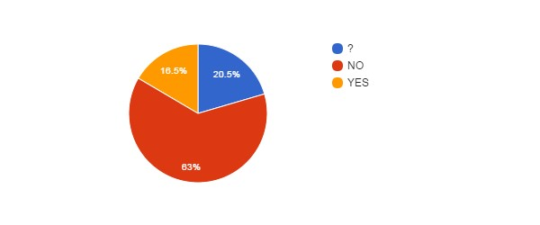

Reform will improve some employment conditions vs Position (IRSNB­KBIN)
↓Q18\Q3→ | CON | MAN | OTH | STA
NoAnswer
? | 17 |  | 1 | 8
NO | 37 |  | 1 | 42
YES | 13 |  |  | 8

Reform will improve some employment conditions vs Age (IRSNB­KBIN)
↓Q18\Q5→ | NoAnswer | 21­30 | 31­40 | 41­50 | 51­60 | 61­65 | >65
NoAnswer
? |  | 3 | 5 | 9 | 8 | 1
NO | 2 | 6 | 20 | 32 | 18 | 1 | 1
YES |  | 3 | 5 | 9 | 3 | 1

Reform will improve some employment conditions vs Career (IRSNB­KBIN)
↓Q18\Q2→ | ? | Sci | Tech/Admin
NoAnswer
? | 1 | 11 | 14
NO | 1 | 32 | 47
YES |  | 11 | 10

Reform will deteriorate some employment conditions ? (IRSNB­KBIN)
Q20 | count(*)
No answer | 1
? | 14
NO | 3
YES | 109
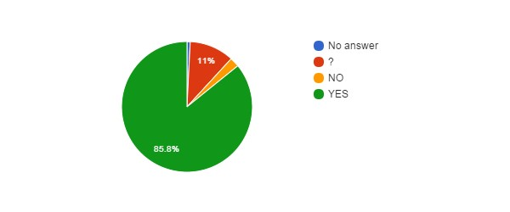

Reform will deteriorate some employment conditions vs Position (IRSNB­KBIN)
↓Q20\Q3→ | CON | MAN | OTH | STA
NoAnswer | 1
? | 11 |  |  | 3
NO | 2 |  |  | 1
YES | 53 |  | 2 | 54

Reform will deteriorate some employment conditions vs Age (IRSNB­KBIN)
↓Q20\Q5→ | NoAnswer | 21­30 | 31­40 | 41­50 | 51­60 | 61­65 | >65
NoAnswer |  |  |  |  |  | 1
? |  | 2 | 5 | 2 | 4 | 1
NO |  | 1 |  | 1 |  | 1
YES | 2 | 9 | 25 | 47 | 25 |  | 1

Reform will deteriorate some employment conditions vs Career (IRSNB­KBIN)
↓Q20\Q2→ | ? | Sci | Tech/Admin
NoAnswer |  | 1
? |  | 9 | 5
NO |  | 2 | 1
YES | 2 | 42 | 65

Impact of BELSPO's reform on the FSIs (IRSNB­KBIN)
Q22 | count(*)
No answer | 1
? | 42
NO | 5
YES+ | 7
YES­ | 72
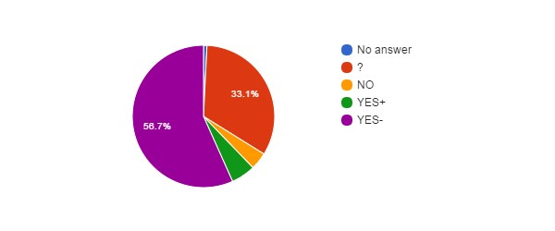

Impact of BELSPO's reform on the FSIs vs Career (IRSNB­KBIN)
↓Q22\Q2→ | ? | Sci | Tech/Admin
NoAnswer |  |  | 1
? | 1 | 15 | 26
NO |  | 3 | 2
YES+ |  | 3 | 4
YES­ | 1 | 33 | 38

Impact of BELSPO's reform on the FSIs vs Position (IRSNB­KBIN)
↓Q22\Q3→ | CON | MAN | OTH | STA
NoAnswer |  |  |  | 1
? | 22 |  | 1 | 19
NO | 4 |  |  | 1
YES+ | 3 |  |  | 4
YES­ | 38 |  | 1 | 33

Language (IRSNB­KBIN)
Lang | count(*)
EN | 1
FR | 76
NL | 50
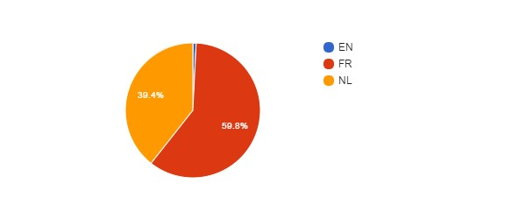

Language vs Age (IRSNB­KBIN)
↓Lang\Q5→ | NoAnswer | 21­30 | 31­40 | 41­50 | 51­60 | 61­65 | >65
EN |  | 1
FR | 2 | 9 | 17 | 29 | 18 | 1
NL |  | 2 | 13 | 21 | 11 | 2 | 1

Language vs Position (IRSNB­KBIN)
↓Lang\Q3→ | CON | MAN | OTH | STA
EN | 1
FR | 43 |  | 1 | 32
NL | 23 |  | 1 | 26

Which improvements do you expect ? (IRSNB­KBIN)
#answers Q19 | 38
MealVouchers | 21
CompanyCar | 2
FreeHospInsurance | 16
BetterInstCulture | 14
2dPension | 19
BetterPromotions | 28

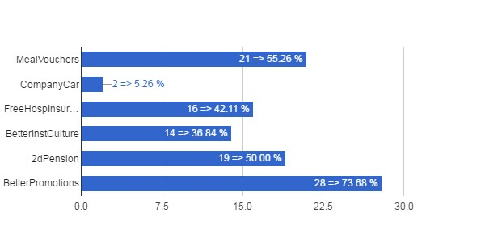

Which Improvements vs Career (IRSNB­KBIN)
↓Q19\Q2→ | ? | Sci | Tech/Admin
MealVouchers | 1 | 6 | 14
CompanyCar |  | 2
FreeHospInsurance |  | 4 | 12
BetterInstCulture | 1 | 5 | 8
2dPension | 1 | 9 | 9
BetterPromotions | 1 | 12 | 15

Which Improvements vs Position (IRSNB­KBIN)
↓Q19\Q3→ | CON | MAN | OTH | STA
MealVouchers | 13 |  | 1 | 7
CompanyCar | 1 |  |  | 1
FreeHospInsurance | 10 |  | 1 | 5
BetterInstCulture | 8 |  | 1 | 5
2dPension | 12 |  | 1 | 6
BetterPromotions | 21 |  | 1 | 6

Which Improvements vs Age (IRSNB­KBIN)
↓Q19\Q5→ | NoAnswer | 21­30 | 31­40 | 41­50 | 51­60 | 61­65 | >65
MealVouchers |  | 2 | 5 | 7 | 6 | 1
CompanyCar |  | 1 |  |  |  | 1
FreeHospInsurance |  | 2 | 2 | 6 | 5 | 1
BetterInstCulture |  |  | 2 | 9 | 2 | 1
2dPension |  | 2 | 3 | 9 | 4 | 1
BetterPromotions |  | 3 | 8 | 11 | 5 | 1

Which deteriorations do you expect ? (IRSNB­KBIN)
#answers Q21 | 113
JobInsecurity | 84
IncrPressureStress | 69
RedEfficiency | 59
IncomeLoss | 60
WorseWorkAtmos | 68
WorkAutonomyLoss | 55
SciFreedomLoss | 54
FSIAutonomyLoss | 63
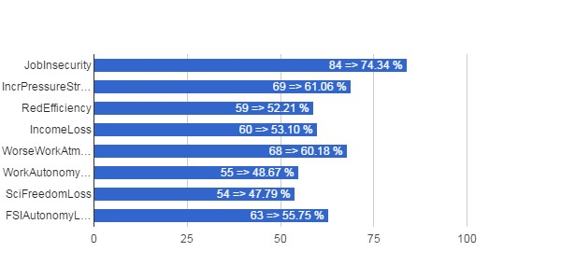

Which Deteriorations vs Career (IRSNB­KBIN)
↓Q21\Q2→ | ? | Sci | Tech/Admin
JobInsecurity | 2 | 33 | 49
IncrPressureStress | 2 | 29 | 38
RedEfficiency | 1 | 20 | 38
IncomeLoss |  | 18 | 42
WorseWorkAtmos | 2 | 30 | 36
WorkAutonomyLoss | 2 | 27 | 26
SciFreedomLoss |  | 33 | 21
FSIAutonomyLoss | 2 | 33 | 28

Which Deteriorations vs Position (IRSNB­KBIN)
↓Q21\Q3→ | CON | MAN | OTH | STA
JobInsecurity | 44 |  | 1 | 39
IncrPressureStress | 32 |  | 1 | 36
RedEfficiency | 27 |  |  | 32
IncomeLoss | 28 |  |  | 32
WorseWorkAtmos | 35 |  | 2 | 31
WorkAutonomyLoss | 30 |  | 1 | 24
SciFreedomLoss | 29 |  | 1 | 24
FSIAutonomyLoss | 31 |  | 1 | 31

Which Deteriorations vs Age (IRSNB­KBIN)
↓Q21\Q5→ | NoAnswer | 21­30 | 31­40 | 41­50 | 51­60 | 61­65 | >65
JobInsecurity | 1 | 7 | 20 | 35 | 19 | 1 | 1
IncrPressureStress | 2 | 4 | 14 | 33 | 15 |  | 1
RedEfficiency | 2 | 3 | 13 | 28 | 13
IncomeLoss | 1 | 4 | 12 | 27 | 15 | 1
WorseWorkAtmos |  | 3 | 17 | 30 | 16 | 1 | 1
WorkAutonomyLoss |  | 3 | 10 | 27 | 13 | 1 | 1
SciFreedomLoss | 1 | 3 | 9 | 28 | 12 |  | 1
FSIAutonomyLoss | 1 | 3 | 13 | 31 | 14 | 1

MRAH­KMKG

Total number of answers (MRAH­KMKG)
Q1 | count(*)
MRAH­KMKG | 108

Scientific or Administrative/Technical Career? (MRAH­KMKG)
Q2 | count(*)
? | 1
Sci | 34
Tech/Admin | 73
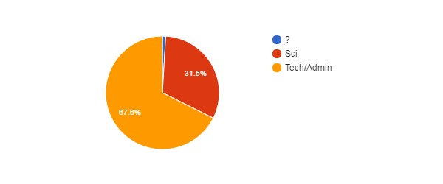

Position (MRAH­KMKG)
Q3 | count(*)
CON | 82
STA | 26
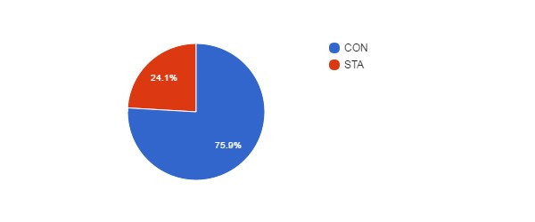

Position vs Age (MRAH­KMKG)
↓Q3\Q5→ | NoAnswer | 21­30 | 31­40 | 41­50 | 51­60 | 61­65 | >65
CON | 1 | 2 | 24 | 29 | 24 | 2
MAN
OTH
STA |  |  | 1 | 15 | 7 | 3

Gender (MRAH­KMKG)
Q4 | count(*)
F | 57
M | 51
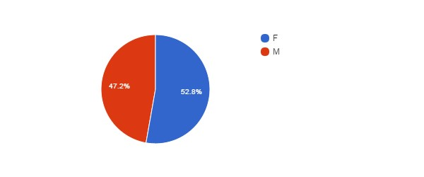

Age (MRAH­KMKG)
Q5 | count(*)
No answer | 1
21­30 | 2
31­40 | 25
41­50 | 44
51­60 | 31
61­65 | 5
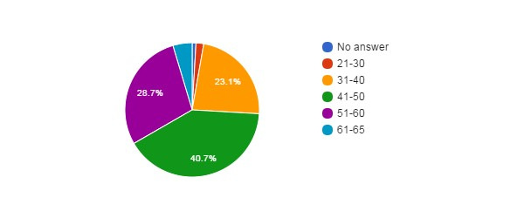

Feel Concerned by the Reform ? (MRAH­KMKG)
Q6 | count(*)
No answer | 3
NO | 5
YES | 53
YES, BUT | 47
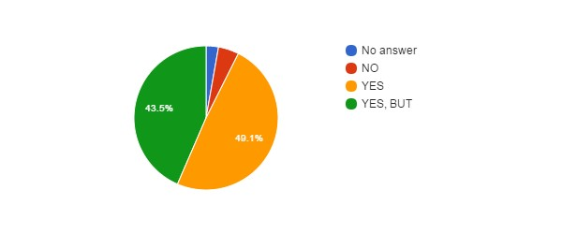

Concerned vs Career (MRAH­KMKG)
↓Q6\Q2→ | ? | Sci | Tech/Admin
NoAnswer | 1 |  | 2
NO |  | 2 | 3
YES |  | 19 | 34
YES, BUT |  | 13 | 34

Concerned vs Position (MRAH­KMKG)
↓Q6\Q3→ | CON | MAN | OTH | STA
NoAnswer | 3
NO | 4 |  |  | 1
YES | 35 |  |  | 18
YES, BUT | 40 |  |  | 7

Concerned vs Gender (MRAH­KMKG)
↓Q6\Q4→ | NoAnswer | F | M
NoAnswer |  | 2 | 1
NO |  | 2 | 3
YES |  | 33 | 20
YES, BUT |  | 20 | 27

Concerned vs Age (MRAH­KMKG)
↓Q6\Q5→ | NoAnswer | 21­30 | 31­40 | 41­50 | 51­60 | 61­65 | >65
NoAnswer |  |  |  | 2 | 1
NO |  |  | 1 | 1 | 3
YES |  | 1 | 10 | 24 | 14 | 4
YES, BUT | 1 | 1 | 14 | 17 | 13 | 1

How Informed ? (MRAH­KMKG)
Q7 | count(*)
No answer | 1
0 | 28
1 | 35
2 | 32
3 | 12
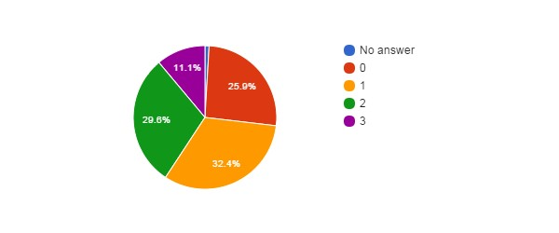

How Informed vs Career (MRAH­KMKG)
↓Q7\Q2→ | ? | Sci | Tech/Admin
NoAnswer |  |  | 1
0 |  | 8 | 20
1 | 1 | 9 | 25
2 |  | 11 | 21
3 |  | 6 | 6

How Informed vs Position (MRAH­KMKG)
↓Q7\Q3→ | CON | MAN | OTH | STA
NoAnswer | 1
0 | 22 |  |  | 6
1 | 27 |  |  | 8
2 | 22 |  |  | 10
3 | 10 |  |  | 2

How Informed vs Age (MRAH­KMKG)
↓Q7\Q5→ | NoAnswer | 21­30 | 31­40 | 41­50 | 51­60 | 61­65 | >65
NoAnswer |  |  |  | 1
0 |  | 1 | 4 | 13 | 9 | 1
1 |  |  | 10 | 13 | 10 | 2
2 |  |  | 7 | 13 | 10 | 2
3 | 1 | 1 | 4 | 4 | 2

Agree with Objectives ? (MRAH­KMKG)
Q8 | count(*)
No answer | 17
? | 38
NO | 44
YES | 9
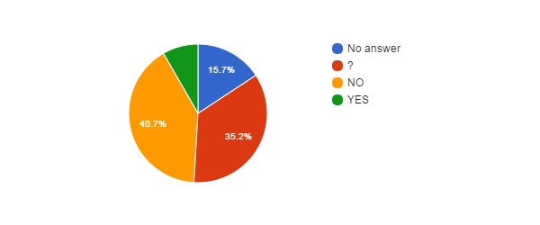

Agree with Objectives vs Career (MRAH­KMKG)
↓Q8\Q2→ | ? | Sci | Tech/Admin
NoAnswer |  | 8 | 9
? | 1 | 13 | 24
NO |  | 8 | 36
YES |  | 5 | 4

Agree with Objectives vs Position (MRAH­KMKG)
↓Q8\Q3→ | CON | MAN | OTH | STA
NoAnswer | 15 |  |  | 2
? | 30 |  |  | 8
NO | 32 |  |  | 12
YES | 5 |  |  | 4

Agree with Objectives vs Age (MRAH­KMKG)
↓Q8\Q5→ | NoAnswer | 21­30 | 31­40 | 41­50 | 51­60 | 61­65 | >65
NoAnswer |  | 1 | 2 | 6 | 8
? | 1 |  | 13 | 12 | 10 | 2
NO |  | 1 | 8 | 22 | 11 | 2
YES |  |  | 2 | 4 | 2 | 1

Reform will Achieve Objectives ? (MRAH­KMKG)
Q9 | count(*)
No answer | 18
? | 42
NO | 39
YES | 9
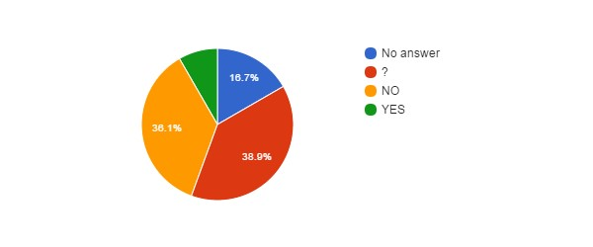

Hidden Agenda ? (MRAH­KMKG)
Q10 | count(*)
No answer | 18
? | 40
NO | 5
YES | 45
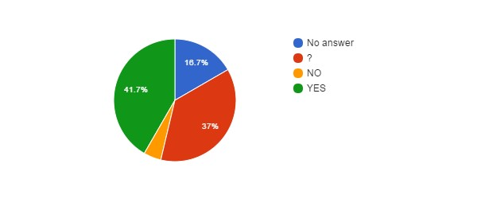

Hidden Agenda vs Language (MRAH­KMKG)
↓Q10\Lang→ | EN | FR | NL
NoAnswer |  | 9 | 9
? |  | 20 | 20
NO |  | 1 | 4
YES |  | 28 | 17

Reform entails... (MRAH­KMKG)
Q11 | count(*)
No answer | 18
? | 19
CONT | 6
PRIV | 32
RISK | 33
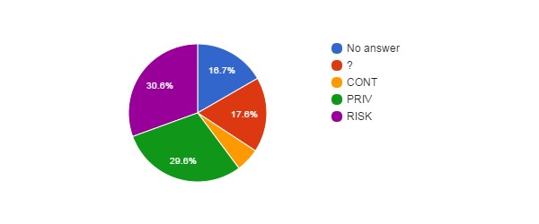

How better will work the institution after the reform ? (MRAH­KMKG)
Q12 | count(*)
No answer | 17
+ | 7
­ | 32
= | 11
? | 41
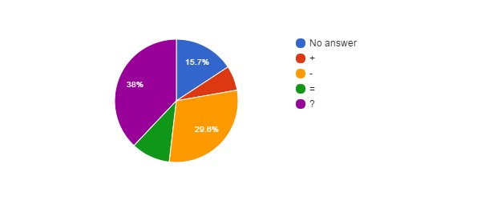

How better will work the institution vs Career (MRAH­KMKG)
↓Q12\Q2→ | ? | Sci | Tech/Admin
NoAnswer |  | 8 | 9
+ |  | 3 | 4
­ |  | 7 | 25
= | 1 | 3 | 7
? |  | 13 | 28

Agree with Privatisation of Public Services ? (MRAH­KMKG)
Q13 | count(*)
? | 12
NO | 88
YES | 8
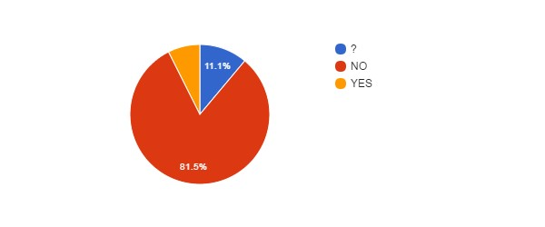

Agree with Privatisation of Public Services vs Age (MRAH­KMKG)
↓Q13\Q5→ | NoAnswer | 21­30 | 31­40 | 41­50 | 51­60 | 61­65 | >65
NoAnswer
? |  |  | 3 | 5 | 3 | 1
NO | 1 | 2 | 20 | 36 | 25 | 4
YES |  |  | 2 | 3 | 3

Agree with Privatisation of Public Services vs Language (MRAH­KMKG)
↓Q13\Lang→ | EN | FR | NL
NoAnswer
? |  | 2 | 10
NO |  | 55 | 33
YES |  | 1 | 7

Agree with Privatisation of the FSIs ? (MRAH­KMKG)
Q14 | count(*)
? | 14
NO | 86
YES | 8
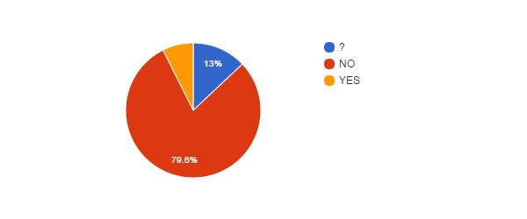

Agree with Privatisation of FSIs vs Agree with Privatisation of Public Services (MRAH­KMKG)
↓Q14\Q13→ | NoAnswer | ? | NO | YES
NoAnswer
? |  | 9 | 5
NO |  | 3 | 82 | 1
YES |  |  | 1 | 7

Agree with Privatisation of FSIs vs Career (MRAH­KMKG)
↓Q14\Q2→ | ? | Sci | Tech/Admin
NoAnswer
? | 1 | 4 | 9
NO |  | 24 | 62
YES |  | 6 | 2

FSIs need Major Reforms ? (MRAH­KMKG)
Q15 | count(*)
? | 31
NO | 17
YES | 60
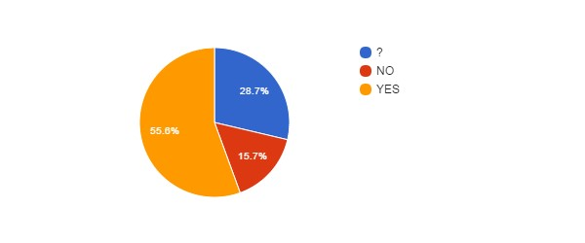

FSIs need Major Reforms vs Career (MRAH­KMKG)
↓Q15\Q2→ | ? | Sci | Tech/Admin
NoAnswer
? | 1 | 4 | 26
NO |  | 2 | 15
YES |  | 28 | 32

FSIs need Major Reforms vs Position (MRAH­KMKG)
↓Q15\Q3→ | CON | MAN | OTH | STA
NoAnswer
? | 28 |  |  | 3
NO | 14 |  |  | 3
YES | 40 |  |  | 20

FSIs need Major Reforms vs Age (MRAH­KMKG)
↓Q15\Q5→ | NoAnswer | 21­30 | 31­40 | 41­50 | 51­60 | 61­65 | >65
NoAnswer
? |  | 1 | 8 | 12 | 10
NO |  |  | 3 | 9 | 5
YES | 1 | 1 | 14 | 23 | 16 | 5

FSIs Reforms need status change ? (MRAH­KMKG)
Q16 | count(*)
No answer | 17
? | 30
NO | 50
YES | 11
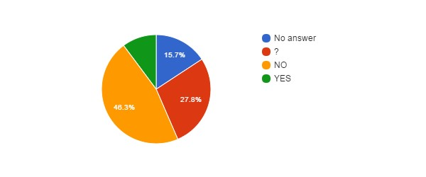

Fear for your Job ? (MRAH­KMKG)
Q17 | count(*)
No answer | 3
NO | 29
YES | 76
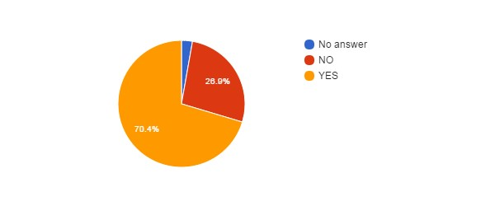

Fear for Job vs Position (MRAH­KMKG)
↓Q17\Q3→ | CON | MAN | OTH | STA
NoAnswer | 3
NO | 18 |  |  | 11
YES | 61 |  |  | 15

Fear for Job vs Age (MRAH­KMKG)
↓Q17\Q5→ | NoAnswer | 21­30 | 31­40 | 41­50 | 51­60 | 61­65 | >65
NoAnswer |  |  | 1 | 2
NO |  |  | 6 | 10 | 10 | 3
YES | 1 | 2 | 18 | 32 | 21 | 2

Fear for Job vs Career (MRAH­KMKG)
↓Q17\Q2→ | ? | Sci | Tech/Admin
NoAnswer |  |  | 3
NO |  | 14 | 15
YES | 1 | 20 | 55

Reform will improve some employment conditions ? (MRAH­KMKG)
Q18 | count(*)
No answer | 4
? | 29
NO | 63
YES | 12
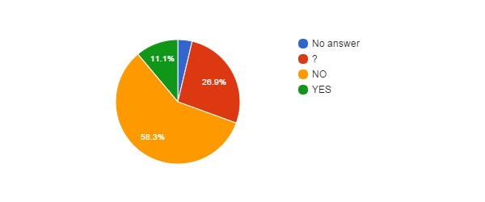

Reform will improve some employment conditions vs Position (MRAH­KMKG)
↓Q18\Q3→ | CON | MAN | OTH | STA
NoAnswer | 4
? | 22 |  |  | 7
NO | 49 |  |  | 14
YES | 7 |  |  | 5

Reform will improve some employment conditions vs Age (MRAH­KMKG)
↓Q18\Q5→ | NoAnswer | 21­30 | 31­40 | 41­50 | 51­60 | 61­65 | >65
NoAnswer |  |  | 1 | 2 | 1
? | 1 | 1 | 6 | 16 | 5
NO |  |  | 16 | 20 | 22 | 5
YES |  | 1 | 2 | 6 | 3

Reform will improve some employment conditions vs Career (MRAH­KMKG)
↓Q18\Q2→ | ? | Sci | Tech/Admin
NoAnswer | 1 | 1 | 2
? |  | 8 | 21
NO |  | 19 | 44
YES |  | 6 | 6

Reform will deteriorate some employment conditions ? (MRAH­ KMKG)
Q20 | count(*)
No answer | 2
? | 10
NO | 5
YES | 91
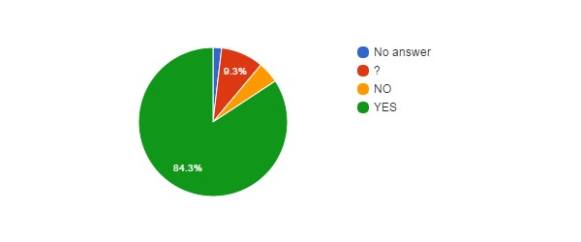Reform will deteriorate some employment conditions vs Position (MRAH­KMKG)
↓Q20\Q3→ | CON | MAN | OTH | STA
NoAnswer | 2
? | 10
NO | 3 |  |  | 2
YES | 67 |  |  | 24

Reform will deteriorate some employment conditions vs Age (MRAH­KMKG)
↓Q20\Q5→ | NoAnswer | 21­30 | 31­40 | 41­50 | 51­60 | 61­65 | >65
NoAnswer |  |  | 1 |  | 1
? | 1 | 1 |  | 5 | 3
NO |  |  |  | 3 | 2
YES |  | 1 | 24 | 36 | 25 | 5

Reform will deteriorate some employment conditions vs Career (MRAH­KMKG)
↓Q20\Q2→ | ? | Sci | Tech/Admin
NoAnswer |  | 1 | 1
? |  | 4 | 6
NO |  | 3 | 2
YES | 1 | 26 | 64

Impact of BELSPO's reform on the FSIs (MRAH­KMKG)
Q22 | count(*)
No answer | 4
? | 58
NO | 3
YES+ | 11
YES­ | 32
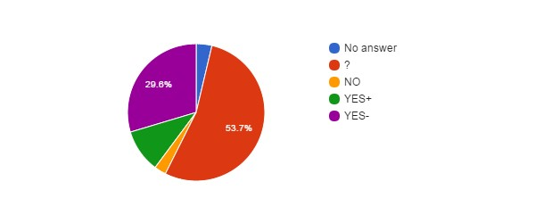

Impact of BELSPO's reform on the FSIs vs Career (MRAH­KMKG)
↓Q22\Q2→ | ? | Sci | Tech/Admin
NoAnswer |  | 2 | 2
? | 1 | 18 | 39
NO |  |  | 3
YES+ |  | 7 | 4
YES­ |  | 7 | 25

Impact of BELSPO's reform on the FSIs vs Position (MRAH­KMKG)
↓Q22\Q3→ | CON | MAN | OTH | STA
NoAnswer | 4
? | 49 |  |  | 9
NO | 2 |  |  | 1
YES+ | 3 |  |  | 8
YES­ | 24 |  |  | 8

Language (MRAH­KMKG)
Lang | count(*)
FR | 58
NL | 50
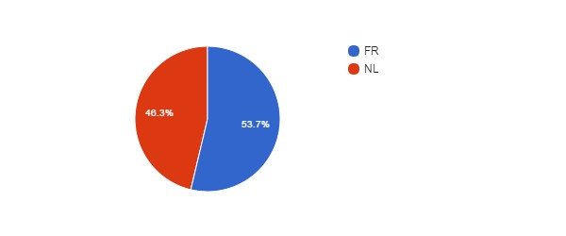

Language vs Age (MRAH­KMKG)
↓Lang\Q5→ | NoAnswer | 21­30 | 31­40 | 41­50 | 51­60 | 61­65 | >65
EN
FR |  | 2 | 13 | 26 | 15 | 2
NL | 1 |  | 12 | 18 | 16 | 3

Language vs Position (MRAH­KMKG)
↓Lang\Q3→ | CON | MAN | OTH | STA
EN
FR | 45 |  |  | 13
NL | 37 |  |  | 13

Which improvements do you expect ? (MRAH­KMKG)
#answers Q19 | 37
MealVouchers | 19
CompanyCar | 1
FreeHospInsurance | 15
BetterInstCulture | 17
2dPension | 14
BetterPromotions | 23
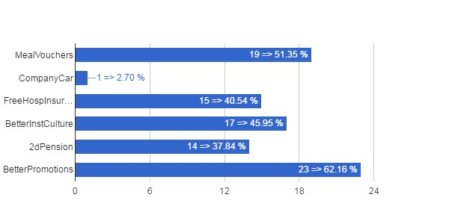

Which Improvements vs Career (MRAH­KMKG)
↓Q19\Q2→ | ? | Sci | Tech/Admin
MealVouchers | 1 | 6 | 12
CompanyCar |  |  | 1
FreeHospInsurance | 1 | 2 | 12
BetterInstCulture |  | 9 | 8
2dPension |  | 3 | 11
BetterPromotions |  | 8 | 15

Which Improvements vs Position (MRAH­KMKG)
↓Q19\Q3→ | CON | MAN | OTH | STA
MealVouchers | 17 |  |  | 2
CompanyCar | 1
FreeHospInsurance | 12 |  |  | 3
BetterInstCulture | 11 |  |  | 6
2dPension | 11 |  |  | 3
BetterPromotions | 17 |  |  | 6

Which Improvements vs Age (MRAH­KMKG)
↓Q19\Q5→ | NoAnswer | 21­30 | 31­40 | 41­50 | 51­60 | 61­65 | >65
MealVouchers |  |  | 5 | 7 | 6 | 1
CompanyCar |  |  |  | 1
FreeHospInsurance |  |  | 4 | 7 | 3 | 1
BetterInstCulture |  |  | 2 | 10 | 4 | 1
2dPension |  | 1 | 4 | 6 | 3
BetterPromotions |  | 1 | 6 | 10 | 5 | 1

Which deteriorations do you expect ? (MRAH­KMKG)
#answers Q21 | 94
JobInsecurity | 75
IncrPressureStress | 64
RedEfficiency | 47
IncomeLoss | 49
WorseWorkAtmos | 64
WorkAutonomyLoss | 36
SciFreedomLoss | 37
FSIAutonomyLoss | 45
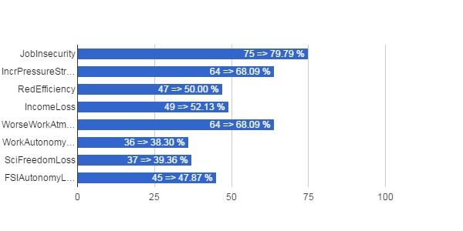

Which Deteriorations vs Career (MRAH­KMKG)
↓Q21\Q2→ | ? | Sci | Tech/Admin
JobInsecurity | 1 | 21 | 53
IncrPressureStress |  | 18 | 46
RedEfficiency |  | 12 | 35
IncomeLoss |  | 10 | 39
WorseWorkAtmos |  | 20 | 44
WorkAutonomyLoss |  | 13 | 23
SciFreedomLoss |  | 20 | 17
FSIAutonomyLoss |  | 18 | 27

Which Deteriorations vs Position (MRAH­KMKG)
↓Q21\Q3→ | CON | MAN | OTH | STA
JobInsecurity | 60 |  |  | 15
IncrPressureStress | 46 |  |  | 18
RedEfficiency | 36 |  |  | 11
IncomeLoss | 42 |  |  | 7
WorseWorkAtmos | 46 |  |  | 18
WorkAutonomyLoss | 26 |  |  | 10
SciFreedomLoss | 25 |  |  | 12
FSIAutonomyLoss | 31 |  |  | 14

Which Deteriorations vs Age (MRAH­KMKG)
↓Q21\Q5→ | NoAnswer | 21­30 | 31­40 | 41­50 | 51­60 | 61­65 | >65
JobInsecurity |  | 1 | 20 | 34 | 17 | 3
IncrPressureStress |  | 1 | 16 | 24 | 18 | 5
RedEfficiency |  |  | 15 | 21 | 9 | 2
IncomeLoss |  | 1 | 14 | 19 | 11 | 4
WorseWorkAtmos |  |  | 20 | 25 | 15 | 4
WorkAutonomyLoss |  |  | 10 | 14 | 10 | 2
SciFreedomLoss |  |  | 9 | 15 | 10 | 3
FSIAutonomyLoss |  | 1 | 10 | 20 | 12 | 2

IASB­BIRA

Total number of answers (IASB­BIRA)
Q1 | count(*)
IASB­BIRA | 97

Scientific or Administrative/Technical Career? (IASB­BIRA)
Q2 | count(*)
? | 1
Sci | 58
Tech/Admin | 38
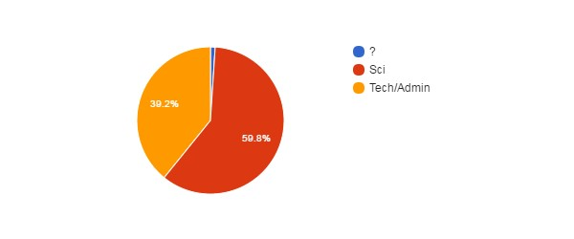

Position (IASB­BIRA)
Q3 | count(*)
CON | 64
STA | 33
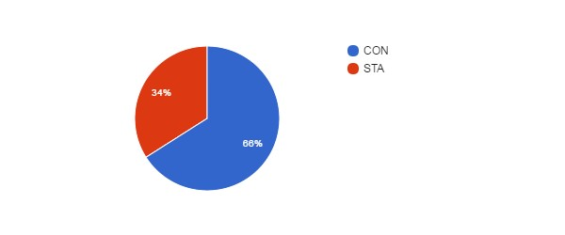

Position vs Age (IASB­BIRA)
↓Q3\Q5→ | NoAnswer | 21­30 | 31­40 | 41­50 | 51­60 | 61­65 | >65
CON | 1 | 5 | 38 | 13 | 3 | 3 | 1
MAN
OTH
STA |  | 1 | 6 | 13 | 12 |  | 1

Gender (IASB­BIRA)
Q4 | count(*)
No answer | 1
F | 22
M | 74
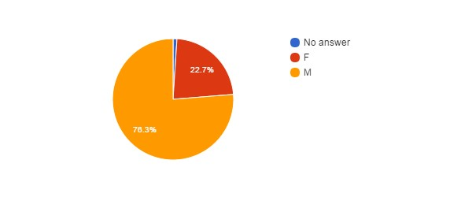

Age (IASB­BIRA)
Q5 | count(*)
No answer | 1
21­30 | 6
31­40 | 44
41­50 | 26
51­60 | 15
61­65 | 3
>65 | 2
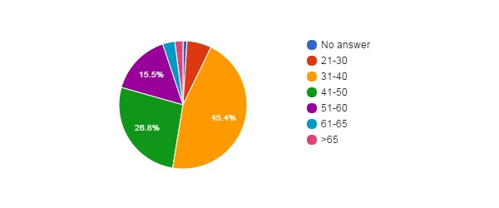

Feel Concerned by the Reform ? (IASB­BIRA)
Q6 | count(*)
NO | 1
YES | 54
YES, BUT | 42
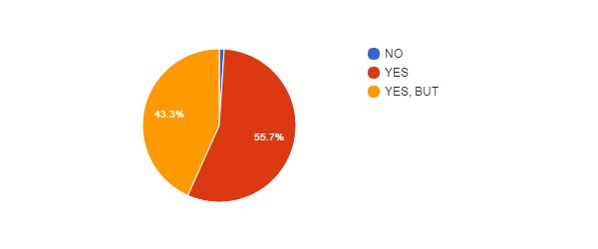

Concerned vs Career (IASB­BIRA)
↓Q6\Q2→ | ? | Sci | Tech/Admin
NoAnswer
NO |  |  | 1
YES |  | 42 | 12
YES, BUT | 1 | 16 | 25

Concerned vs Position (IASB­BIRA)
↓Q6\Q3→ | CON | MAN | OTH | STA
NoAnswer
NO |  |  |  | 1
YES | 34 |  |  | 20
YES, BUT | 30 |  |  | 12

Concerned vs Gender (IASB­BIRA)
↓Q6\Q4→ | NoAnswer | F | M
NoAnswer
NO |  |  | 1
YES | 1 | 10 | 43
YES, BUT |  | 12 | 30

Concerned vs Age (IASB­BIRA)
↓Q6\Q5→ | NoAnswer | 21­30 | 31­40 | 41­50 | 51­60 | 61­65 | >65
NoAnswer
NO |  |  | 1
YES |  | 1 | 23 | 15 | 10 | 3 | 2
YES, BUT | 1 | 5 | 20 | 11 | 5

How Informed ? (IASB­BIRA)
Q7 | count(*)
0 | 7
1 | 25
2 | 24
3 | 41
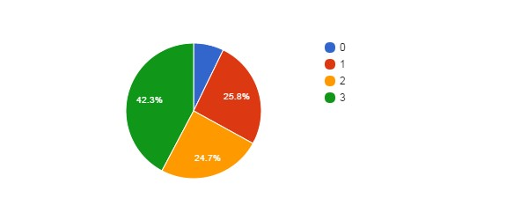

How Informed vs Career (IASB­BIRA)
↓Q7\Q2→ | ? | Sci | Tech/Admin
NoAnswer
0 |  | 4 | 3
1 |  | 9 | 16
2 |  | 18 | 6
3 | 1 | 27 | 13

How Informed vs Position (IASB­BIRA)
↓Q7\Q3→ | CON | MAN | OTH | STA
NoAnswer
0 | 6 |  |  | 1
1 | 17 |  |  | 8
2 | 15 |  |  | 9
3 | 26 |  |  | 15

How Informed vs Age (IASB­BIRA)
↓Q7\Q5→ | NoAnswer | 21­30 | 31­40 | 41­50 | 51­60 | 61­65 | >65
NoAnswer
0 |  | 2 | 3 | 1 | 1
1 | 1 | 1 | 11 | 6 | 4 | 1 | 1
2 |  | 1 | 8 | 10 | 4 |  | 1
3 |  | 2 | 22 | 9 | 6 | 2

Agree with Objectives ? (IASB­BIRA)
Q8 | count(*)
No answer | 5
? | 39
NO | 45
YES | 8
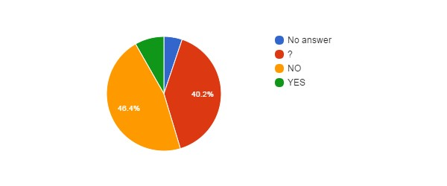

Agree with Objectives vs Career (IASB­BIRA)
↓Q8\Q2→ | ? | Sci | Tech/Admin
NoAnswer |  | 3 | 2
? |  | 23 | 16
NO | 1 | 29 | 15
YES |  | 3 | 5

Agree with Objectives vs Position (IASB­BIRA)
↓Q8\Q3→ | CON | MAN | OTH | STA
NoAnswer | 4 |  |  | 1
? | 29 |  |  | 10
NO | 24 |  |  | 21
YES | 7 |  |  | 1

Agree with Objectives vs Age (IASB­BIRA)
↓Q8\Q5→ | NoAnswer | 21­30 | 31­40 | 41­50 | 51­60 | 61­65 | >65
NoAnswer |  | 1 | 2 | 1 | 1
? | 1 | 1 | 22 | 9 | 3 | 2 | 1
NO |  | 3 | 16 | 14 | 10 | 1 | 1
YES |  | 1 | 4 | 2 | 1

Reform will Achieve Objectives ? (IASB­BIRA)
Q9 | count(*)
No answer | 6
? | 37
NO | 46
YES | 8
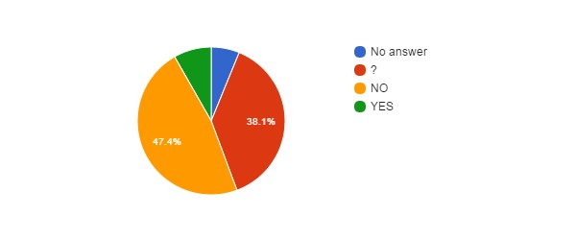

Hidden Agenda ? (IASB­BIRA)
Q10 | count(*)
No answer | 6
? | 28
NO | 3
YES | 60
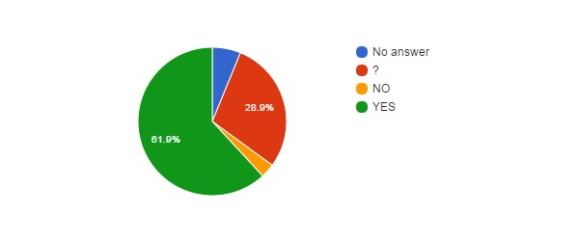

Hidden Agenda vs Language (IASB­BIRA)
↓Q10\Lang→ | EN | FR | NL
NoAnswer | 2 | 2 | 2
? | 3 | 13 | 12
NO |  | 2 | 1
YES | 3 | 43 | 14

Reform entails... (IASB­BIRA)
Q11 | count(*)
No answer | 7
? | 7
CONT | 2
PRIV | 36
RISK | 45
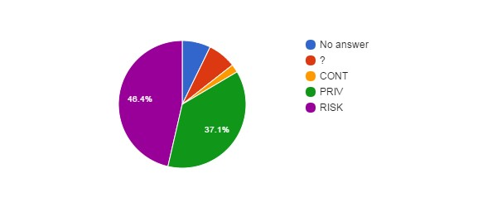

How better will work the institution after the reform ? (IASB­BIRA)
Q12 | count(*)
No answer | 6
+ | 4
­ | 45
= | 14
? | 28
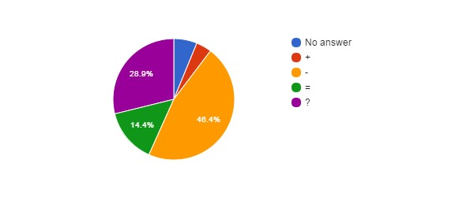

How better will work the institution vs Career (IASB­BIRA)
↓Q12\Q2→ | ? | Sci | Tech/Admin
NoAnswer |  | 3 | 3
+ |  | 1 | 3
­ | 1 | 29 | 15
= |  | 10 | 4
? |  | 15 | 13

Agree with Privatisation of Public Services ? (IASB­BIRA)
Q13 | count(*)
? | 14
NO | 77
YES | 6
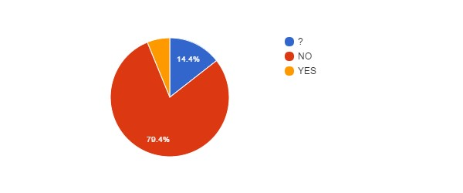

Agree with Privatisation of Public Services vs Age (IASB­BIRA)
↓Q13\Q5→ | NoAnswer | 21­30 | 31­40 | 41­50 | 51­60 | 61­65 | >65
NoAnswer
? |  | 1 | 9 | 2 | 2
NO |  | 2 | 33 | 24 | 13 | 3 | 2
YES | 1 | 3 | 2

Agree with Privatisation of Public Services vs Language (IASB-BIRA)
↓Q13\Lang→ | EN | FR | NL
NoAnswer
? | 1 | 6 | 7
NO | 6 | 52 | 19
YES | 1 | 2 | 3

Agree with Privatisation of the FSIs ? (IASB­BIRA)
Q14 | count(*)
? | 15
NO | 76
YES | 6
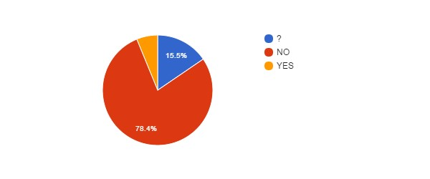

Agree with Privatisation of FSIs vs Agree with Privatisation of Public Services (IASB­BIRA)
↓Q14\Q13→ | NoAnswer | ? | NO | YES
NoAnswer
? |  | 10 | 4 | 1
NO |  | 4 | 72
YES |  |  | 1 | 5

Agree with Privatisation of FSIs vs Career (IASB­BIRA)
↓Q14\Q2→ | ? | Sci | Tech/Admin
NoAnswer
? |  | 8 | 7
NO | 1 | 48 | 27
YES |  | 2 | 4

FSIs need Major Reforms ? (IASB­BIRA)
Q15 | count(*)
? | 20
NO | 28
YES | 49
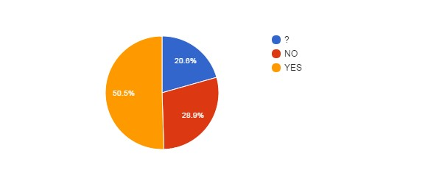

FSIs need Major Reforms vs Career (IASB­BIRA)
↓Q15\Q2→ | ? | Sci | Tech/Admin
NoAnswer
? |  | 16 | 4
NO |  | 18 | 10
YES | 1 | 24 | 24

FSIs need Major Reforms vs Position (IASB­BIRA)
↓Q15\Q3→ | CON | MAN | OTH | STA
NoAnswer
? | 16 |  |  | 4
NO | 13 |  |  | 15
YES | 35 |  |  | 14

FSIs need Major Reforms vs Age (IASB­BIRA)
↓Q15\Q5→ | NoAnswer | 21­30 | 31­40 | 41­50 | 51­60 | 61­65 | >65
NoAnswer
? |  | 1 | 12 | 4 | 2 | 1
NO |  | 2 | 12 | 5 | 8 | 1
YES | 1 | 3 | 20 | 17 | 5 | 1 | 2

FSIs Reforms need status change ? (IASB­BIRA)
Q16 | count(*)
No answer | 24
? | 22
NO | 42
YES | 9
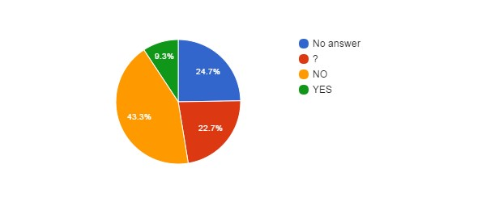

Fear for your Job ? (IASB­BIRA)
Q17 | count(*)
No answer | 3
NO | 44
YES | 50
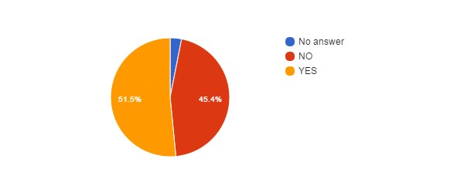

Fear for Job vs Position (IASB­BIRA)
↓Q17\Q3→ | CON | MAN | OTH | STA
NoAnswer | 3
NO | 31 |  |  | 13
YES | 30 |  |  | 20

Fear for Job vs Age (IASB­BIRA)
↓Q17\Q5→ | NoAnswer | 21­30 | 31­40 | 41­50 | 51­60 | 61­65 | >65
NoAnswer |  |  | 3
NO | 1 | 3 | 22 | 10 | 7 |  | 1
YES |  | 3 | 19 | 16 | 8 | 3 | 1

Fear for Job vs Career (IASB­BIRA)
↓Q17\Q2→ | ? | Sci | Tech/Admin
NoAnswer |  | 2 | 1
NO |  | 24 | 20
YES | 1 | 32 | 17

Reform will improve some employment conditions ? (IASB­BIRA)
Q18 | count(*)
? | 29
NO | 43
YES | 25
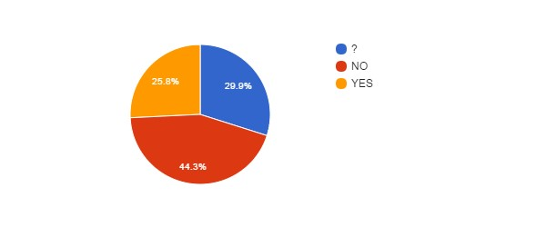
Reform will improve some employment conditions vs Position (IASB­BIRA)
↓Q18\Q3→ | CON | MAN | OTH | STA
NoAnswer
? | 23 |  |  | 6
NO | 21 |  |  | 22
YES | 20 |  |  | 5

Reform will improve some employment conditions vs Age (IASB-BIRA)
↓Q18\Q5→ | NoAnswer | 21­30 | 31­40 | 41­50 | 51­60 | 61­65 | >65
NoAnswer
? | 1 | 2 | 13 | 9 | 2 | 2
NO |  | 3 | 17 | 11 | 10 | 1 | 1
YES |  | 1 | 14 | 6 | 3 |  | 1

Reform will improve some employment conditions vs Career (IASB­BIRA)
↓Q18\Q2→ | ? | Sci | Tech/Admin
NoAnswer
? |  | 20 | 9
NO | 1 | 22 | 20
YES |  | 16 | 9

Reform will deteriorate some employment conditions ? (IASB­BIRA)
Q20 | count(*)
? | 16
NO | 3
YES | 78
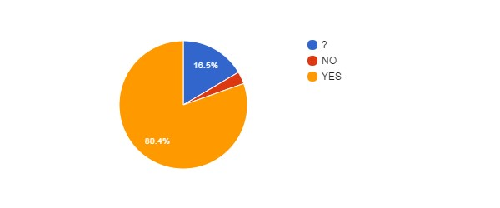Reform will deteriorate some employment conditions vs Position (IASB­BIRA)
↓Q20\Q3→ | CON | MAN | OTH | STA
NoAnswer
? | 15 |  |  | 1
NO | 3
YES | 46 |  |  | 32

Reform will deteriorate some employment conditions vs Age (IASB­BIRA)
↓Q20\Q5→ | NoAnswer | 21­30 | 31­40 | 41­50 | 51­60 | 61­65 | >65
NoAnswer
? |  | 2 | 9 | 3 | 1 | 1
NO |  |  | 3
YES | 1 | 4 | 32 | 23 | 14 | 2 | 2

Reform will deteriorate some employment conditions vs Career (IASB­BIRA)
↓Q20\Q2→ | ? | Sci | Tech/Admin
NoAnswer
? |  | 10 | 6
NO |  | 1 | 2
YES | 1 | 47 | 30

Impact of BELSPO's reform on the FSIs (IASB­BIRA)
Q22 | count(*)
No answer | 51
? | 22
NO | 2
YES+ | 6
YES­ | 16
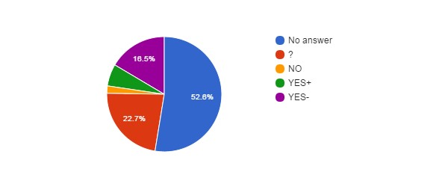

Impact of BELSPO's reform on the FSIs vs Career (IASB­BIRA)
↓Q22\Q2→ | ? | Sci | Tech/Admin
NoAnswer |  | 35 | 16
? |  | 12 | 10
NO |  |  | 2
YES+ |  | 2 | 4
YES­ | 1 | 9 | 6

Impact of BELSPO's reform on the FSIs vs Position (IASB­BIRA)
↓Q22\Q3→ | CON | MAN | OTH | STA
NoAnswer | 33 |  |  | 18
? | 17 |  |  | 5
NO |  |  |  | 2
YES+ | 5 |  |  | 1
YES­ | 9 |  |  | 7

Language (IASB­BIRA)
Lang | count(*)
EN | 8
FR | 60
NL | 29
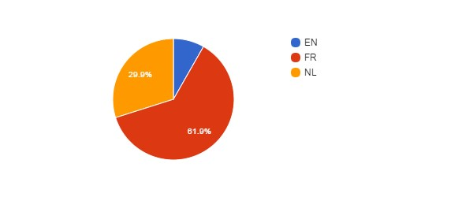

Language vs Age (IASB­BIRA)
↓Lang\Q5→ | NoAnswer | 21­30 | 31­40 | 41­50 | 51­60 | 61­65 | >65
EN |  | 1 | 4 | 3
FR |  | 2 | 24 | 19 | 10 | 3 | 2
NL | 1 | 3 | 16 | 4 | 5

Language vs Position (IASB­BIRA)
↓Lang\Q3→ | CON | MAN | OTH | STA
EN | 8
FR | 39 |  |  | 21
NL | 17 |  |  | 12

Which improvements do you expect ? (IASB­BIRA)
#answers Q19 | 35
MealVouchers | 8
CompanyCar | 5
FreeHospInsurance | 13
BetterInstCulture | 16
2dPension | 25
BetterPromotions | 26
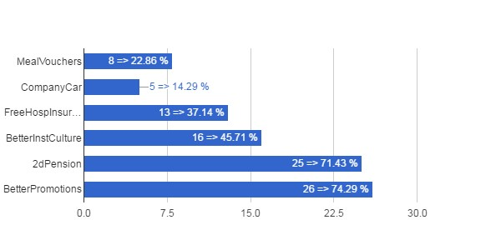

Which Improvements vs Career (IASB­BIRA)
↓Q19\Q2→ | ? | Sci | Tech/Admin
MealVouchers |  | 4 | 4
CompanyCar |  | 2 | 3
FreeHospInsurance |  | 6 | 7
BetterInstCulture |  | 8 | 8
2dPension |  | 16 | 9
BetterPromotions |  | 17 | 9

Which Improvements vs Position (IASB­BIRA)
↓Q19\Q3→ | CON | MAN | OTH | STA
MealVouchers | 6 |  |  | 2
CompanyCar | 3 |  |  | 2
FreeHospInsurance | 10 |  |  | 3
BetterInstCulture | 12 |  |  | 4
2dPension | 20 |  |  | 5
BetterPromotions | 20 |  |  | 6

Which Improvements vs Age (IASB­BIRA)
↓Q19\Q5→ | NoAnswer | 21­30 | 31­40 | 41­50 | 51­60 | 61­65 | >65
MealVouchers |  | 1 | 5 | 1 |  |  | 1
CompanyCar |  |  | 3 | 2
FreeHospInsurance |  | 1 | 6 | 5 |  |  | 1
BetterInstCulture |  |  | 12 | 3 |  |  | 1
2dPension |  |  | 16 | 7 | 1 |  | 1
BetterPromotions |  | 1 | 17 | 6 | 1 |  | 1

Which deteriorations do you expect ? (IASB­BIRA)
#answers Q21 | 82
JobInsecurity | 52
IncrPressureStress | 46
RedEfficiency | 34
IncomeLoss | 44
WorseWorkAtmos | 51
WorkAutonomyLoss | 39
SciFreedomLoss | 51
FSIAutonomyLoss | 53
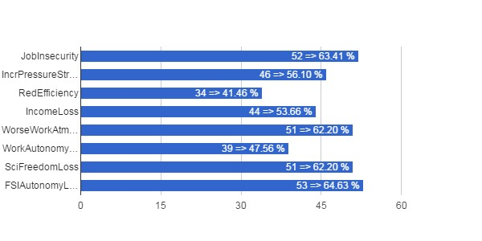

Which Deteriorations vs Career (IASB­BIRA)
↓Q21\Q2→ | ? | Sci | Tech/Admin
JobInsecurity | 1 | 29 | 22
IncrPressureStress | 1 | 23 | 22
RedEfficiency |  | 18 | 16
IncomeLoss | 1 | 24 | 19
WorseWorkAtmos | 1 | 29 | 21
WorkAutonomyLoss | 1 | 21 | 17
SciFreedomLoss |  | 38 | 13
FSIAutonomyLoss | 1 | 34 | 18

Which Deteriorations vs Position (IASB­BIRA)
↓Q21\Q3→ | CON | MAN | OTH | STA
JobInsecurity | 28 |  |  | 24
IncrPressureStress | 27 |  |  | 19
RedEfficiency | 18 |  |  | 16
IncomeLoss | 23 |  |  | 21
WorseWorkAtmos | 28 |  |  | 23
WorkAutonomyLoss | 17 |  |  | 22
SciFreedomLoss | 28 |  |  | 23
FSIAutonomyLoss | 27 |  |  | 26

Which Deteriorations vs Age (IASB­BIRA)
↓Q21\Q5→ | NoAnswer | 21­30 | 31­40 | 41­50 | 51­60 | 61­65 | >65
JobInsecurity | 1 | 1 | 21 | 15 | 10 | 2 | 2
IncrPressureStress | 1 | 4 | 18 | 15 | 7 | 1
RedEfficiency | 1 | 1 | 13 | 10 | 7 | 1 | 1
IncomeLoss |  | 2 | 15 | 14 | 11 | 1 | 1
WorseWorkAtmos | 1 | 4 | 15 | 17 | 11 | 1 | 2
WorkAutonomyLoss |  | 1 | 11 | 14 | 10 | 1 | 2
SciFreedomLoss | 1 | 3 | 20 | 12 | 13 | 1 | 1
FSIAutonomyLoss | 1 | 3 | 20 | 17 | 10 | 1 | 1

AGR­ARA

Total number of answers (AGR­ARA)
Q1 | count(*)
AGR­ARA | 117

Scientific or Administrative/Technical Career? (AGR­ARA)
Q2 | count(*)
Sci | 48
Tech/Admin | 69
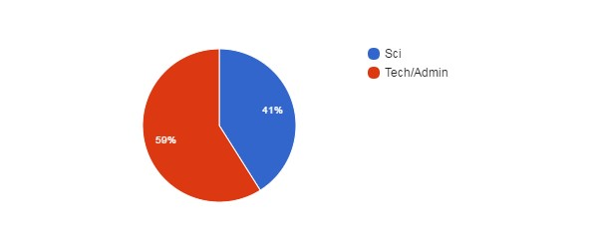

Position (AGR­ARA)
Q3 | count(*)
CON | 56
STA | 61
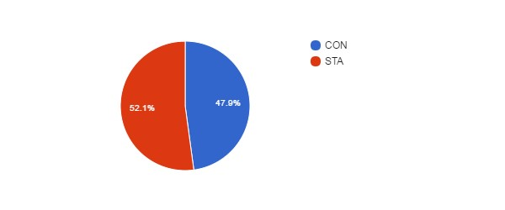

Position vs Age (AGR­ARA)
↓Q3\Q5→ | NoAnswer | 21­30 | 31­40 | 41­50 | 51­60 | 61­65 | >65
CON |  | 14 | 11 | 13 | 15 | 3
MAN
OTH
STA |  | 1 | 12 | 28 | 18 | 2

Gender (AGR­ARA)
Q4 | count(*)
F | 54
M | 63
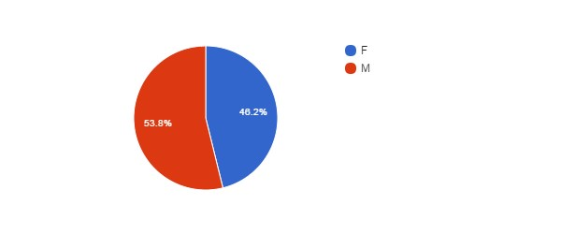

Age (AGR­ARA)
Q5 | count(*)
21­30 | 15
31­40 | 23
41­50 | 41
51­60 | 33
61­65 | 5
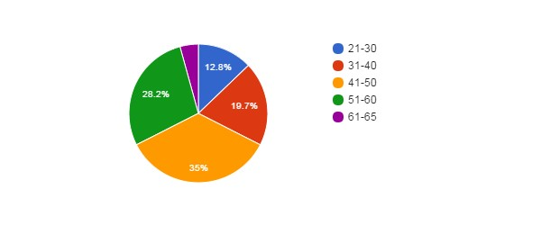

Feel Concerned by the Reform ? (AGR­ARA)
Q6 | count(*)
No answer | 2
NO | 4
YES | 57
YES, BUT | 54
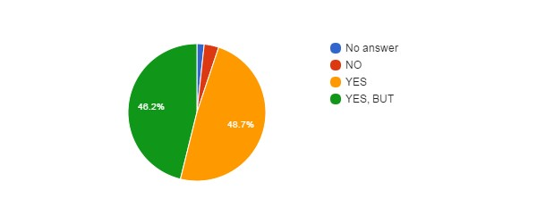

Concerned vs Career (AGR­ARA)
↓Q6\Q2→ | ? | Sci | Tech/Admin
NoAnswer |  |  | 2
NO |  | 1 | 3
YES |  | 29 | 28
YES, BUT |  | 18 | 36

Concerned vs Position (AGR­ARA)
↓Q6\Q3→ | CON | MAN | OTH | STA
NoAnswer | 2
NO | 3 |  |  | 1
YES | 22 |  |  | 35
YES, BUT | 29 |  |  | 25

Concerned vs Gender (AGR­ARA)
↓Q6\Q4→ | NoAnswer | F | M
NoAnswer |  | 2
NO |  | 3 | 1
YES |  | 20 | 37
YES, BUT |  | 29 | 25

Concerned vs Age (AGR­ARA)
↓Q6\Q5→ | NoAnswer | 21­30 | 31­40 | 41­50 | 51­60 | 61­65 | >65
NoAnswer |  |  |  | 1 | 1
NO |  | 2 |  | 1 | 1
YES |  | 6 | 11 | 17 | 20 | 3
YES, BUT |  | 7 | 12 | 22 | 11 | 2

How Informed ? (AGR­ARA)
Q7 | count(*)
0 | 32
1 | 37
2 | 38
3 | 10
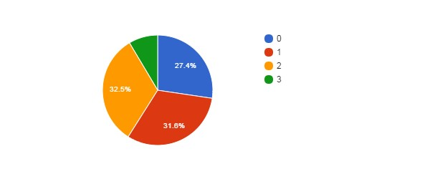

How Informed vs Career (AGR­ARA)
↓Q7\Q2→ | ? | Sci | Tech/Admin
NoAnswer
0 |  | 11 | 21
1 |  | 9 | 28
2 |  | 20 | 18
3 |  | 8 | 2

How Informed vs Position (AGR­ARA)
↓Q7\Q3→ | CON | MAN | OTH | STA
NoAnswer
0 | 16 |  |  | 16
1 | 19 |  |  | 18
2 | 15 |  |  | 23
3 | 6 |  |  | 4

How Informed vs Age (AGR­ARA)
↓Q7\Q5→ | NoAnswer | 21­30 | 31­40 | 41­50 | 51­60 | 61­65 | >65
NoAnswer
0 |  | 5 | 3 | 13 | 11
1 |  | 5 | 6 | 13 | 10 | 3
2 |  | 4 | 10 | 13 | 9 | 2
3 |  | 1 | 4 | 2 | 3

Agree with Objectives ? (AGR­ARA)
Q8 | count(*)
No answer | 30
? | 21
NO | 57
YES | 9
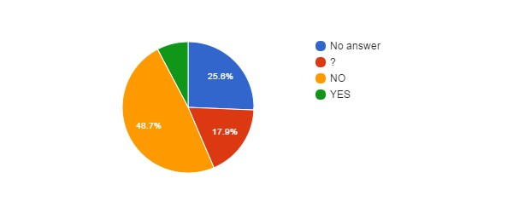Agree with Objectives vs Career (AGR­ARA)
↓Q8\Q2→ | ? | Sci | Tech/Admin
NoAnswer |  | 10 | 20
? |  | 5 | 16
NO |  | 28 | 29
YES |  | 5 | 4

Agree with Objectives vs Position (AGR­ARA)
↓Q8\Q3→ | CON | MAN | OTH | STA
NoAnswer | 15 |  |  | 15
? | 9 |  |  | 12
NO | 27 |  |  | 30
YES | 5 |  |  | 4

Agree with Objectives vs Age (AGR­ARA)
↓Q8\Q5→ | NoAnswer | 21­30 | 31­40 | 41­50 | 51­60 | 61­65 | >65
NoAnswer |  | 5 | 3 | 12 | 10
? |  | 2 | 5 | 8 | 6
NO |  | 4 | 14 | 19 | 15 | 5
YES |  | 4 | 1 | 2 | 2

Reform will Achieve Objectives ? (AGR­ARA)
Q9 | count(*)
No answer | 29
? | 23
NO | 61
YES | 4
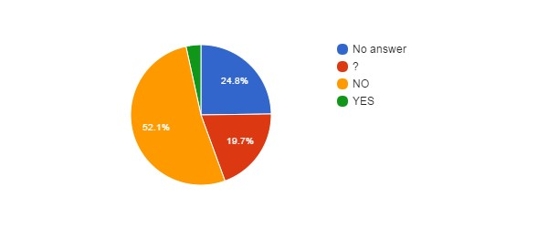

Hidden Agenda ? (AGR­ARA)
Q10 | count(*)
No answer | 29
? | 21
NO | 7
YES | 60
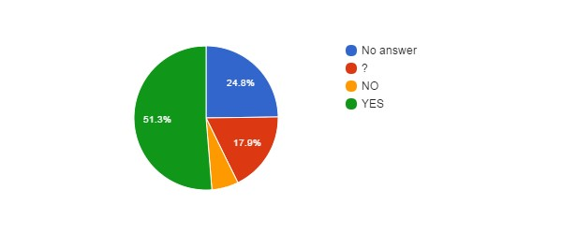

Hidden Agenda vs Language (AGR­ARA)
↓Q10\Lang→ | EN | FR | NL
NoAnswer |  | 16 | 13
? |  | 8 | 13
NO |  | 4 | 3
YES |  | 33 | 27

Reform entails... (AGR­ARA)
Q11 | count(*)
No answer | 29
? | 9
CONT | 6
PRIV | 33
RISK | 40
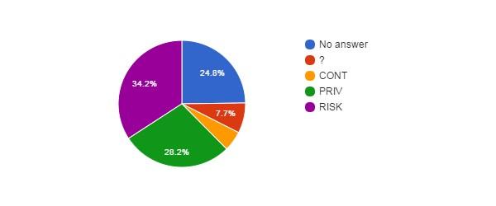

How better will work the institution after the reform ? (AGR­ARA)
Q12 | count(*)
No answer | 29
+ | 5
­ | 52
= | 11
? | 20
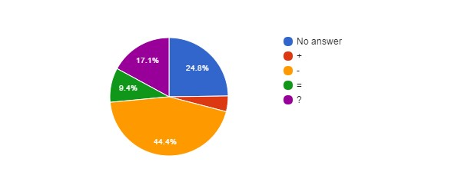

How better will work the institution vs Career (AGR­ARA)
↓Q12\Q2→ | ? | Sci | Tech/Admin
NoAnswer |  | 10 | 19
+ |  | 2 | 3
­ |  | 22 | 30
= |  | 6 | 5
? |  | 8 | 12

Agree with Privatisation of Public Services ? (AGR­ARA)
Q13 | count(*)
? | 9
NO | 104
YES | 4
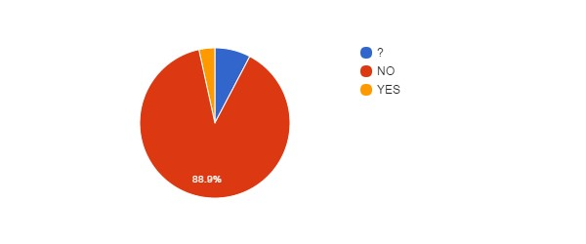

Agree with Privatisation of Public Services vs Age (AGR­ARA)
↓Q13\Q5→ | NoAnswer | 21­30 | 31­40 | 41­50 | 51­60 | 61­65 | >65
NoAnswer
? |  |  | 2 | 6 | 1
NO |  | 14 | 21 | 32 | 32 | 5
YES |  | 1 |  | 3

Agree with Privatisation of Public Services vs Language (AGR­ARA)
↓Q13\Lang→ | EN | FR | NL
NoAnswer
? |  | 5 | 4
NO |  | 55 | 49
YES |  | 1 | 3
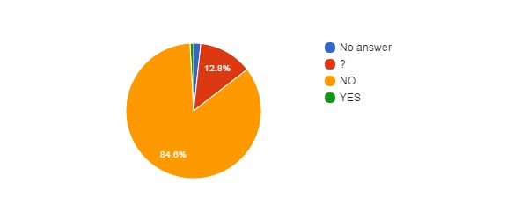
Agree with Privatisation of the FSIs ? (AGR­ARA)
Q14 | count(*)
No answer | 2
? | 15
NO | 99
YES | 1

Agree with Privatisation of FSIs vs Agree with Privatisation of Public Services (AGR­ARA)
↓Q14\Q13→ | NoAnswer | ? | NO | YES
NoAnswer |  | 1 | 1
? |  | 8 | 5 | 2
NO |  |  | 98 | 1
YES |  |  |  | 1

Agree with Privatisation of FSIs vs Career (AGR­ARA)
↓Q14\Q2→ | ? | Sci | Tech/Admin
NoAnswer |  | 2
? |  | 6 | 9
NO |  | 40 | 59
YES |  |  | 1

FSIs need Major Reforms ? (AGR­ARA)
Q15 | count(*)
? | 23
NO | 36
YES | 58
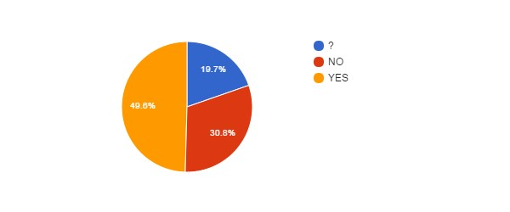

FSIs need Major Reforms vs Career (AGR­ARA)
↓Q15\Q2→ | ? | Sci | Tech/Admin
NoAnswer
? |  | 5 | 18
NO |  | 7 | 29
YES |  | 36 | 22

FSIs need Major Reforms vs Position (AGR­ARA)
↓Q15\Q3→ | CON | MAN | OTH | STA
NoAnswer
? | 13 |  |  | 10
NO | 14 |  |  | 22
YES | 29 |  |  | 29

FSIs need Major Reforms vs Age (AGR­ARA)
↓Q15\Q5→ | NoAnswer | 21­30 | 31­40 | 41­50 | 51­60 | 61­65 | >65
NoAnswer
? |  | 4 | 2 | 9 | 7 | 1
NO |  | 1 | 6 | 13 | 15 | 1
YES |  | 10 | 15 | 19 | 11 | 3

FSIs Reforms need status change ? (AGR­ARA)
Q16 | count(*)
No answer | 41
? | 22
NO | 45
YES | 9
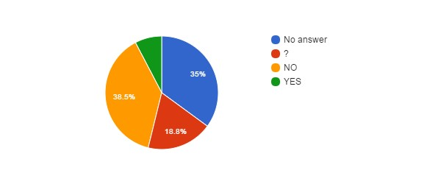

Fear for your Job ? (AGR­ARA)
Q17 | count(*)
No answer | 1
NO | 42
YES | 74
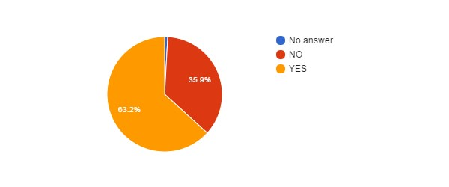

Fear for Job vs Position (AGR­ARA)
↓Q17\Q3→ | CON | MAN | OTH | STA
NoAnswer | 1
NO | 21 |  |  | 21
YES | 34 |  |  | 40

Fear for Job vs Age (AGR­ARA)
↓Q17\Q5→ | NoAnswer | 21­30 | 31­40 | 41­50 | 51­60 | 61­65 | >65
NoAnswer |  |  |  | 1
NO |  | 7 | 8 | 11 | 13 | 3
YES |  | 8 | 15 | 29 | 20 | 2

Fear for Job vs Career (AGR­ARA)
↓Q17\Q2→ | ? | Sci | Tech/Admin
NoAnswer |  |  | 1
NO |  | 23 | 19
YES |  | 25 | 49

Reform will improve some employment conditions ? (AGR­ARA)
Q18 | count(*)
? | 26
NO | 79
YES | 12
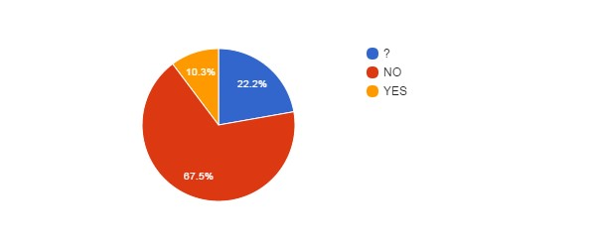

Reform will improve some employment conditions vs Position (AGR­ARA)
↓Q18\Q3→ | CON | MAN | OTH | STA
NoAnswer
? | 16 |  |  | 10
NO | 32 |  |  | 47
YES | 8 |  |  | 4

Reform will improve some employment conditions vs Age (AGR-ARA)
↓Q18\Q5→ | NoAnswer | 21­30 | 31­40 | 41­50 | 51­60 | 61­65 | >65
NoAnswer
? |  | 6 | 9 | 7 | 3 | 1
NO |  | 6 | 12 | 30 | 27 | 4
YES |  | 3 | 2 | 4 | 3

Reform will improve some employment conditions vs Career (AGR­ARA)
↓Q18\Q2→ | ? | Sci | Tech/Admin
NoAnswer
? |  | 13 | 13
NO |  | 30 | 49
YES |  | 5 | 7

Reform will deteriorate some employment conditions ? (AGR­ARA)
Q20 | count(*)
? | 10
NO | 5
YES | 102
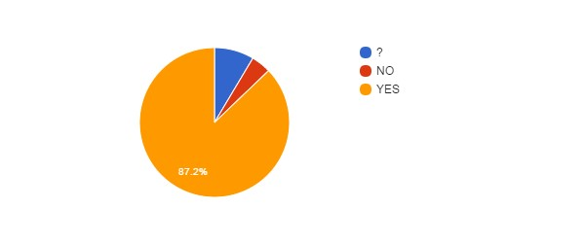

Reform will deteriorate some employment conditions vs Position (AGR­ARA)
↓Q20\Q3→ | CON | MAN | OTH | STA
NoAnswer
? | 6 |  |  | 4
NO | 5
YES | 45 |  |  | 57

Reform will deteriorate some employment conditions vs Age (AGR­ARA)
↓Q20\Q5→ | NoAnswer | 21­30 | 31­40 | 41­50 | 51­60 | 61­65 | >65
NoAnswer
? |  | 2 | 2 | 5 | 1
NO |  | 3 | 1 |  | 1
YES |  | 10 | 20 | 36 | 31 | 5

Reform will deteriorate some employment conditions vs Career (AGR­ARA)
↓Q20\Q2→ | ? | Sci | Tech/Admin
NoAnswer
? |  | 5 | 5
NO |  | 3 | 2
YES |  | 40 | 62

Impact of BELSPO's reform on the FSIs (AGR­ARA)
Q22 | count(*)
No answer | 3
? | 45
NO | 6
YES+ | 9
YES­ | 54
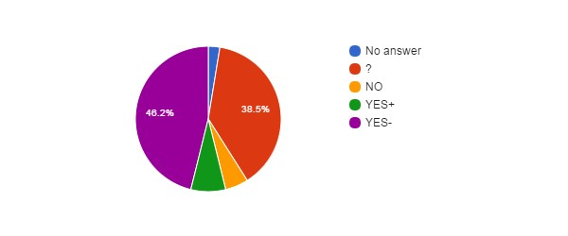

Impact of BELSPO's reform on the FSIs vs Career (AGR­ARA)
↓Q22\Q2→ | ? | Sci | Tech/Admin
NoAnswer |  |  | 3
? |  | 21 | 24
NO |  | 4 | 2
YES+ |  | 7 | 2
YES­ |  | 16 | 38

Impact of BELSPO's reform on the FSIs vs Position (AGR­ARA)
↓Q22\Q3→ | CON | MAN | OTH | STA
NoAnswer | 2 |  |  | 1
? | 21 |  |  | 24
NO | 2 |  |  | 4
YES+ | 4 |  |  | 5
YES­ | 27 |  |  | 27

Language (AGR­ARA)
Lang | count(*)
FR | 61
NL | 56
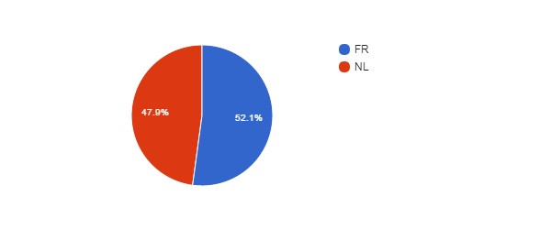

Language vs Age (AGR­ARA)
↓Lang\Q5→ | NoAnswer | 21­30 | 31­40 | 41­50 | 51­60 | 61­65 | >65
EN
FR |  | 9 | 12 | 24 | 15 | 1
NL |  | 6 | 11 | 17 | 18 | 4

Language vs Position (AGR­ARA)
↓Lang\Q3→ | CON | MAN | OTH | STA
EN
FR | 29 |  |  | 32
NL | 27 |  |  | 29

Which improvements do you expect ? (AGR­ARA)
#answers Q19 | 20
MealVouchers | 9
CompanyCar | 0
FreeHospInsurance | 5
BetterInstCulture | 13
2dPension | 7
BetterPromotions | 14
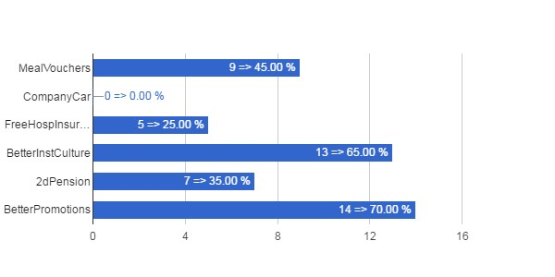

Which Improvements vs Career (AGR­ARA)
↓Q19\Q2→ | ? | Sci | Tech/Admin
MealVouchers |  | 1 | 8
CompanyCar
FreeHospInsurance |  | 1 | 4
BetterInstCulture |  | 8 | 5
2dPension |  | 3 | 4
BetterPromotions |  | 2 | 12

Which Improvements vs Position (AGR­ARA)
↓Q19\Q3→ | CON | MAN | OTH | STA
MealVouchers | 6 |  |  | 3
CompanyCar
FreeHospInsurance | 3 |  |  | 2
BetterInstCulture | 7 |  |  | 6
2dPension | 4 |  |  | 3
BetterPromotions | 9 |  |  | 5

Which Improvements vs Age (AGR­ARA)
↓Q19\Q5→ | NoAnswer | 21­30 | 31­40 | 41­50 | 51­60 | 61­65 | >65
MealVouchers |  | 1 | 3 | 1 | 4
CompanyCar
FreeHospInsurance |  |  | 1 | 1 | 3
BetterInstCulture |  | 3 | 3 | 4 | 2 | 1
2dPension |  | 2 | 1 | 2 | 1 | 1
BetterPromotions |  | 3 | 3 | 3 | 4 | 1

Which deteriorations do you expect ? (AGR­ARA)
#answers Q21 | 98
JobInsecurity | 80
IncrPressureStress | 69
RedEfficiency | 58
IncomeLoss | 51
WorseWorkAtmos | 58
WorkAutonomyLoss | 36
SciFreedomLoss | 39
FSIAutonomyLoss | 58
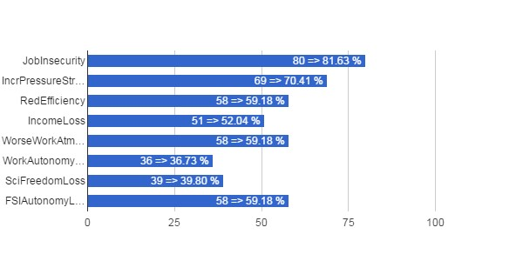

Which Deteriorations vs Career (AGR­ARA)
↓Q21\Q2→ | ? | Sci | Tech/Admin
JobInsecurity |  | 32 | 48
IncrPressureStress |  | 28 | 41
RedEfficiency |  | 21 | 37
IncomeLoss |  | 12 | 39
WorseWorkAtmos |  | 24 | 34
WorkAutonomyLoss |  | 14 | 22
SciFreedomLoss |  | 25 | 14
FSIAutonomyLoss |  | 31 | 27

Which Deteriorations vs Position (AGR­ARA)
↓Q21\Q3→ | CON | MAN | OTH | STA
JobInsecurity | 36 |  |  | 44
IncrPressureStress | 31 |  |  | 38
RedEfficiency | 24 |  |  | 34
IncomeLoss | 19 |  |  | 32
WorseWorkAtmos | 25 |  |  | 33
WorkAutonomyLoss | 11 |  |  | 25
SciFreedomLoss | 16 |  |  | 23
FSIAutonomyLoss | 23 |  |  | 35

Which Deteriorations vs Age (AGR­ARA)
↓Q21\Q5→ | NoAnswer | 21­30 | 31­40 | 41­50 | 51­60 | 61­65 | >65
JobInsecurity |  | 8 | 19 | 25 | 23 | 5
IncrPressureStress |  | 9 | 15 | 18 | 23 | 4
RedEfficiency |  | 5 | 12 | 16 | 21 | 4
IncomeLoss |  | 2 | 10 | 19 | 17 | 3
WorseWorkAtmos |  | 6 | 15 | 17 | 16 | 4
WorkAutonomyLoss |  | 4 | 7 | 10 | 13 | 2
SciFreedomLoss |  | 5 | 9 | 11 | 10 | 4
FSIAutonomyLoss |  | 6 | 12 | 18 | 18 | 4

MRAC­KMMA

Total number of answers (MRAC­KMMA)
Q1 | count(*)
MRAC­KMMA | 53

Scientific or Administrative/Technical Career? (MRAC­KMMA)
Q2 | count(*)
? | 1
Sci | 23
Tech/Admin | 29
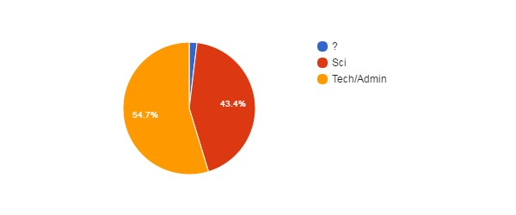

Position (MRAC­KMMA)
Q3 | count(*)
CON | 19
MAN | 1
OTH | 1
STA | 32
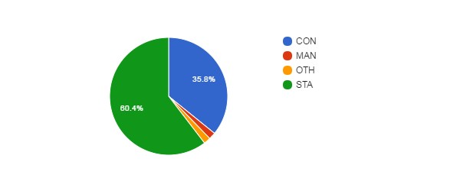Position vs Age (MRAC­KMMA)
↓Q3\Q5→ | NoAnswer | 21­30 | 31­40 | 41­50 | 51­60 | 61­65 | >65
CON |  | 3 | 8 | 3 | 5
MAN |  |  |  |  | 1
OTH |  |  | 1
STA | 1 |  | 4 | 3 | 22 |  | 2

Gender (MRAC­KMMA)
Q4 | count(*)
No answer | 2
F | 23
M | 28
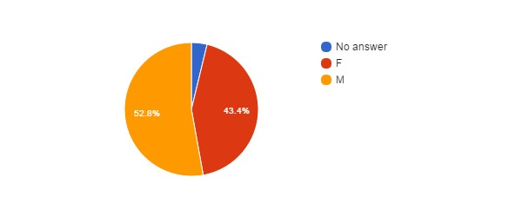

Age (MRAC­KMMA)
Q5 | count(*)
No answer | 1
21­30 | 3
31­40 | 13
41­50 | 6
51­60 | 28
>65 | 2
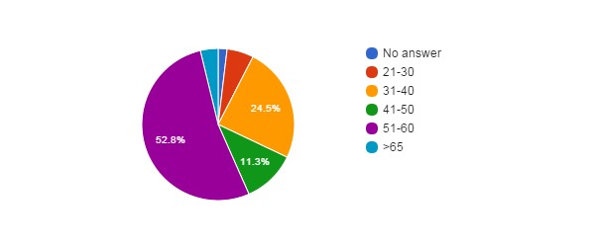

Feel Concerned by the Reform ? (MRAC­KMMA)
Q6 | count(*)
No answer | 1
NO | 2
YES | 26
YES, BUT | 24
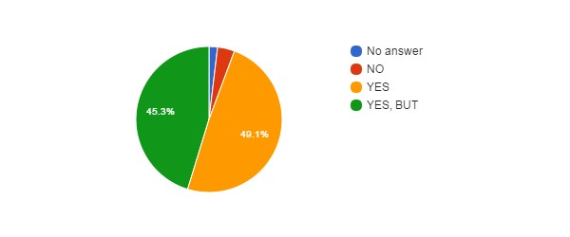

Concerned vs Career (MRAC­KMMA)
↓Q6\Q2→ | ? | Sci | Tech/Admin
NoAnswer | 1
NO |  |  | 2
YES |  | 17 | 9
YES, BUT |  | 6 | 18

Concerned vs Position (MRAC­KMMA)
↓Q6\Q3→ | CON | MAN | OTH | STA
NoAnswer | 1
NO | 1 |  |  | 1
YES | 7 | 1 |  | 18
YES, BUT | 10 |  | 1 | 13

Concerned vs Gender (MRAC­KMMA)
↓Q6\Q4→ | NoAnswer | F | M
NoAnswer |  |  | 1
NO |  |  | 2
YES | 1 | 10 | 15
YES, BUT | 1 | 13 | 10

Concerned vs Age (MRAC­KMMA)
↓Q6\Q5→ | NoAnswer | 21­30 | 31­40 | 41­50 | 51­60 | 61­65 | >65
NoAnswer |  |  |  |  | 1
NO |  |  |  | 1 | 1
YES |  | 1 | 3 | 4 | 16 |  | 2
YES, BUT | 1 | 2 | 10 | 1 | 10

How Informed ? (MRAC­KMMA)
Q7 | count(*)
0 | 17
1 | 14
2 | 16
3 | 6
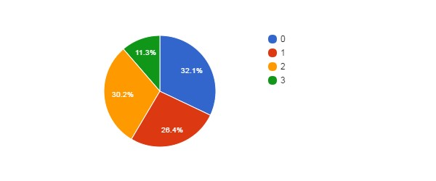

How Informed vs Career (MRAC­KMMA)
↓Q7\Q2→ | ? | Sci | Tech/Admin
NoAnswer
0 | 1 | 7 | 9
1 |  | 2 | 12
2 |  | 8 | 8
3 |  | 6

How Informed vs Position (MRAC­KMMA)
↓Q7\Q3→ | CON | MAN | OTH | STA
NoAnswer
0 | 7 |  | 1 | 9
1 | 4 |  |  | 10
2 | 6 |  |  | 10
3 | 2 | 1 |  | 3

How Informed vs Age (MRAC­KMMA)
↓Q7\Q5→ | NoAnswer | 21­30 | 31­40 | 41­50 | 51­60 | 61­65 | >65
NoAnswer
0 | 1 | 1 | 4 | 2 | 8 |  | 1
1 |  | 2 | 4 |  | 8
2 |  |  | 4 | 3 | 8 |  | 1
3 |  |  | 1 | 1 | 4

Agree with Objectives ? (MRAC­KMMA)
Q8 | count(*)
No answer | 13
? | 9
NO | 28
YES | 3
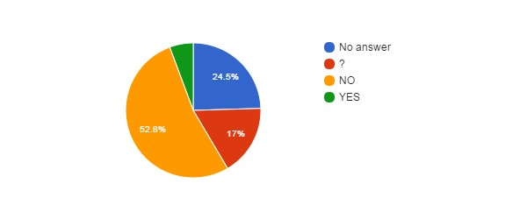

Agree with Objectives vs Career (MRAC­KMMA)
↓Q8\Q2→ | ? | Sci | Tech/Admin
NoAnswer | 1 | 6 | 6
? |  | 3 | 6
NO |  | 12 | 16
YES |  | 2 | 1

Agree with Objectives vs Position (MRAC­KMMA)
↓Q8\Q3→ | CON | MAN | OTH | STA
NoAnswer | 6 |  | 1 | 6
? | 4 |  |  | 5
NO | 8 |  |  | 20
YES | 1 | 1 |  | 1

Agree with Objectives vs Age (MRAC­KMMA)
↓Q8\Q5→ | NoAnswer | 21­30 | 31­40 | 41­50 | 51­60 | 61­65 | >65
NoAnswer |  | 1 | 4 | 1 | 6 |  | 1
? | 1 | 1 | 2 | 2 | 3
NO |  | 1 | 7 | 2 | 17 |  | 1
YES |  |  |  | 1 | 2

Reform will Achieve Objectives ? (MRAC­KMMA)
Q9 | count(*)
No answer | 13
? | 8
NO | 29
YES | 3
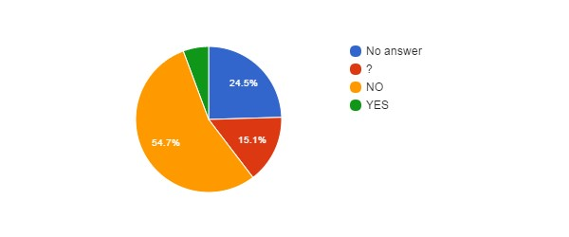

Hidden Agenda ? (MRAC­KMMA)
Q10 | count(*)
No answer | 13
? | 5
NO | 2
YES | 33
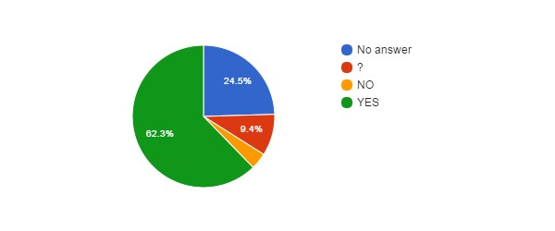

Hidden Agenda vs Language (MRAC­KMMA)
↓Q10\Lang→ | EN | FR | NL
NoAnswer |  | 5 | 8
? |  | 1 | 4
NO |  |  | 2
YES |  | 23 | 10

Reform entails... (MRAC­KMMA)
Q11 | count(*)
No answer | 13
? | 3
CONT | 4
PRIV | 13
RISK | 20
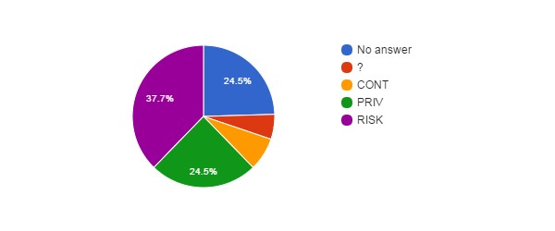

How better will work the institution after the reform ? (MRAC­KMMA)
Q12 | count(*)
No answer | 13
+ | 3
­ | 25
= | 3
? | 9
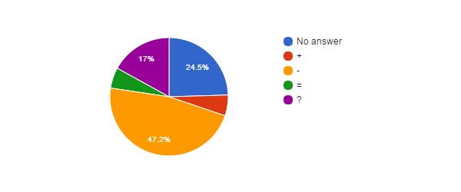

How better will work the institution vs Career (MRAC­KMMA)
↓Q12\Q2→ | ? | Sci | Tech/Admin
NoAnswer | 1 | 6 | 6
+ |  | 2 | 1
­ |  | 10 | 15
= |  |  | 3
? |  | 5 | 4

Agree with Privatisation of Public Services ? (MRAC­KMMA)
Q13 | count(*)
? | 6
NO | 43
YES | 4
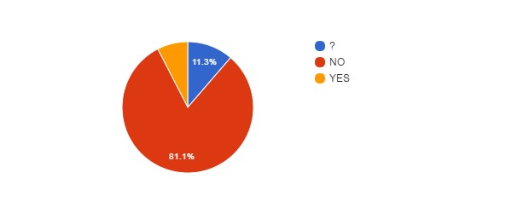

Agree with Privatisation of Public Services vs Age (MRAC­KMMA)
↓Q13\Q5→ | NoAnswer | 21­30 | 31­40 | 41­50 | 51­60 | 61­65 | >65
NoAnswer
? |  | 2 | 3 |  | 1
NO |  | 1 | 9 | 5 | 26 |  | 2
YES | 1 |  | 1 | 1 | 1

Agree with Privatisation of Public Services vs Language (MRAC­KMMA)
↓Q13\Lang→ | EN | FR | NL
NoAnswer
? |  | 2 | 4
NO |  | 26 | 17
YES |  | 1 | 3

Agree with Privatisation of the FSIs ? (MRAC­KMMA)
Q14 | count(*)
? | 3
NO | 46
YES | 4
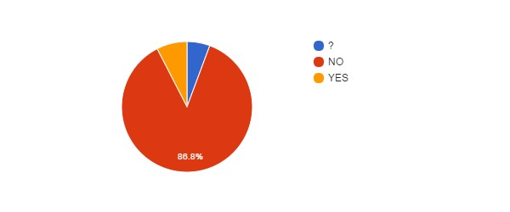

Agree with Privatisation of FSIs vs Agree with Privatisation of Public Services (MRAC­KMMA)
↓Q14\Q13→ | NoAnswer | ? | NO | YES
NoAnswer
? |  | 3
NO |  | 2 | 42 | 2
YES |  | 1 | 1 | 2

Agree with Privatisation of FSIs vs Career (MRAC­KMMA)
↓Q14\Q2→ | ? | Sci | Tech/Admin
NoAnswer
? |  | 1 | 2
NO | 1 | 20 | 25
YES |  | 2 | 2

FSIs need Major Reforms ? (MRAC­KMMA)
Q15 | count(*)
? | 16
NO | 16
YES | 21
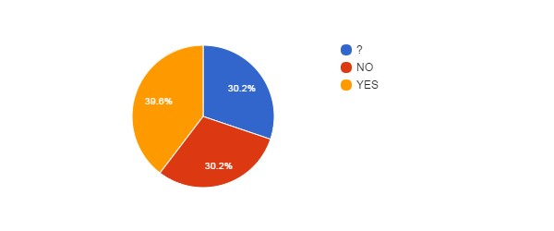

FSIs need Major Reforms vs Career (MRAC­KMMA)
↓Q15\Q2→ | ? | Sci | Tech/Admin
NoAnswer
? | 1 | 4 | 11
NO |  | 5 | 11
YES |  | 14 | 7

FSIs need Major Reforms vs Position (MRAC­KMMA)
↓Q15\Q3→ | CON | MAN | OTH | STA
NoAnswer
? | 9 |  | 1 | 6
NO | 1 |  |  | 15
YES | 9 | 1 |  | 11

FSIs need Major Reforms vs Age (MRAC­KMMA)
↓Q15\Q5→ | NoAnswer | 21­30 | 31­40 | 41­50 | 51­60 | 61­65 | >65
NoAnswer
? |  | 2 | 6 | 1 | 7
NO |  | 1 |  | 1 | 12 |  | 2
YES | 1 |  | 7 | 4 | 9

FSIs Reforms need status change ? (MRAC­KMMA)
Q16 | count(*)
No answer | 23
? | 5
NO | 19
YES | 6
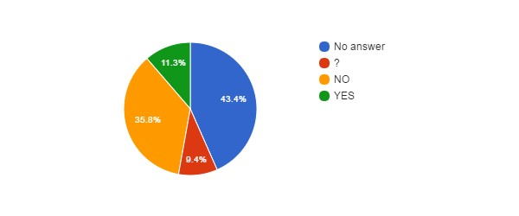

Fear for your Job ? (MRAC­KMMA)
Q17 | count(*)
No answer | 3
NO | 14
YES | 36
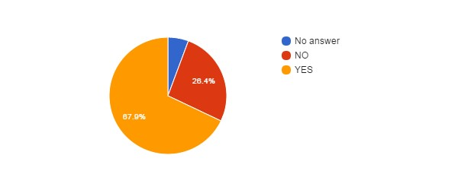

Fear for Job vs Position (MRAC­KMMA)
↓Q17\Q3→ | CON | MAN | OTH | STA
NoAnswer | 1 |  | 1 | 1
NO | 5 | 1 |  | 8
YES | 13 |  |  | 23

Fear for Job vs Age (MRAC­KMMA)
↓Q17\Q5→ | NoAnswer | 21­30 | 31­40 | 41­50 | 51­60 | 61­65 | >65
NoAnswer |  |  | 1 |  | 2
NO | 1 | 1 | 1 | 3 | 7 |  | 1
YES |  | 2 | 11 | 3 | 19 |  | 1

Fear for Job vs Career (MRAC­KMMA)
↓Q17\Q2→ | ? | Sci | Tech/Admin
NoAnswer | 1 | 1 | 1
NO |  | 6 | 8
YES |  | 16 | 20

Reform will improve some employment conditions ? (MRAC­KMMA)
Q18 | count(*)
? | 11
NO | 37
YES | 5
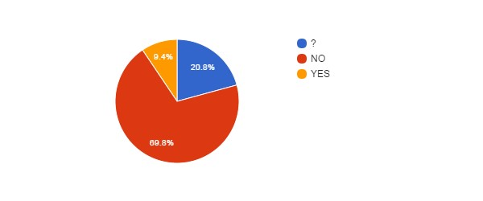

Reform will improve some employment conditions vs Position (MRAC­KMMA)
↓Q18\Q3→ | CON | MAN | OTH | STA
NoAnswer
? | 6 |  | 1 | 4
NO | 11 |  |  | 26
YES | 2 | 1 |  | 2

Reform will improve some employment conditions vs Age (MRAC­KMMA)
↓Q18\Q5→ | NoAnswer | 21­30 | 31­40 | 41­50 | 51­60 | 61­65 | >65
NoAnswer
? |  | 2 | 4 | 1 | 4
NO | 1 | 1 | 9 | 3 | 21 |  | 2
YES |  |  |  | 2 | 3

Reform will improve some employment conditions vs Career (MRAC­KMMA)
↓Q18\Q2→ | ? | Sci | Tech/Admin
NoAnswer
? | 1 | 4 | 6
NO |  | 16 | 21
YES |  | 3 | 2

Reform will deteriorate some employment conditions ? (MRAC­KMMA)
Q20 | count(*)
? | 6
NO | 3
YES | 44
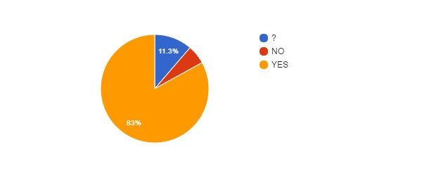Reform will deteriorate some employment conditions vs Position (MRAC­KMMA)
↓Q20\Q3→ | CON | MAN | OTH | STA
NoAnswer
? | 3 |  | 1 | 2
NO | 1 | 1 |  | 1
YES | 15 |  |  | 29

Reform will deteriorate some employment conditions vs Age (MRAC­KMMA)
↓Q20\Q5→ | NoAnswer | 21­30 | 31­40 | 41­50 | 51­60 | 61­65 | >65
NoAnswer
? |  | 1 | 2 |  | 3
NO |  |  |  | 1 | 2
YES | 1 | 2 | 11 | 5 | 23 |  | 2

Reform will deteriorate some employment conditions vs Career (MRAC­KMMA)
↓Q20\Q2→ | ? | Sci | Tech/Admin
NoAnswer
? |  | 1 | 5
NO |  | 2 | 1
YES | 1 | 20 | 23

Impact of BELSPO's reform on the FSIs (MRAC­KMMA)
Q22 | count(*)
No answer | 1
? | 16
NO | 3
YES+ | 3
YES­ | 30
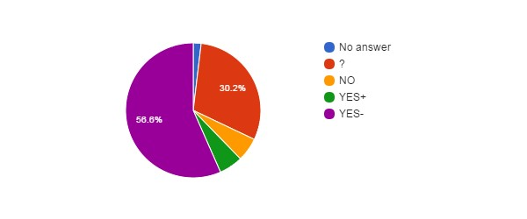

Impact of BELSPO's reform on the FSIs vs Career (MRAC­KMMA)
↓Q22\Q2→ | ? | Sci | Tech/Admin
NoAnswer |  | 1
? | 1 | 2 | 13
NO |  | 1 | 2
YES+ |  | 2 | 1
YES­ |  | 17 | 13

Impact of BELSPO's reform on the FSIs vs Position (MRAC­KMMA)
↓Q22\Q3→ | CON | MAN | OTH | STA
NoAnswer |  |  |  | 1
? | 7 |  |  | 9
NO | 1 |  |  | 2
YES+ | 1 | 1 |  | 1
YES­ | 10 |  | 1 | 19

Language (MRAC­KMMA)
Lang | count(*)
FR | 29
NL | 24
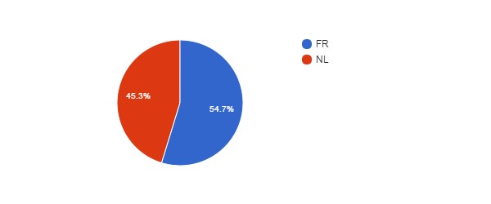

Language vs Age (MRAC­KMMA)
↓Lang\Q5→ | NoAnswer | 21­30 | 31­40 | 41­50 | 51­60 | 61­65 | >65
EN
FR |  | 1 | 7 | 3 | 17 |  | 1
NL | 1 | 2 | 6 | 3 | 11 |  | 1

Language vs Position (MRAC­KMMA)
↓Lang\Q3→ | CON | MAN | OTH | STA
EN
FR | 7 |  | 1 | 21
NL | 12 | 1 |  | 11

Which improvements do you expect ? (MRAC­KMMA)
#answers Q19 | 14
MealVouchers | 9
CompanyCar | 0
FreeHospInsurance | 6
BetterInstCulture | 9
2dPension | 9
BetterPromotions | 12
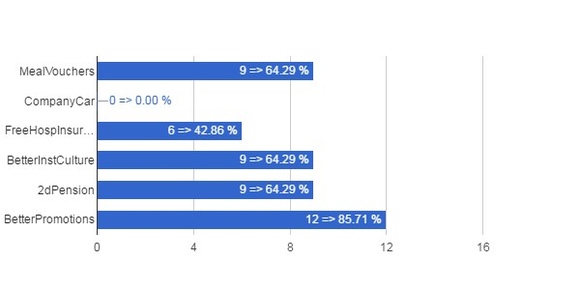

Which Improvements vs Career (MRAC­KMMA)
↓Q19\Q2→ | ? | Sci | Tech/Admin
MealVouchers |  | 4 | 5
CompanyCar
FreeHospInsurance |  | 2 | 4
BetterInstCulture |  | 6 | 3
2dPension |  | 4 | 5
BetterPromotions |  | 6 | 6

Which Improvements vs Position (MRAC­KMMA)
↓Q19\Q3→ | CON | MAN | OTH | STA
MealVouchers | 2 | 1 |  | 6
CompanyCar
FreeHospInsurance | 2 | 1 |  | 3
BetterInstCulture | 2 | 1 |  | 6
2dPension | 2 | 1 |  | 6
BetterPromotions | 3 | 1 |  | 8

Which Improvements vs Age (MRAC­KMMA)
↓Q19\Q5→ | NoAnswer | 21­30 | 31­40 | 41­50 | 51­60 | 61­65 | >65
MealVouchers | 1 |  | 2 | 3 | 3
CompanyCar
FreeHospInsurance |  |  |  | 3 | 3
BetterInstCulture | 1 |  | 1 | 3 | 4
2dPension | 1 |  | 1 | 2 | 5
BetterPromotions | 1 |  | 1 | 3 | 7

Which deteriorations do you expect ? (MRAC­KMMA)
#answers Q21 | 44
JobInsecurity | 37
IncrPressureStress | 34
RedEfficiency | 30
IncomeLoss | 27
WorseWorkAtmos | 32
WorkAutonomyLoss | 28
SciFreedomLoss | 27
FSIAutonomyLoss | 28
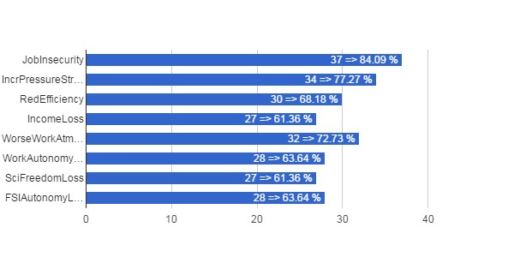

Which Deteriorations vs Career (MRAC­KMMA)
↓Q21\Q2→ | ? | Sci | Tech/Admin
JobInsecurity | 1 | 16 | 20
IncrPressureStress | 1 | 13 | 20
RedEfficiency |  | 12 | 18
IncomeLoss |  | 10 | 17
WorseWorkAtmos |  | 12 | 20
WorkAutonomyLoss |  | 11 | 17
SciFreedomLoss |  | 14 | 13
FSIAutonomyLoss |  | 14 | 14

Which Deteriorations vs Position (MRAC­KMMA)
↓Q21\Q3→ | CON | MAN | OTH | STA
JobInsecurity | 13 |  |  | 24
IncrPressureStress | 8 |  |  | 26
RedEfficiency | 7 |  |  | 23
IncomeLoss | 6 |  |  | 21
WorseWorkAtmos | 8 |  |  | 24
WorkAutonomyLoss | 5 |  |  | 23
SciFreedomLoss | 8 |  |  | 19
FSIAutonomyLoss | 8 |  |  | 20

Which Deteriorations vs Age (MRAC­KMMA)
↓Q21\Q5→ | NoAnswer | 21­30 | 31­40 | 41­50 | 51­60 | 61­65 | >65
JobInsecurity |  | 2 | 10 | 4 | 19 |  | 2
IncrPressureStress | 1 |  | 6 | 5 | 20 |  | 2
RedEfficiency |  | 1 | 6 | 5 | 17 |  | 1
IncomeLoss |  | 1 | 6 | 4 | 15 |  | 1
WorseWorkAtmos | 1 |  | 5 | 5 | 20 |  | 1
WorkAutonomyLoss | 1 |  | 5 | 4 | 17 |  | 1
SciFreedomLoss |  | 2 | 6 | 4 | 13 |  | 2
FSIAutonomyLoss | 1 | 1 | 7 | 3 | 15 |  | 1

ORB­KSB

Total number of answers (ORB­KSB)
Q1 | count(*)
ORB­KSB | 87

Scientific or Administrative/Technical Career? (ORB­KSB)
Q2 | count(*)
? | 1
Sci | 54
Tech/Admin | 32
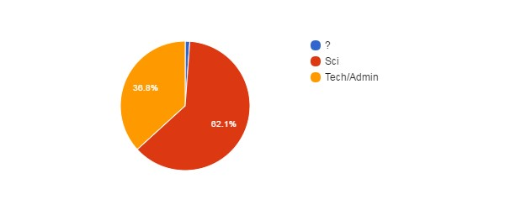

Position (ORB­KSB)
Q3 | count(*)
CON | 52
OTH | 1
STA | 34
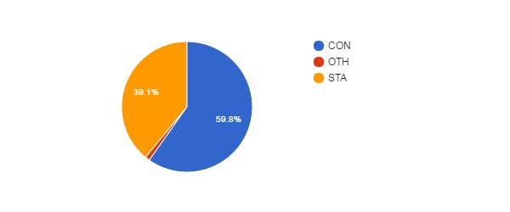Position vs Age (ORB­KSB)
↓Q3\Q5→ | NoAnswer | 21­30 | 31­40 | 41­50 | 51­60 | 61­65 | >65
CON |  | 5 | 22 | 21 | 3 | 1
MAN
OTH |  | 1
STA | 2 | 1 | 6 | 10 | 10 | 4 | 1

Gender (ORB­KSB)
Q4 | count(*)
No answer | 1
F | 23
M | 63
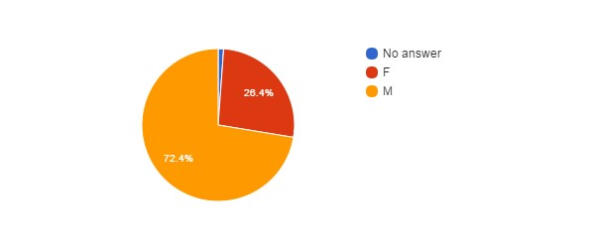

Age (ORB­KSB)
Q5 | count(*)
No answer | 2
21­30 | 7
31­40 | 28
41­50 | 31
51­60 | 13
61­65 | 5
>65 | 1
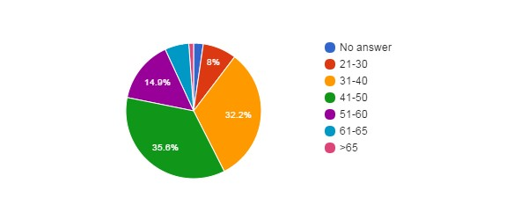

Feel Concerned by the Reform ? (ORB­KSB)
Q6 | count(*)
No answer | 1
NO | 3
YES | 46
YES, BUT | 37
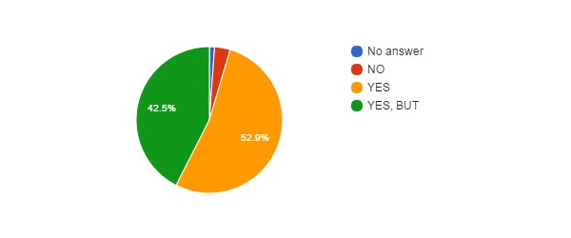

Concerned vs Career (ORB­KSB)
↓Q6\Q2→ | ? | Sci | Tech/Admin
NoAnswer |  |  | 1
NO |  | 3
YES |  | 29 | 17
YES, BUT | 1 | 22 | 14

Concerned vs Position (ORB­KSB)
↓Q6\Q3→ | CON | MAN | OTH | STA
NoAnswer | 1
NO | 2 |  |  | 1
YES | 27 |  | 1 | 18
YES, BUT | 22 |  |  | 15

Concerned vs Gender (ORB­KSB)
↓Q6\Q4→ | NoAnswer | F | M
NoAnswer |  | 1
NO |  | 1 | 2
YES |  | 13 | 33
YES, BUT | 1 | 8 | 28

Concerned vs Age (ORB­KSB)
↓Q6\Q5→ | NoAnswer | 21­30 | 31­40 | 41­50 | 51­60 | 61­65 | >65
NoAnswer |  | 1
NO |  |  | 1 | 1 |  |  | 1
YES |  | 3 | 15 | 14 | 10 | 4
YES, BUT | 2 | 3 | 12 | 16 | 3 | 1

How Informed ? (ORB­KSB)
Q7 | count(*)
No answer | 1
0 | 18
1 | 28
2 | 30
3 | 10
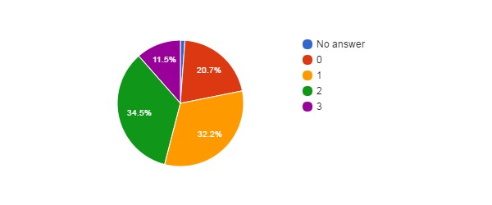

How Informed vs Career (ORB­KSB)
↓Q7\Q2→ | ? | Sci | Tech/Admin
NoAnswer |  |  | 1
0 |  | 12 | 6
1 | 1 | 19 | 8
2 |  | 13 | 17
3 |  | 10

How Informed vs Position (ORB­KSB)
↓Q7\Q3→ | CON | MAN | OTH | STA
NoAnswer | 1
0 | 13 |  |  | 5
1 | 17 |  |  | 11
2 | 15 |  | 1 | 14
3 | 6 |  |  | 4

How Informed vs Age (ORB­KSB)
↓Q7\Q5→ | NoAnswer | 21­30 | 31­40 | 41­50 | 51­60 | 61­65 | >65
NoAnswer |  |  | 1
0 | 2 | 2 | 4 | 7 | 3
1 |  | 3 | 7 | 12 | 3 | 2 | 1
2 |  | 2 | 13 | 7 | 5 | 3
3 |  |  | 3 | 5 | 2

Agree with Objectives ? (ORB­KSB)
Q8 | count(*)
No answer | 16
? | 27
NO | 41
YES | 3
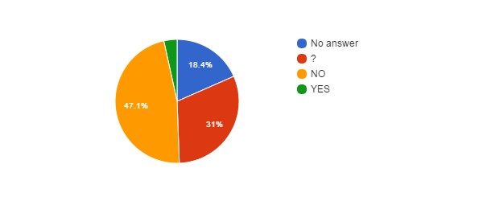

Agree with Objectives vs Career (ORB­KSB)
↓Q8\Q2→ | ? | Sci | Tech/Admin
NoAnswer |  | 10 | 6
? |  | 19 | 8
NO | 1 | 22 | 18
YES |  | 3

Agree with Objectives vs Position (ORB­KSB)
↓Q8\Q3→ | CON | MAN | OTH | STA
NoAnswer | 14 |  |  | 2
? | 15 |  |  | 12
NO | 23 |  |  | 18
YES |  |  | 1 | 2

Agree with Objectives vs Age (ORB­KSB)
↓Q8\Q5→ | NoAnswer | 21­30 | 31­40 | 41­50 | 51­60 | 61­65 | >65
NoAnswer |  | 2 | 6 | 6 | 2
? | 2 | 2 | 10 | 9 | 3 |  | 1
NO |  | 2 | 12 | 15 | 7 | 5
YES |  | 1 |  | 1 | 1

Reform will Achieve Objectives ? (ORB­KSB)
Q9 | count(*)
No answer | 15
? | 26
NO | 44
YES | 2
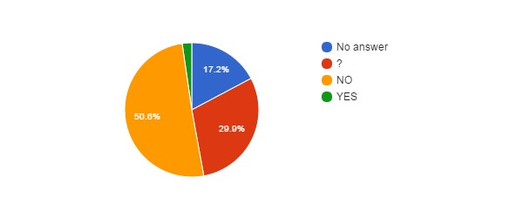

Hidden Agenda ? (ORB­KSB)
Q10 | count(*)
No answer | 16
? | 28
NO | 3
YES | 40
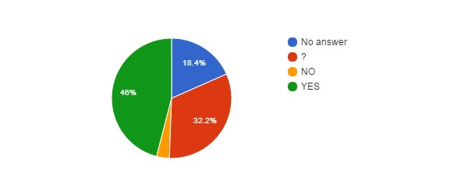

Hidden Agenda vs Language (ORB­KSB)
↓Q10\Lang→ | EN | FR | NL
NoAnswer | 3 | 9 | 4
? | 6 | 11 | 11
NO | 2 |  | 1
YES | 2 | 27 | 11

Reform entails... (ORB­KSB)
Q11 | count(*)
No answer | 16
? | 12
CONT | 5
PRIV | 15
RISK | 39
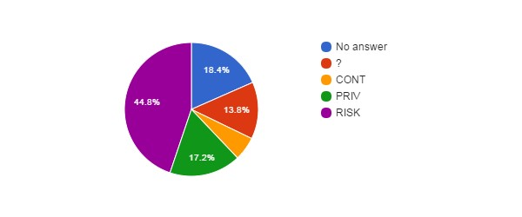

How better will work the institution after the reform ? (ORB­KSB)
Q12 | count(*)
No answer | 16
+ | 1
­ | 34
= | 15
? | 21
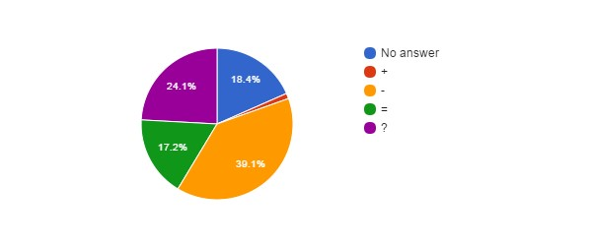

How better will work the institution vs Career (ORB­KSB)
↓Q12\Q2→ | ? | Sci | Tech/Admin
NoAnswer |  | 10 | 6
+ |  | 1
­ |  | 21 | 13
= | 1 | 10 | 4
? |  | 12 | 9

Agree with Privatisation of Public Services ? (ORB­KSB)
Q13 | count(*)
No answer | 1
? | 7
NO | 73
YES | 6
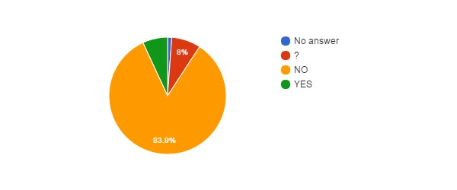

Agree with Privatisation of Public Services vs Age (ORB­KSB)
↓Q13\Q5→ | NoAnswer | 21­30 | 31­40 | 41­50 | 51­60 | 61­65 | >65
NoAnswer |  |  | 1
? |  | 2 |  | 3 | 2
NO | 2 | 5 | 25 | 25 | 11 | 5
YES |  |  | 2 | 3 |  |  | 1

Agree with Privatisation of Public Services vs Language (ORBKSB)
↓Q13\Lang→ | EN | FR | NL
NoAnswer |  |  | 1
? | 1 | 1 | 5
NO | 9 | 43 | 21
YES | 3 | 3

Agree with Privatisation of the FSIs ? (ORB­KSB)
Q14 | count(*)
? | 9
NO | 74
YES | 4
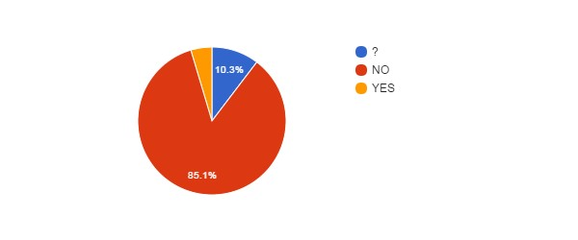

Agree with Privatisation of FSIs vs Agree with Privatisation of Public Services (ORB­KSB)
↓Q14\Q13→ | NoAnswer | ? | NO | YES
NoAnswer
? |  | 6 | 3
NO | 1 | 1 | 70 | 2
YES |  |  |  | 4

Agree with Privatisation of FSIs vs Career (ORB­KSB)
↓Q14\Q2→ | ? | Sci | Tech/Admin
NoAnswer
? |  | 7 | 2
NO | 1 | 43 | 30
YES |  | 4

FSIs need Major Reforms ? (ORB­KSB)
Q15 | count(*)
? | 16
NO | 32
YES | 39
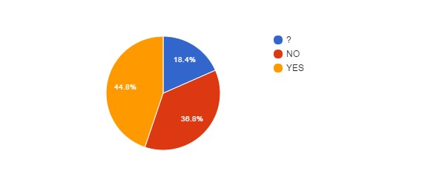

FSIs need Major Reforms vs Career (ORB­KSB)
↓Q15\Q2→ | ? | Sci | Tech/Admin
NoAnswer
? |  | 11 | 5
NO | 1 | 18 | 13
YES |  | 25 | 14

FSIs need Major Reforms vs Position (ORB­KSB)
↓Q15\Q3→ | CON | MAN | OTH | STA
NoAnswer
? | 12 |  |  | 4
NO | 17 |  |  | 15
YES | 23 |  | 1 | 15

FSIs need Major Reforms vs Age (ORB­KSB)
↓Q15\Q5→ | NoAnswer | 21­30 | 31­40 | 41­50 | 51­60 | 61­65 | >65
NoAnswer
? |  | 1 | 5 | 7 | 2 |  | 1
NO | 2 | 2 | 10 | 13 | 4 | 1
YES |  | 4 | 13 | 11 | 7 | 4

FSIs Reforms need status change ? (ORB­KSB)
Q16 | count(*)
No answer | 28
? | 12
NO | 43
YES | 4
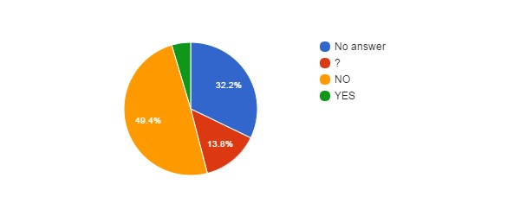

Fear for your Job ? (ORB­KSB)
Q17 | count(*)
No answer | 3
NO | 27
YES | 57
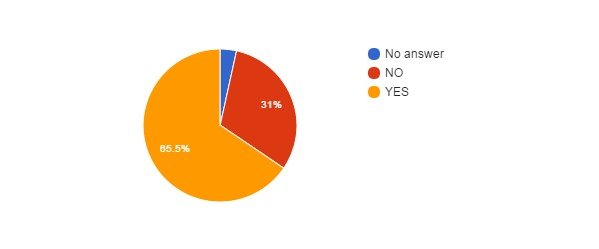

Fear for Job vs Position (ORB­KSB)
↓Q17\Q3→ | CON | MAN | OTH | STA
NoAnswer | 2 |  |  | 1
NO | 11 |  | 1 | 15
YES | 39 |  |  | 18

Fear for Job vs Age (ORB­KSB)
↓Q17\Q5→ | NoAnswer | 21­30 | 31­40 | 41­50 | 51­60 | 61­65 | >65
NoAnswer |  |  | 1 | 1 | 1
NO |  | 3 | 7 | 9 | 5 | 2 | 1
YES | 2 | 4 | 20 | 21 | 7 | 3

Fear for Job vs Career (ORB­KSB)
↓Q17\Q2→ | ? | Sci | Tech/Admin
NoAnswer |  | 3
NO |  | 17 | 10
YES | 1 | 34 | 22

Reform will improve some employment conditions ? (ORB­KSB)
Q18 | count(*)
? | 21
NO | 55
YES | 11
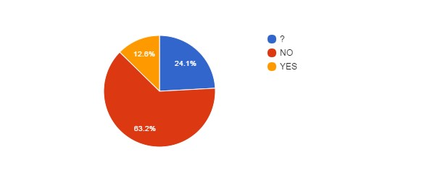

Reform will improve some employment conditions vs Position (ORB­KSB)
↓Q18\Q3→ | CON | MAN | OTH | STA
NoAnswer
? | 16 |  |  | 5
NO | 28 |  |  | 27
YES | 8 |  | 1 | 2

Reform will improve some employment conditions vs Age (ORB-KSB)
↓Q18\Q5→ | NoAnswer | 21­30 | 31­40 | 41­50 | 51­60 | 61­65 | >65
NoAnswer
? |  | 1 | 10 | 7 | 2 |  | 1
NO | 2 | 3 | 15 | 20 | 10 | 5
YES |  | 3 | 3 | 4 | 1

Reform will improve some employment conditions vs Career (ORB­KSB)
↓Q18\Q2→ | ? | Sci | Tech/Admin
NoAnswer
? |  | 15 | 6
NO | 1 | 31 | 23
YES |  | 8 | 3

Reform will deteriorate some employment conditions ? (ORB­KSB)
Q20 | count(*)
No answer | 1
? | 16
NO | 2
YES | 68
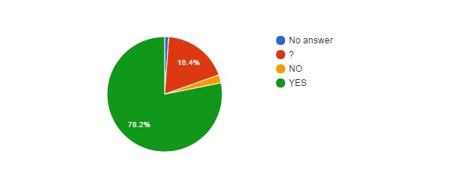Reform will deteriorate some employment conditions vs Position (ORB­KSB)
↓Q20\Q3→ | CON | MAN | OTH | STA
NoAnswer | 1
? | 10 |  |  | 6
NO | 1 |  |  | 1
YES | 40 |  | 1 | 27

Reform will deteriorate some employment conditions vs Age (ORB­KSB)
↓Q20\Q5→ | NoAnswer | 21­30 | 31­40 | 41­50 | 51­60 | 61­65 | >65
NoAnswer |  | 1
? | 1 | 2 | 6 | 6 |  |  | 1
NO |  |  |  | 1 | 1
YES | 1 | 4 | 22 | 24 | 12 | 5

Reform will deteriorate some employment conditions vs Career (ORB­KSB)
↓Q20\Q2→ | ? | Sci | Tech/Admin
NoAnswer |  |  | 1
? |  | 11 | 5
NO |  | 2
YES | 1 | 41 | 26

Impact of BELSPO's reform on the FSIs (ORB­KSB)
Q22 | count(*)
No answer | 47
? | 21
NO | 5
YES+ | 2
YES­ | 12
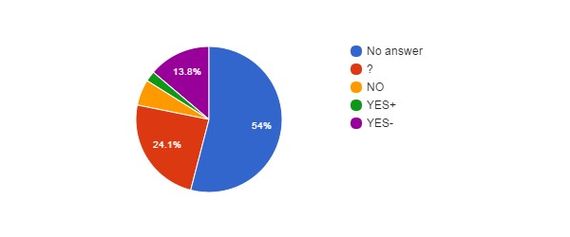

Impact of BELSPO's reform on the FSIs vs Career (ORB­KSB)
↓Q22\Q2→ | ? | Sci | Tech/Admin
NoAnswer | 1 | 31 | 15
? |  | 12 | 9
NO |  | 5
YES+ |  | 1 | 1
YES­ |  | 5 | 7

Impact of BELSPO's reform on the FSIs vs Position (ORB­KSB)
↓Q22\Q3→ | CON | MAN | OTH | STA
NoAnswer | 27 |  |  | 20
? | 12 |  | 1 | 8
NO | 4 |  |  | 1
YES+ | 2
YES­ | 7 |  |  | 5

Language (ORB­KSB)
Lang | count(*)
EN | 13
FR | 47
NL | 27
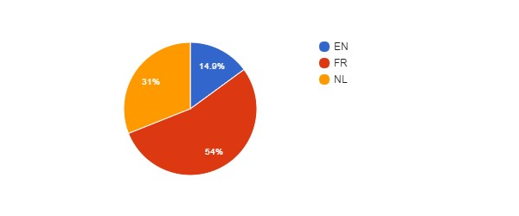

Language vs Age (ORB­KSB)
↓Lang\Q5→ | NoAnswer | 21­30 | 31­40 | 41­50 | 51­60 | 61­65 | >65
EN |  |  | 3 | 9 |  |  | 1
FR |  | 3 | 19 | 13 | 8 | 4
NL | 2 | 4 | 6 | 9 | 5 | 1

Language vs Position (ORB­KSB)
↓Lang\Q3→ | CON | MAN | OTH | STA
EN | 11 |  |  | 2
FR | 24 |  | 1 | 22
NL | 17 |  |  | 10

Which improvements do you expect ? (ORB­KSB)
#answers Q19 | 22
MealVouchers | 10
CompanyCar | 1
FreeHospInsurance | 9
BetterInstCulture | 6
2dPension | 14
BetterPromotions | 14
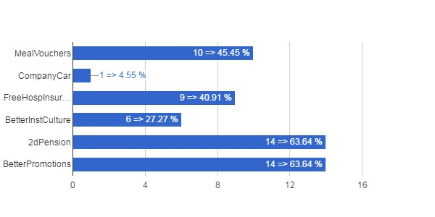

Which Improvements vs Career (ORB­KSB)
↓Q19\Q2→ | ? | Sci | Tech/Admin
MealVouchers |  | 6 | 4
CompanyCar |  | 1
FreeHospInsurance |  | 6 | 3
BetterInstCulture |  | 4 | 2
2dPension |  | 9 | 5
BetterPromotions |  | 11 | 3

Which Improvements vs Position (ORB­KSB)
↓Q19\Q3→ | CON | MAN | OTH | STA
MealVouchers | 6 |  | 1 | 3
CompanyCar |  |  | 1
FreeHospInsurance | 7 |  |  | 2
BetterInstCulture | 4 |  |  | 2
2dPension | 10 |  | 1 | 3
BetterPromotions | 10 |  | 1 | 3

Which Improvements vs Age (ORB­KSB)
↓Q19\Q5→ | NoAnswer | 21­30 | 31­40 | 41­50 | 51­60 | 61­65 | >65
MealVouchers | 2 | 3 | 4 |  | 1
CompanyCar |  | 1
FreeHospInsurance | 2 | 1 | 5 | 1
BetterInstCulture | 1 | 1 | 3 | 1
2dPension | 2 | 3 | 6 | 2 | 1
BetterPromotions | 1 | 2 | 5 | 5 | 1

Which deteriorations do you expect ? (ORB­KSB)
#answers Q21 | 73
JobInsecurity | 52
IncrPressureStress | 51
RedEfficiency | 42
IncomeLoss | 32
WorseWorkAtmos | 47
WorkAutonomyLoss | 43
SciFreedomLoss | 48
FSIAutonomyLoss | 41
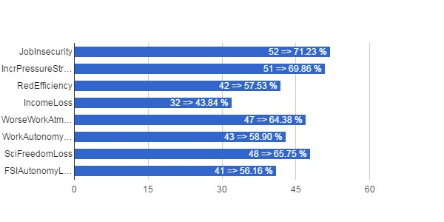

Which Deteriorations vs Career (ORB­KSB)
↓Q21\Q2→ | ? | Sci | Tech/Admin
JobInsecurity | 1 | 34 | 17
IncrPressureStress | 1 | 32 | 18
RedEfficiency | 1 | 29 | 12
IncomeLoss | 1 | 19 | 12
WorseWorkAtmos | 1 | 29 | 17
WorkAutonomyLoss | 1 | 28 | 14
SciFreedomLoss | 1 | 36 | 11
FSIAutonomyLoss | 1 | 23 | 17

Which Deteriorations vs Position (ORB­KSB)
↓Q21\Q3→ | CON | MAN | OTH | STA
JobInsecurity | 31 |  |  | 21
IncrPressureStress | 31 |  |  | 20
RedEfficiency | 26 |  |  | 16
IncomeLoss | 22 |  |  | 10
WorseWorkAtmos | 29 |  | 1 | 17
WorkAutonomyLoss | 29 |  |  | 14
SciFreedomLoss | 28 |  | 1 | 19
FSIAutonomyLoss | 21 |  |  | 20

Which Deteriorations vs Age (ORB­KSB)
↓Q21\Q5→ | NoAnswer | 21­30 | 31­40 | 41­50 | 51­60 | 61­65 | >65
JobInsecurity | 2 | 4 | 12 | 20 | 10 | 4
IncrPressureStress | 2 | 3 | 17 | 19 | 7 | 3
RedEfficiency | 2 | 2 | 13 | 17 | 6 | 2
IncomeLoss | 2 | 3 | 10 | 7 | 8 | 2
WorseWorkAtmos | 2 | 3 | 13 | 20 | 7 | 2
WorkAutonomyLoss |  | 2 | 16 | 13 | 10 | 2
SciFreedomLoss | 2 | 3 | 13 | 21 | 6 | 3
FSIAutonomyLoss | 1 | 2 | 12 | 16 | 7 | 3

MRBAB­KMSKB

Total number of answers (MRBAB­KMSKB)
Q1 | count(*)
MRBAB­KMSKB | 59

Scientific or Administrative/Technical Career? (MRBAB­KMSKB)
Q2 | count(*)
? | 8
Sci | 10
Tech/Admin | 41
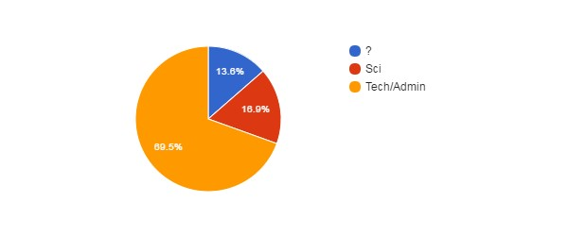

Position (MRBAB­KMSKB)
Q3 | count(*)
CON | 39
STA | 20
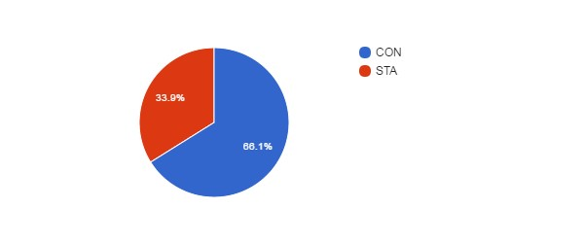

Position vs Age (MRBAB­KMSKB)
↓Q3\Q5→ | NoAnswer | 21­30 | 31­40 | 41­50 | 51­60 | 61­65 | >65
CON |  | 7 | 8 | 14 | 10
MAN
OTH
STA | 1 |  | 5 | 7 | 6 | 1

Gender (MRBAB­KMSKB)
Q4 | count(*)
F | 31
M | 28
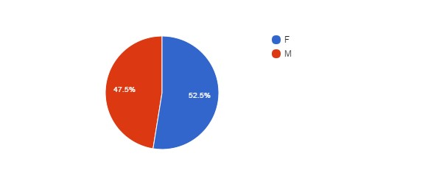

Age (MRBAB­KMSKB)
Q5 | count(*)
No answer | 1
21­30 | 7
31­40 | 13
41­50 | 21
51­60 | 16
61­65 | 1
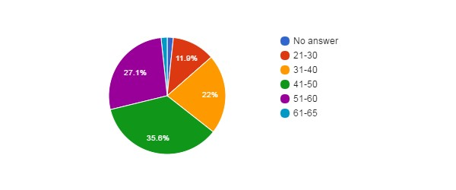

Feel Concerned by the Reform ? (MRBAB­KMSKB)
Q6 | count(*)
No answer | 1
NO | 2
YES | 26
YES, BUT | 30
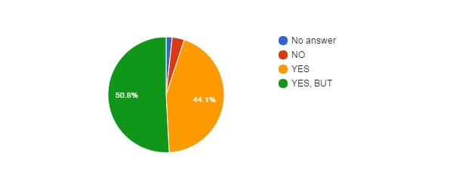

Concerned vs Career (MRBAB­KMSKB)
↓Q6\Q2→ | ? | Sci | Tech/Admin
NoAnswer |  | 1
NO | 1 |  | 1
YES | 1 | 4 | 21
YES, BUT | 6 | 5 | 19

Concerned vs Position (MRBAB­KMSKB)
↓Q6\Q3→ | CON | MAN | OTH | STA
NoAnswer | 1
NO | 1 |  |  | 1
YES | 13 |  |  | 13
YES, BUT | 24 |  |  | 6

Concerned vs Gender (MRBAB­KMSKB)
↓Q6\Q4→ | NoAnswer | F | M
NoAnswer |  | 1
NO |  | 1 | 1
YES |  | 12 | 14
YES, BUT |  | 17 | 13

Concerned vs Age (MRBAB­KMSKB)
↓Q6\Q5→ | NoAnswer | 21­30 | 31­40 | 41­50 | 51­60 | 61­65 | >65
NoAnswer |  | 1
NO |  |  | 1 |  | 1
YES |  | 1 | 5 | 10 | 9 | 1
YES, BUT | 1 | 5 | 7 | 11 | 6

How Informed ? (MRBAB­KMSKB)
Q7 | count(*)
0 | 15
1 | 20
2 | 24
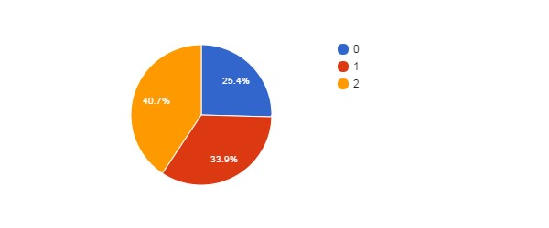

How Informed vs Career (MRBAB­KMSKB)
↓Q7\Q2→ | ? | Sci | Tech/Admin
NoAnswer
0 | 2 | 3 | 10
1 | 6 | 4 | 10
2 |  | 3 | 21
3

How Informed vs Position (MRBAB­KMSKB)
↓Q7\Q3→ | CON | MAN | OTH | STA
NoAnswer
0 | 12 |  |  | 3
1 | 15 |  |  | 5
2 | 12 |  |  | 12
3

How Informed vs Age (MRBAB­KMSKB)
↓Q7\Q5→ | NoAnswer | 21­30 | 31­40 | 41­50 | 51­60 | 61­65 | >65
NoAnswer
0 |  | 2 | 3 | 5 | 5
1 |  | 1 | 6 | 9 | 4
2 | 1 | 4 | 4 | 7 | 7 | 1
3

Agree with Objectives ? (MRBAB­KMSKB)
Q8 | count(*)
No answer | 9
? | 19
NO | 27
YES | 4
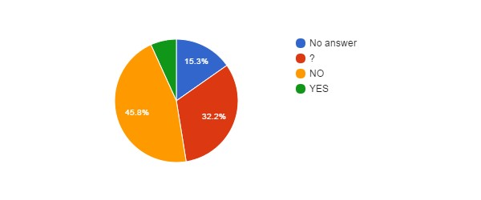

Agree with Objectives vs Career (MRBAB­KMSKB)
↓Q8\Q2→ | ? | Sci | Tech/Admin
NoAnswer | 3 | 2 | 4
? | 3 | 7 | 9
NO | 2 | 1 | 24
YES |  |  | 4

Agree with Objectives vs Position (MRBAB­KMSKB)
↓Q8\Q3→ | CON | MAN | OTH | STA
NoAnswer | 7 |  |  | 2
? | 16 |  |  | 3
NO | 13 |  |  | 14
YES | 3 |  |  | 1

Agree with Objectives vs Age (MRBAB­KMSKB)
↓Q8\Q5→ | NoAnswer | 21­30 | 31­40 | 41­50 | 51­60 | 61­65 | >65
NoAnswer |  | 2 | 2 | 3 | 2
? | 1 | 2 | 3 | 10 | 3
NO |  | 2 | 7 | 8 | 9 | 1
YES |  | 1 | 1 |  | 2

Reform will Achieve Objectives ? (MRBAB­KMSKB)
Q9 | count(*)
No answer | 9
? | 18
NO | 31
YES | 1
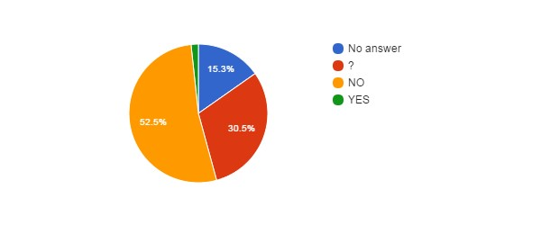

Hidden Agenda ? (MRBAB­KMSKB)
Q10 | count(*)
No answer | 9
? | 18
NO | 3
YES | 29
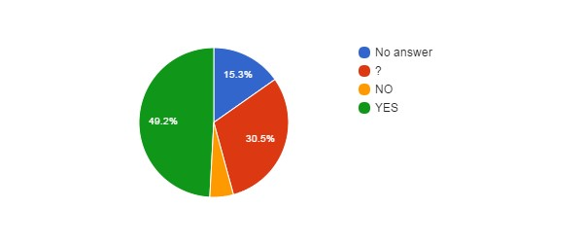

Hidden Agenda vs Language (MRBAB­KMSKB)
↓Q10\Lang→ | EN | FR | NL
NoAnswer |  | 3 | 6
? |  | 6 | 12
NO |  | 1 | 2
YES |  | 11 | 18

Reform entails... (MRBAB­KMSKB)
Q11 | count(*)
No answer | 10
? | 7
CONT | 3
PRIV | 11
RISK | 28
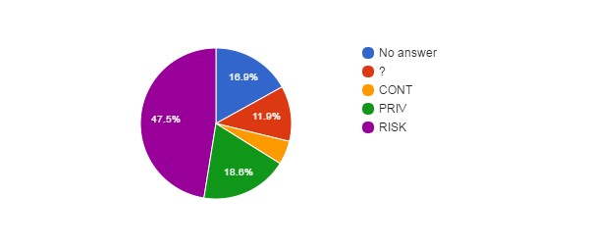

How better will work the institution after the reform ? (MRBAB­KMSKB)
Q12 | count(*)
No answer | 11
+ | 2
­ | 18
= | 13
? | 15
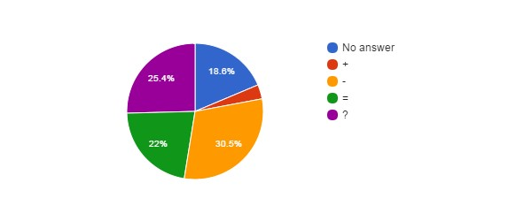

How better will work the institution vs Career (MRBAB­KMSKB)
↓Q12\Q2→ | ? | Sci | Tech/Admin
NoAnswer | 4 | 2 | 5
+ |  |  | 2
­ |  | 2 | 16
= | 2 | 1 | 10
? | 2 | 5 | 8

Agree with Privatisation of Public Services ? (MRBAB­KMSKB)
Q13 | count(*)
? | 7
NO | 49
YES | 3
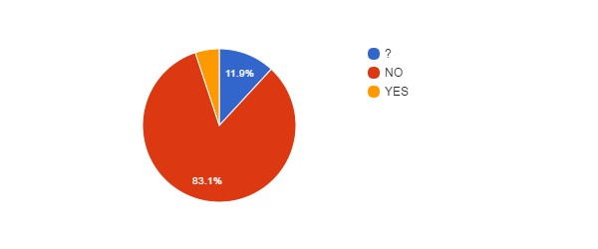

Agree with Privatisation of Public Services vs Age (MRBAB­KMSKB)
↓Q13\Q5→ | NoAnswer | 21­30 | 31­40 | 41­50 | 51­60 | 61­65 | >65
NoAnswer
? |  | 2 |  | 4 | 1
NO | 1 | 4 | 11 | 17 | 15 | 1
YES |  | 1 | 2

Agree with Privatisation of Public Services vs Language (MRBAB­KMSKB)
↓Q13\Lang→ | EN | FR | NL
NoAnswer
? |  | 2 | 5
NO |  | 18 | 31
YES |  | 1 | 2

Agree with Privatisation of the FSIs ? (MRBAB­KMSKB)
Q14 | count(*)
? | 7
NO | 50
YES | 2
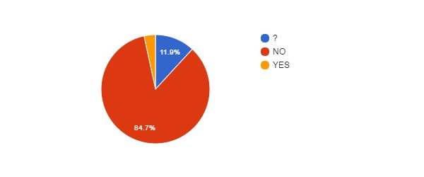

Agree with Privatisation of FSIs vs Agree with Privatisation of Public Services (MRBAB­KMSKB)
↓Q14\Q13→ | NoAnswer | ? | NO | YES
NoAnswer
? |  | 7
NO |  |  | 49 | 1
YES |  |  |  | 2

Agree with Privatisation of FSIs vs Career (MRBAB­KMSKB)
↓Q14\Q2→ | ? | Sci | Tech/Admin
NoAnswer
? | 3 | 1 | 3
NO | 5 | 9 | 36
YES |  |  | 2

FSIs need Major Reforms ? (MRBAB­KMSKB)
Q15 | count(*)
? | 11
NO | 16
YES | 32
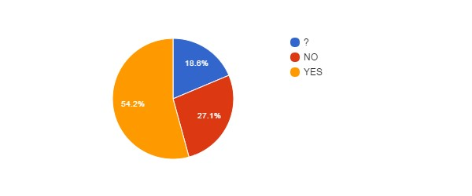

FSIs need Major Reforms vs Career (MRBAB­KMSKB)
↓Q15\Q2→ | ? | Sci | Tech/Admin
NoAnswer
? | 5 | 1 | 5
NO | 1 |  | 15
YES | 2 | 9 | 21

FSIs need Major Reforms vs Position (MRBAB­KMSKB)
↓Q15\Q3→ | CON | MAN | OTH | STA
NoAnswer
? | 11
NO | 9 |  |  | 7
YES | 19 |  |  | 13

FSIs need Major Reforms vs Age (MRBAB­KMSKB)
↓Q15\Q5→ | NoAnswer | 21­30 | 31­40 | 41­50 | 51­60 | 61­65 | >65
NoAnswer
? |  | 3 | 1 | 5 | 2
NO |  |  | 3 | 6 | 7
YES | 1 | 4 | 9 | 10 | 7 | 1

FSIs Reforms need status change ? (MRBAB­KMSKB)
Q16 | count(*)
No answer | 14
? | 12
NO | 23
YES | 10
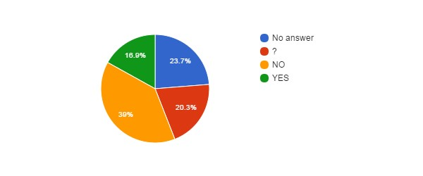

Fear for your Job ? (MRBAB­KMSKB)
Q17 | count(*)
No answer | 1
NO | 23
YES | 35
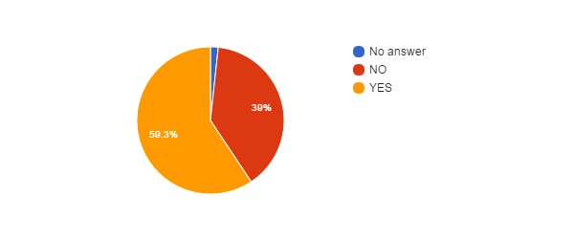

Fear for Job vs Position (MRBAB­KMSKB)
↓Q17\Q3→ | CON | MAN | OTH | STA
NoAnswer | 1
NO | 13 |  |  | 10
YES | 25 |  |  | 10

Fear for Job vs Age (MRBAB­KMSKB)
↓Q17\Q5→ | NoAnswer | 21­30 | 31­40 | 41­50 | 51­60 | 61­65 | >65
NoAnswer |  |  |  |  | 1
NO | 1 | 4 | 6 | 7 | 4 | 1
YES |  | 3 | 7 | 14 | 11

Fear for Job vs Career (MRBAB­KMSKB)
↓Q17\Q2→ | ? | Sci | Tech/Admin
NoAnswer | 1
NO | 3 | 4 | 16
YES | 4 | 6 | 25

Reform will improve some employment conditions ? (MRBAB­KMSKB)
Q18 | count(*)
No answer | 1
? | 11
NO | 42
YES | 5
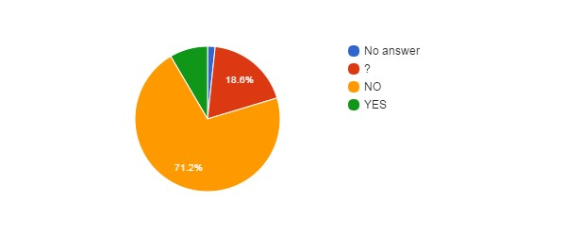
Reform will improve some employment conditions vs Position (MRBAB­KMSKB)
↓Q18\Q3→ | CON | MAN | OTH | STA
NoAnswer | 1
? | 9 |  |  | 2
NO | 25 |  |  | 17
YES | 4 |  |  | 1

Reform will improve some employment conditions vs Age (MRBAB­KMSKB)
↓Q18\Q5→ | NoAnswer | 21­30 | 31­40 | 41­50 | 51­60 | 61­65 | >65
NoAnswer |  |  |  |  | 1
? | 1 | 2 | 2 | 4 | 2
NO |  | 3 | 10 | 15 | 13 | 1
YES |  | 2 | 1 | 2

Reform will improve some employment conditions vs Career (MRBAB­KMSKB)
↓Q18\Q2→ | ? | Sci | Tech/Admin
NoAnswer | 1
? | 2 | 5 | 4
NO | 4 | 3 | 35
YES | 1 | 2 | 2

Reform will deteriorate some employment conditions ? (MRBAB­KMSKB)
Q20 | count(*)
No answer | 2
? | 7
YES | 50
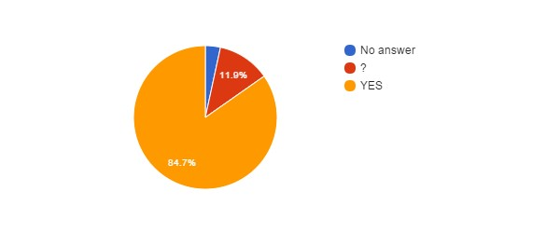Reform will deteriorate some employment conditions vs Position (MRBAB­KMSKB)
↓Q20\Q3→ | CON | MAN | OTH | STA
NoAnswer | 2
? | 4 |  |  | 3
NO
YES | 33 |  |  | 17

Reform will deteriorate some employment conditions vs Age (MRBAB­KMSKB)
↓Q20\Q5→ | NoAnswer | 21­30 | 31­40 | 41­50 | 51­60 | 61­65 | >65
NoAnswer |  |  |  | 1 | 1
? | 1 | 1 | 1 | 1 | 3
NO
YES |  | 6 | 12 | 19 | 12 | 1

Reform will deteriorate some employment conditions vs Career (MRBAB­KMSKB)
↓Q20\Q2→ | ? | Sci | Tech/Admin
NoAnswer | 1 | 1
? |  | 3 | 4
NO
YES | 7 | 6 | 37

Impact of BELSPO's reform on the FSIs (MRBAB­KMSKB)
Q22 | count(*)
No answer | 1
? | 28
NO | 2
YES+ | 6
YES­ | 22
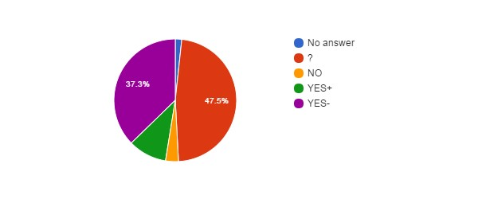

Impact of BELSPO's reform on the FSIs vs Career (MRBAB­KMSKB)
↓Q22\Q2→ | ? | Sci | Tech/Admin
NoAnswer | 1
? | 4 | 5 | 19
NO |  |  | 2
YES+ | 1 | 3 | 2
YES­ | 2 | 2 | 18

Impact of BELSPO's reform on the FSIs vs Position (MRBAB­KMSKB)
↓Q22\Q3→ | CON | MAN | OTH | STA
NoAnswer | 1
? | 24 |  |  | 4
NO | 1 |  |  | 1
YES+ | 1 |  |  | 5
YES­ | 12 |  |  | 10

Language (MRBAB­KMSKB)
Lang | count(*)
FR | 21
NL | 38
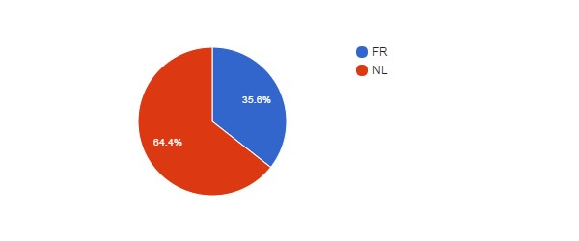

Language vs Age (MRBAB­KMSKB)
↓Lang\Q5→ | NoAnswer | 21­30 | 31­40 | 41­50 | 51­60 | 61­65 | >65
EN
FR |  | 3 | 5 | 9 | 3 | 1
NL | 1 | 4 | 8 | 12 | 13

Language vs Position (MRBAB­KMSKB)
↓Lang\Q3→ | CON | MAN | OTH | STA
EN
FR | 13 |  |  | 8
NL | 26 |  |  | 12

Which improvements do you expect ? (MRBAB­KMSKB)
#answers Q19 | 17
MealVouchers | 9
CompanyCar | 0
FreeHospInsurance | 3
BetterInstCulture | 5
2dPension | 5
BetterPromotions | 9
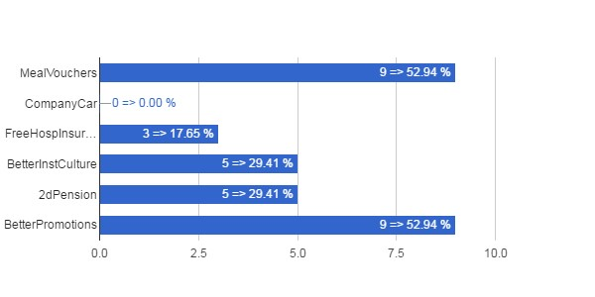

Which Improvements vs Career (MRBAB­KMSKB)
↓Q19\Q2→ | ? | Sci | Tech/Admin
MealVouchers | 2 | 1 | 6
CompanyCar
FreeHospInsurance |  |  | 3
BetterInstCulture |  | 3 | 2
2dPension | 1 |  | 4
BetterPromotions | 1 | 2 | 6

Which Improvements vs Position (MRBAB­KMSKB)
↓Q19\Q3→ | CON | MAN | OTH | STA
MealVouchers | 6 |  |  | 3
CompanyCar
FreeHospInsurance | 2 |  |  | 1
BetterInstCulture | 3 |  |  | 2
2dPension | 3 |  |  | 2
BetterPromotions | 8 |  |  | 1

Which Improvements vs Age (MRBAB­KMSKB)
↓Q19\Q5→ | NoAnswer | 21­30 | 31­40 | 41­50 | 51­60 | 61­65 | >65
MealVouchers |  | 3 | 2 | 2 | 1 | 1
CompanyCar
FreeHospInsurance |  | 1 | 1 |  |  | 1
BetterInstCulture |  | 1 | 1 | 1 | 1 | 1
2dPension |  | 1 |  | 1 | 2 | 1
BetterPromotions |  | 3 | 2 | 2 | 1 | 1

Which deteriorations do you expect ? (MRBAB­KMSKB)
#answers Q21 | 54
JobInsecurity | 38
IncrPressureStress | 44
RedEfficiency | 31
IncomeLoss | 33
WorseWorkAtmos | 33
WorkAutonomyLoss | 18
SciFreedomLoss | 13
FSIAutonomyLoss | 26
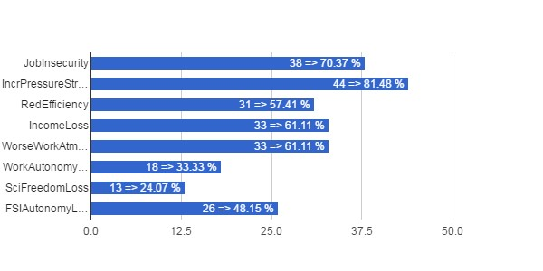

Which Deteriorations vs Career (MRBAB­KMSKB)
↓Q21\Q2→ | ? | Sci | Tech/Admin
JobInsecurity | 4 | 5 | 29
IncrPressureStress | 7 | 6 | 31
RedEfficiency | 4 | 6 | 21
IncomeLoss | 2 | 5 | 26
WorseWorkAtmos | 4 | 5 | 24
WorkAutonomyLoss | 1 | 3 | 14
SciFreedomLoss |  | 4 | 9
FSIAutonomyLoss |  | 4 | 22

Which Deteriorations vs Position (MRBAB­KMSKB)
↓Q21\Q3→ | CON | MAN | OTH | STA
JobInsecurity | 24 |  |  | 14
IncrPressureStress | 30 |  |  | 14
RedEfficiency | 18 |  |  | 13
IncomeLoss | 20 |  |  | 13
WorseWorkAtmos | 21 |  |  | 12
WorkAutonomyLoss | 11 |  |  | 7
SciFreedomLoss | 8 |  |  | 5
FSIAutonomyLoss | 12 |  |  | 14

Which Deteriorations vs Age (MRBAB­KMSKB)
↓Q21\Q5→ | NoAnswer | 21­30 | 31­40 | 41­50 | 51­60 | 61­65 | >65
JobInsecurity |  | 3 | 8 | 16 | 10 | 1
IncrPressureStress |  | 4 | 11 | 17 | 11 | 1
RedEfficiency |  | 2 | 7 | 14 | 7 | 1
IncomeLoss |  | 4 | 6 | 14 | 9
WorseWorkAtmos |  | 2 | 9 | 13 | 9
WorkAutonomyLoss |  |  | 5 | 11 | 2
SciFreedomLoss |  |  | 3 | 4 | 6
FSIAutonomyLoss |  | 1 | 7 | 12 | 5 | 1

IRM­KMI

Total number of answers (IRM­KMI)
Q1 | count(*)
IRM­KMI | 100

Scientific or Administrative/Technical Career? (IRM­KMI)
Q2 | count(*)
? | 8
Sci | 42
Tech/Admin | 50
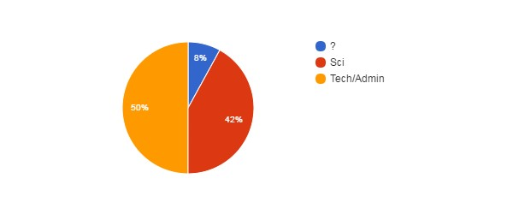

Position (IRM­KMI)
Q3 | count(*)
CON | 48
OTH | 4
STA | 48
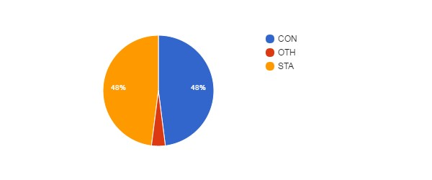

Position vs Age (IRM­KMI)
↓Q3\Q5→ | NoAnswer | 21­30 | 31­40 | 41­50 | 51­60 | 61­65 | >65
CON |  | 9 | 21 | 7 | 9 | 2
MAN
OTH |  | 3 |  |  |  |  | 1
STA | 1 | 6 | 13 | 15 | 11 | 2

Gender (IRM­KMI)
Q4 | count(*)
No answer | 1
F | 22
M | 77
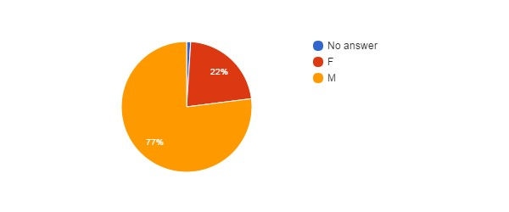

Age (IRM­KMI)
Q5 | count(*)
No answer | 1
21­30 | 18
31­40 | 34
41­50 | 22
51­60 | 20
61­65 | 4
>65 | 1
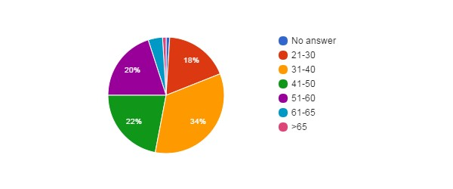

Feel Concerned by the Reform ? (IRM­KMI)
Q6 | count(*)
NO | 2
YES | 43
YES, BUT | 55
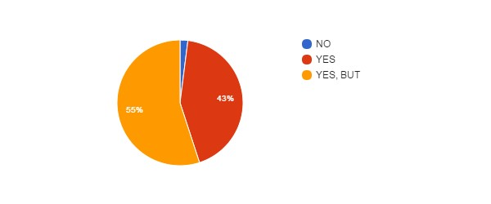

Concerned vs Career (IRM­KMI)
↓Q6\Q2→ | ? | Sci | Tech/Admin
NoAnswer
NO |  | 1 | 1
YES |  | 20 | 23
YES, BUT | 8 | 21 | 26

Concerned vs Position (IRM­KMI)
↓Q6\Q3→ | CON | MAN | OTH | STA
NoAnswer
NO | 1 |  | 1
YES | 18 |  | 2 | 23
YES, BUT | 29 |  | 1 | 25

Concerned vs Gender (IRM­KMI)
↓Q6\Q4→ | NoAnswer | F | M
NoAnswer
NO |  |  | 2
YES |  | 6 | 37
YES, BUT | 1 | 16 | 38

Concerned vs Age (IRM­KMI)
↓Q6\Q5→ | NoAnswer | 21­30 | 31­40 | 41­50 | 51­60 | 61­65 | >65
NoAnswer
NO |  | 1 | 1
YES |  | 7 | 14 | 11 | 7 | 3 | 1
YES, BUT | 1 | 10 | 19 | 11 | 13 | 1

How Informed ? (IRM­KMI)
Q7 | count(*)
0 | 13
1 | 34
2 | 32
3 | 21
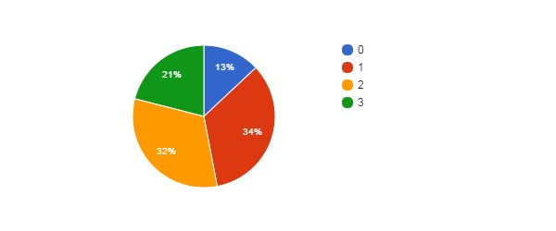

How Informed vs Career (IRM­KMI)
↓Q7\Q2→ | ? | Sci | Tech/Admin
NoAnswer
0 | 1 | 3 | 9
1 | 2 | 16 | 16
2 | 2 | 15 | 15
3 | 3 | 8 | 10

How Informed vs Position (IRM­KMI)
↓Q7\Q3→ | CON | MAN | OTH | STA
NoAnswer
0 | 4 |  | 1 | 8
1 | 12 |  | 2 | 20
2 | 20 |  | 1 | 11
3 | 12 |  |  | 9

How Informed vs Age (IRM­KMI)
↓Q7\Q5→ | NoAnswer | 21­30 | 31­40 | 41­50 | 51­60 | 61­65 | >65
NoAnswer
0 |  | 2 | 4 | 3 | 4
1 |  | 11 | 6 | 10 | 5 | 2
2 |  | 4 | 14 | 4 | 7 | 2 | 1
3 | 1 | 1 | 10 | 5 | 4

Agree with Objectives ? (IRM­KMI)
Q8 | count(*)
No answer | 11
? | 36
NO | 45
YES | 8
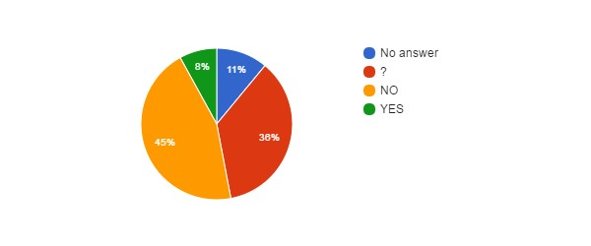

Agree with Objectives vs Career (IRM­KMI)
↓Q8\Q2→ | ? | Sci | Tech/Admin
NoAnswer |  | 3 | 8
? | 3 | 21 | 12
NO | 5 | 14 | 26
YES |  | 4 | 4

Agree with Objectives vs Position (IRM­KMI)
↓Q8\Q3→ | CON | MAN | OTH | STA
NoAnswer | 4 |  |  | 7
? | 22 |  | 3 | 11
NO | 18 |  | 1 | 26
YES | 4 |  |  | 4

Agree with Objectives vs Age (IRM­KMI)
↓Q8\Q5→ | NoAnswer | 21­30 | 31­40 | 41­50 | 51­60 | 61­65 | >65
NoAnswer |  | 1 | 3 | 3 | 4
? |  | 9 | 15 | 4 | 6 | 2
NO | 1 | 5 | 13 | 14 | 9 | 2 | 1
YES |  | 3 | 3 | 1 | 1

Reform will Achieve Objectives ? (IRM­KMI)
Q9 | count(*)
No answer | 11
? | 39
NO | 45
YES | 5
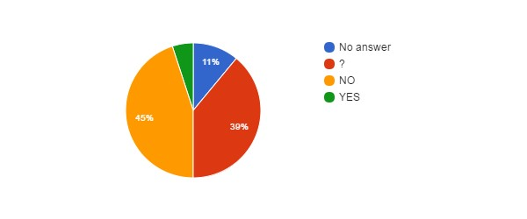

Hidden Agenda ? (IRM­KMI)
Q10 | count(*)
No answer | 11
? | 31
NO | 4
YES | 54
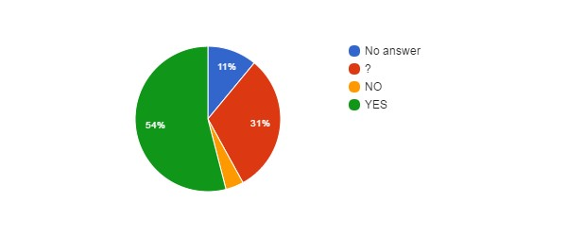

Hidden Agenda vs Language (IRM­KMI)
↓Q10\Lang→ | EN | FR | NL
NoAnswer |  | 5 | 6
? |  | 19 | 12
NO |  | 2 | 2
YES |  | 34 | 20

Reform entails... (IRM­KMI)
Q11 | count(*)
No answer | 11
? | 11
CONT | 6
PRIV | 38
RISK | 34
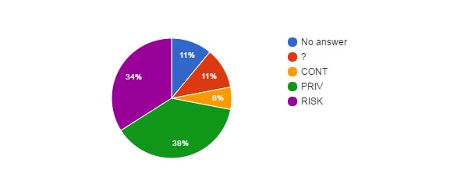

How better will work the institution after the reform ? (IRM­KMI)
Q12 | count(*)
No answer | 11
+ | 7
­ | 44
= | 11
? | 27
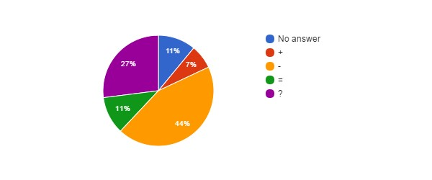

How better will work the institution vs Career (IRM­KMI)
↓Q12\Q2→ | ? | Sci | Tech/Admin
NoAnswer |  | 3 | 8
+ |  | 4 | 3
­ | 5 | 15 | 24
= |  | 5 | 6
? | 3 | 15 | 9

Agree with Privatisation of Public Services ? (IRM­KMI)
Q13 | count(*)
No answer | 1
? | 10
NO | 83
YES | 6
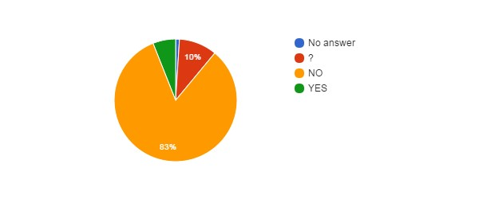

Agree with Privatisation of Public Services vs Age (IRM­KMI)
↓Q13\Q5→ | NoAnswer | 21­30 | 31­40 | 41­50 | 51­60 | 61­65 | >65
NoAnswer |  |  |  |  | 1
? | 1 | 1 | 5 | 1 | 2
NO |  | 14 | 27 | 20 | 17 | 4 | 1
YES |  | 3 | 2 | 1

Agree with Privatisation of Public Services vs Language (IRM­KMI)
↓Q13\Lang→ | EN | FR | NL
NoAnswer |  |  | 1
? |  | 5 | 5
NO |  | 52 | 31
YES |  | 3 | 3

Agree with Privatisation of the FSIs ? (IRM­KMI)
Q14 | count(*)
? | 10
NO | 85
YES | 5
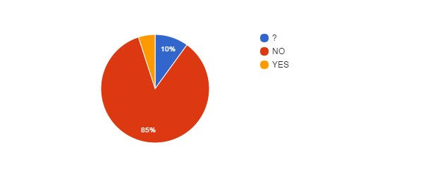

Agree with Privatisation of FSIs vs Agree with Privatisation of Public Services (IRM­KMI)
↓Q14\Q13→ | NoAnswer | ? | NO | YES
NoAnswer
? |  | 6 | 3 | 1
NO | 1 | 4 | 80
YES |  |  |  | 5

Agree with Privatisation of FSIs vs Career (IRM­KMI)
↓Q14\Q2→ | ? | Sci | Tech/Admin
NoAnswer
? | 2 | 3 | 5
NO | 6 | 37 | 42
YES |  | 2 | 3

FSIs need Major Reforms ? (IRM­KMI)
Q15 | count(*)
? | 31
NO | 24
YES | 45
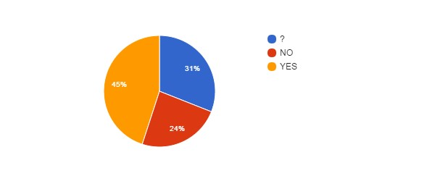

FSIs need Major Reforms vs Career (IRM­KMI)
↓Q15\Q2→ | ? | Sci | Tech/Admin
NoAnswer
? | 3 | 13 | 15
NO | 3 | 7 | 14
YES | 2 | 22 | 21

FSIs need Major Reforms vs Position (IRM­KMI)
↓Q15\Q3→ | CON | MAN | OTH | STA
NoAnswer
? | 13 |  | 3 | 15
NO | 9 |  | 1 | 14
YES | 26 |  |  | 19

FSIs need Major Reforms vs Age (IRM­KMI)
↓Q15\Q5→ | NoAnswer | 21­30 | 31­40 | 41­50 | 51­60 | 61­65 | >65
NoAnswer
? | 1 | 9 | 7 | 7 | 7
NO |  | 1 | 8 | 6 | 6 | 2 | 1
YES |  | 8 | 19 | 9 | 7 | 2

FSIs Reforms need status change ? (IRM­KMI)
Q16 | count(*)
No answer | 31
? | 28
NO | 30
YES | 11
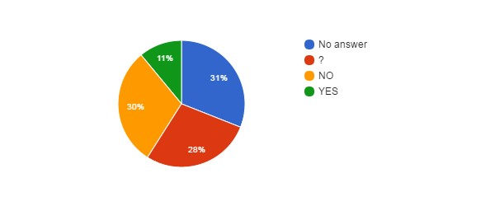

Fear for your Job ? (IRM­KMI)
Q17 | count(*)
No answer | 1
NO | 30
YES | 69
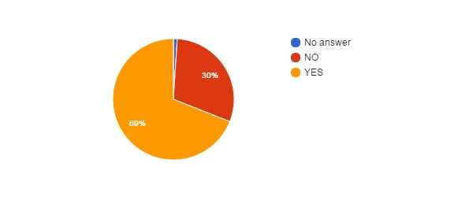

Fear for Job vs Position (IRM­KMI)
↓Q17\Q3→ | CON | MAN | OTH | STA
NoAnswer | 1
NO | 12 |  | 4 | 14
YES | 35 |  |  | 34

Fear for Job vs Age (IRM­KMI)
↓Q17\Q5→ | NoAnswer | 21­30 | 31­40 | 41­50 | 51­60 | 61­65 | >65
NoAnswer |  |  |  |  | 1
NO |  | 6 | 16 | 1 | 5 | 1 | 1
YES | 1 | 12 | 18 | 21 | 14 | 3

Fear for Job vs Career (IRM­KMI)
↓Q17\Q2→ | ? | Sci | Tech/Admin
NoAnswer |  | 1
NO | 1 | 15 | 14
YES | 7 | 26 | 36

Reform will improve some employment conditions ? (IRM­KMI)
Q18 | count(*)
? | 25
NO | 59
YES | 16
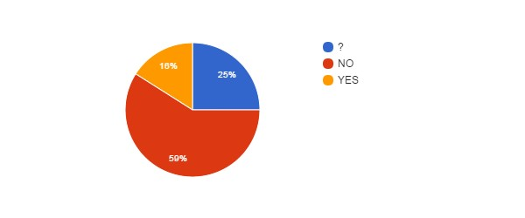
Reform will improve some employment conditions vs Position (IRM­KMI)
↓Q18\Q3→ | CON | MAN | OTH | STA
NoAnswer
? | 14 |  | 4 | 7
NO | 26 |  |  | 33
YES | 8 |  |  | 8

Reform will improve some employment conditions vs Age (IRMKMI)
↓Q18\Q5→ | NoAnswer | 21­30 | 31­40 | 41­50 | 51­60 | 61­65 | >65
NoAnswer
? | 1 | 7 | 8 | 3 | 4 | 1 | 1
NO |  | 6 | 21 | 14 | 16 | 2
YES |  | 5 | 5 | 5 |  | 1

Reform will improve some employment conditions vs Career (IRM­KMI)
↓Q18\Q2→ | ? | Sci | Tech/Admin
NoAnswer
? | 4 | 14 | 7
NO | 4 | 19 | 36
YES |  | 9 | 7

Reform will deteriorate some employment conditions ? (IRM­KMI)
Q20 | count(*)
? | 16
NO | 2
YES | 82
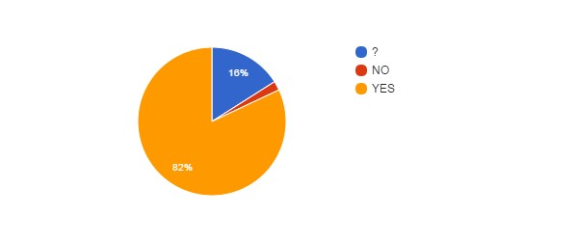

Reform will deteriorate some employment conditions vs Position (IRM­KMI)
↓Q20\Q3→ | CON | MAN | OTH | STA
NoAnswer
? | 9 |  | 3 | 4
NO | 1 |  |  | 1
YES | 38 |  | 1 | 43

Reform will deteriorate some employment conditions vs Age (IRM­KMI)
↓Q20\Q5→ | NoAnswer | 21­30 | 31­40 | 41­50 | 51­60 | 61­65 | >65
NoAnswer
? |  | 4 | 8 | 1 | 2 | 1
NO |  | 1 |  |  | 1
YES | 1 | 13 | 26 | 21 | 17 | 3 | 1

Reform will deteriorate some employment conditions vs Career (IRM­KMI)
↓Q20\Q2→ | ? | Sci | Tech/Admin
NoAnswer
? | 1 | 9 | 6
NO |  |  | 2
YES | 7 | 33 | 42

Impact of BELSPO's reform on the FSIs (IRM­KMI)
Q22 | count(*)
No answer | 54
? | 21
NO | 3
YES+ | 5
YES­ | 17
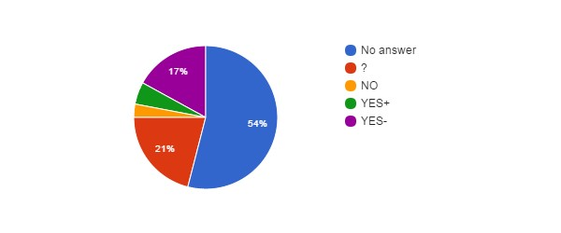

Impact of BELSPO's reform on the FSIs vs Career (IRM­KMI)
↓Q22\Q2→ | ? | Sci | Tech/Admin
NoAnswer | 5 | 26 | 23
? | 3 | 9 | 9
NO |  | 1 | 2
YES+ |  | 2 | 3
YES­ |  | 4 | 13

Impact of BELSPO's reform on the FSIs vs Position (IRM­KMI)
↓Q22\Q3→ | CON | MAN | OTH | STA
NoAnswer | 23 |  | 2 | 29
? | 13 |  | 1 | 7
NO | 3
YES+ | 2 |  |  | 3
YES­ | 7 |  | 1 | 9

Language (IRM­KMI)
Lang | count(*)
FR | 60
NL | 40
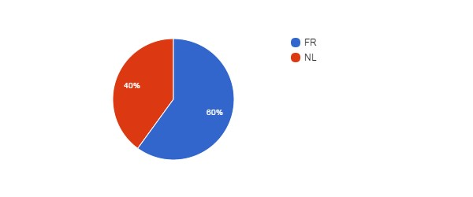

Language vs Age (IRM­KMI)
↓Lang\Q5→ | NoAnswer | 21­30 | 31­40 | 41­50 | 51­60 | 61­65 | >65
EN
FR | 1 | 11 | 15 | 18 | 11 | 4
NL |  | 7 | 19 | 4 | 9 |  | 1

Language vs Position (IRM­KMI)
↓Lang\Q3→ | CON | MAN | OTH | STA
EN
FR | 29 |  | 1 | 30
NL | 19 |  | 3 | 18

Which improvements do you expect ? (IRM­KMI)
#answers Q19 | 27
MealVouchers | 12
CompanyCar | 4
FreeHospInsurance | 12
BetterInstCulture | 15
2dPension | 13
BetterPromotions | 16
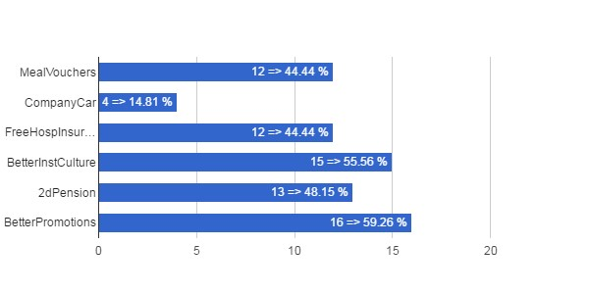

Which Improvements vs Career (IRM­KMI)
↓Q19\Q2→ | ? | Sci | Tech/Admin
MealVouchers |  | 6 | 6
CompanyCar |  | 1 | 3
FreeHospInsurance | 1 | 5 | 6
BetterInstCulture |  | 9 | 6
2dPension | 1 | 5 | 7
BetterPromotions | 1 | 9 | 6

Which Improvements vs Position (IRM­KMI)
↓Q19\Q3→ | CON | MAN | OTH | STA
MealVouchers | 6 |  |  | 6
CompanyCar | 1 |  |  | 3
FreeHospInsurance | 7 |  |  | 5
BetterInstCulture | 7 |  | 2 | 6
2dPension | 7 |  |  | 6
BetterPromotions | 11 |  | 1 | 4

Which Improvements vs Age (IRM­KMI)
↓Q19\Q5→ | NoAnswer | 21­30 | 31­40 | 41­50 | 51­60 | 61­65 | >65
MealVouchers |  | 2 | 3 | 5 | 1 | 1
CompanyCar |  | 2 |  | 2
FreeHospInsurance |  | 1 | 3 | 5 | 2 | 1
BetterInstCulture |  | 7 | 3 | 4 |  | 1
2dPension |  | 2 | 3 | 4 | 2 | 2
BetterPromotions |  | 5 | 5 | 4 | 1 | 1

Which deteriorations do you expect ? (IRM­KMI)
#answers Q21 | 85
JobInsecurity | 65
IncrPressureStress | 56
RedEfficiency | 48
IncomeLoss | 34
WorseWorkAtmos | 61
WorkAutonomyLoss | 53
SciFreedomLoss | 42
FSIAutonomyLoss | 54
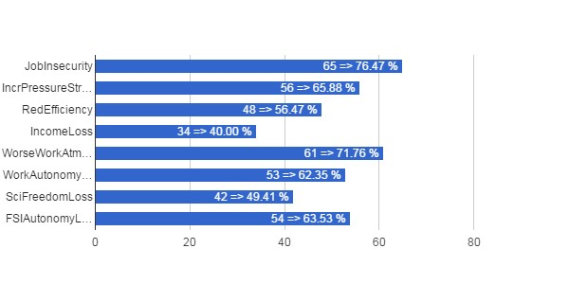

Which Deteriorations vs Career (IRM­KMI)
↓Q21\Q2→ | ? | Sci | Tech/Admin
JobInsecurity | 6 | 25 | 34
IncrPressureStress | 6 | 16 | 34
RedEfficiency | 6 | 12 | 30
IncomeLoss | 2 | 9 | 23
WorseWorkAtmos | 5 | 22 | 34
WorkAutonomyLoss | 4 | 21 | 28
SciFreedomLoss |  | 30 | 12
FSIAutonomyLoss | 4 | 25 | 25

Which Deteriorations vs Position (IRM­KMI)
↓Q21\Q3→ | CON | MAN | OTH | STA
JobInsecurity | 31 |  | 1 | 33
IncrPressureStress | 23 |  |  | 33
RedEfficiency | 19 |  |  | 29
IncomeLoss | 11 |  |  | 23
WorseWorkAtmos | 26 |  |  | 35
WorkAutonomyLoss | 22 |  | 1 | 30
SciFreedomLoss | 21 |  | 2 | 19
FSIAutonomyLoss | 24 |  | 2 | 28

Which Deteriorations vs Age (IRM­KMI)
↓Q21\Q5→ | NoAnswer | 21­30 | 31­40 | 41­50 | 51­60 | 61­65 | >65
JobInsecurity |  | 8 | 18 | 19 | 17 | 3
IncrPressureStress | 1 | 10 | 14 | 19 | 10 | 2
RedEfficiency | 1 | 6 | 11 | 17 | 10 | 3
IncomeLoss |  | 5 | 8 | 13 | 7 | 1
WorseWorkAtmos | 1 | 9 | 16 | 19 | 14 | 2
WorkAutonomyLoss |  | 9 | 17 | 14 | 11 | 1 | 1
SciFreedomLoss |  | 8 | 14 | 12 | 6 | 1 | 1
FSIAutonomyLoss | 1 | 6 | 15 | 18 | 11 | 2 | 1

BELSPO

Total number of answers (BELSPO)
Q1 | count(*)
BELSPO | 4

KIK­IRPA

Total number of answers (KIK­IRPA)
Q1 | count(*)
KIK­IRPA | 1

SpacePole

Total number of answers: 284 (SpacePole)
Q1 | count(*)
IASB­BIRA | 97
IRM­KMI | 100
ORB­KSB | 87
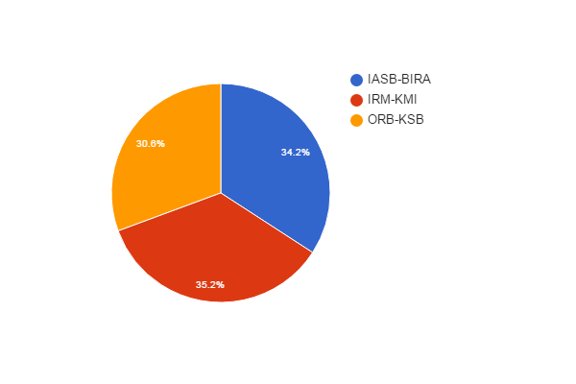

Scientific or Administrative/Technical Career? (SpacePole)
Q2 | count(*)
? | 10
Sci | 154
Tech/Admin | 120
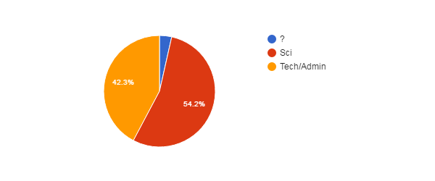

Position (SpacePole)
Q3 | count(*)
CON | 164
OTH | 5
STA | 115
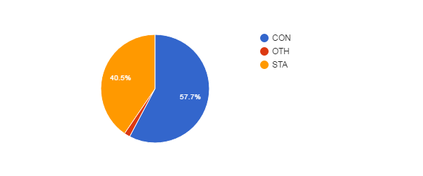

Position vs Age (SpacePole)
↓Q3\Q5→ | NoAnswer | 21­30 | 31­40 | 41­50 | 51­60 | 61­65 | >65
CON | 1 | 19 | 81 | 41 | 15 | 6 | 1
MAN
OTH |  | 4 |  |  |  |  | 1
STA | 3 | 8 | 25 | 38 | 33 | 6 | 2

Gender (SpacePole)
Q4 | count(*)
No answer | 3
F | 67
M | 214
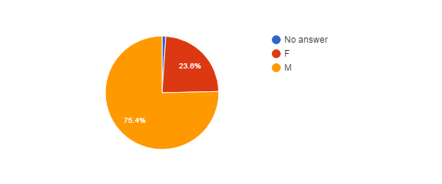

Age (SpacePole)
Q5 | count(*)
No answer | 4
21­30 | 31
31­40 | 106
41­50 | 79
51­60 | 48
61­65 | 12
>65 | 4
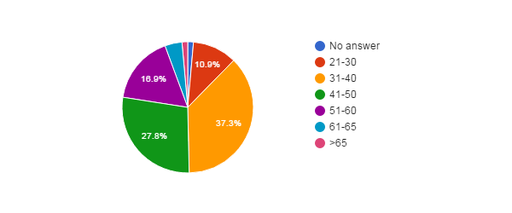

Feel Concerned by the Reform ? (SpacePole)
Q6 | count(*)
No answer | 1
NO | 6
YES | 143
YES, BUT | 134
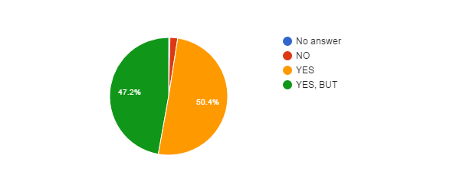

Concerned vs Career (SpacePole)
↓Q6\Q2→ | ? | Sci | Tech/Admin
NoAnswer |  |  | 1
NO |  | 4 | 2
YES |  | 91 | 52
YES, BUT | 10 | 59 | 65

Concerned vs Position (SpacePole)
↓Q6\Q3→ | CON | MAN | OTH | STA
NoAnswer | 1
NO | 3 |  | 1 | 2
YES | 79 |  | 3 | 61
YES, BUT | 81 |  | 1 | 52

Concerned vs Gender (SpacePole)
↓Q6\Q4→ | NoAnswer | F | M
NoAnswer |  | 1
NO |  | 1 | 5
YES | 1 | 29 | 113
YES, BUT | 2 | 36 | 96

Concerned vs Age (SpacePole)
↓Q6\Q5→ | NoAnswer | 21­30 | 31­40 | 41­50 | 51­60 | 61­65 | >65
NoAnswer |  | 1
NO |  | 1 | 3 | 1 |  |  | 1
YES |  | 11 | 52 | 40 | 27 | 10 | 3
YES, BUT | 4 | 18 | 51 | 38 | 21 | 2

How Informed ? (SpacePole)
Q7 | count(*)
No answer | 1
0 | 38
1 | 87
2 | 86
3 | 72
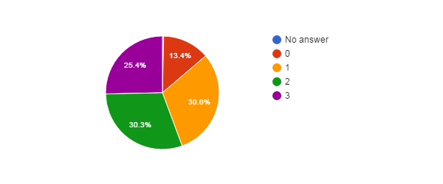

How Informed vs Career (SpacePole)
↓Q7\Q2→ | ? | Sci | Tech/Admin
NoAnswer |  |  | 1
0 | 1 | 19 | 18
1 | 3 | 44 | 40
2 | 2 | 46 | 38
3 | 4 | 45 | 23

How Informed vs Position (SpacePole)
↓Q7\Q3→ | CON | MAN | OTH | STA
NoAnswer | 1
0 | 23 |  | 1 | 14
1 | 46 |  | 2 | 39
2 | 50 |  | 2 | 34
3 | 44 |  |  | 28

How Informed vs Age (SpacePole)
↓Q7\Q5→ | NoAnswer | 21­30 | 31­40 | 41­50 | 51­60 | 61­65 | >65
NoAnswer |  |  | 1
0 | 2 | 6 | 11 | 11 | 8
1 | 1 | 15 | 24 | 28 | 12 | 5 | 2
2 |  | 7 | 35 | 21 | 16 | 5 | 2
3 | 1 | 3 | 35 | 19 | 12 | 2

Agree with Objectives ? (SpacePole)
Q8 | count(*)
No answer | 32
? | 102
NO | 131
YES | 19
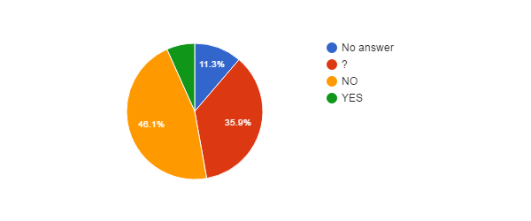

Agree with Objectives vs Career (SpacePole)
↓Q8\Q2→ | ? | Sci | Tech/Admin
NoAnswer |  | 16 | 16
? | 3 | 63 | 36
NO | 7 | 65 | 59
YES |  | 10 | 9

Agree with Objectives vs Position (SpacePole)
↓Q8\Q3→ | CON | MAN | OTH | STA
NoAnswer | 22 |  |  | 10
? | 66 |  | 3 | 33
NO | 65 |  | 1 | 65
YES | 11 |  | 1 | 7

Agree with Objectives vs Age (SpacePole)
↓Q8\Q5→ | NoAnswer | 21­30 | 31­40 | 41­50 | 51­60 | 61­65 | >65
NoAnswer |  | 4 | 11 | 10 | 7
? | 3 | 12 | 47 | 22 | 12 | 4 | 2
NO | 1 | 10 | 41 | 43 | 26 | 8 | 2
YES |  | 5 | 7 | 4 | 3

Reform will Achieve Objectives ? (SpacePole)
Q9 | count(*)
No answer | 32
? | 102
NO | 135
YES | 15
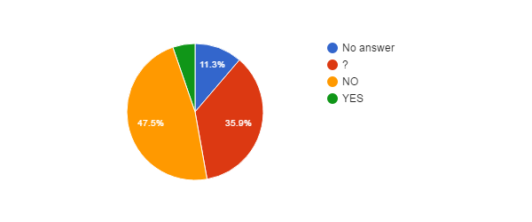Hidden Agenda ? (SpacePole)
Q10 | count(*)
No answer | 33
? | 87
NO | 10
YES | 154

Hidden Agenda vs Language (SpacePole)
↓Q10\Lang→ | EN | FR | NL
NoAnswer | 5 | 16 | 12
? | 9 | 43 | 35
NO | 2 | 4 | 4
YES | 5 | 104 | 45
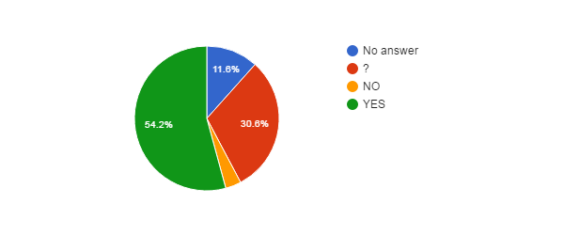

Reform entails... (SpacePole)
Q11 | count(*)
No answer | 34
? | 30
CONT | 13
PRIV | 89
RISK | 118
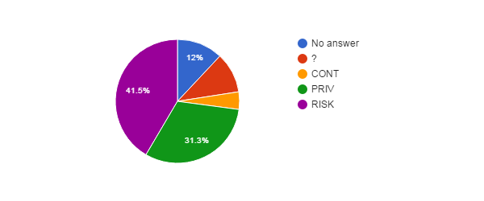

How better will work the institution after the reform ? (SpacePole)
Q12 | count(*)
No answer | 33
+ | 12
­ | 123
= | 40
? | 76

How better will work the institution vs Career (SpacePole)
↓Q12\Q2→ | ? | Sci | Tech/Admin
NoAnswer |  | 16 | 17
+ |  | 6 | 6
­ | 6 | 65 | 52
= | 1 | 25 | 14
? | 3 | 42 | 31
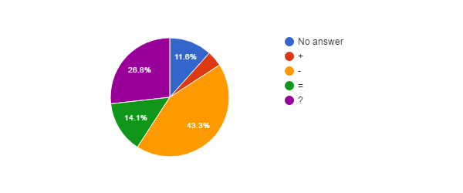

Agree with Privatisation of Public Services ? (SpacePole)
Q13 | count(*)
No answer | 2
? | 31
NO | 233
YES | 18
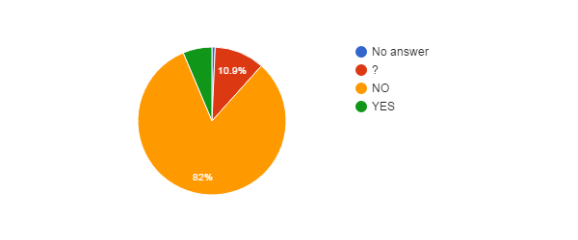

Agree with Privatisation of Public Services vs Age (SpacePole)
↓Q13\Q5→ | NoAnswer | 21­30 | 31­40 | 41­50 | 51­60 | 61­65 | >65
NoAnswer |  |  | 1 |  | 1
? | 1 | 4 | 14 | 6 | 6
NO | 2 | 21 | 85 | 69 | 41 | 12 | 3
YES | 1 | 6 | 6 | 4 |  |  | 1

Agree with Privatisation of Public Services vs Language (SpacePole)
↓Q13\Lang→ | EN | FR | NL
NoAnswer |  |  | 2
? | 2 | 12 | 17
NO | 15 | 147 | 71
YES | 4 | 8 | 6

Agree with Privatisation of the FSIs ? (SpacePole)
Q14 | count(*)
? | 34
NO | 235
YES | 15
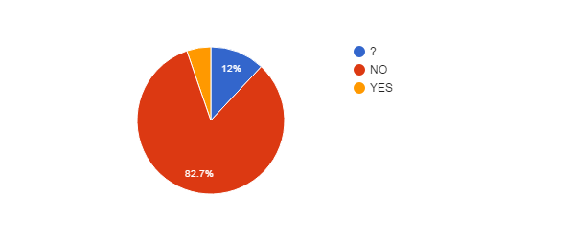
Agree with Privatisation of FSIs vs Agree with Privatisation of Public Services (SpacePole)
↓Q14\Q13→ | NoAnswer | ? | NO | YES
NoAnswer
? |  | 22 | 10 | 2
NO | 2 | 9 | 222 | 2
YES |  |  | 1 | 14

Agree with Privatisation of FSIs vs Career (SpacePole)
↓Q14\Q2→ | ? | Sci | Tech/Admin
NoAnswer
? | 2 | 18 | 14
NO | 8 | 128 | 99
YES |  | 8 | 7

FSIs need Major Reforms ? (SpacePole)
Q15 | count(*)
? | 67
NO | 84
YES | 133
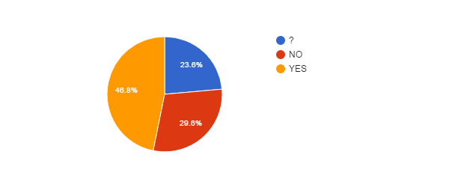

FSIs need Major Reforms vs Career (SpacePole)
↓Q15\Q2→ | ? | Sci | Tech/Admin
NoAnswer
? | 3 | 40 | 24
NO | 4 | 43 | 37
YES | 3 | 71 | 59

FSIs need Major Reforms vs Position (SpacePole)
↓Q15\Q3→ | CON | MAN | OTH | STA
NoAnswer
? | 41 |  | 3 | 23
NO | 39 |  | 1 | 44
YES | 84 |  | 1 | 48

FSIs need Major Reforms vs Age (SpacePole)
↓Q15\Q5→ | NoAnswer | 21­30 | 31­40 | 41­50 | 51­60 | 61­65 | >65
NoAnswer
? | 1 | 11 | 24 | 18 | 11 | 1 | 1
NO | 2 | 5 | 30 | 24 | 18 | 4 | 1
YES | 1 | 15 | 52 | 37 | 19 | 7 | 2

FSIs Reforms need status change ? (SpacePole)
Q16 | count(*)
No answer | 83
? | 62
NO | 115
YES | 24
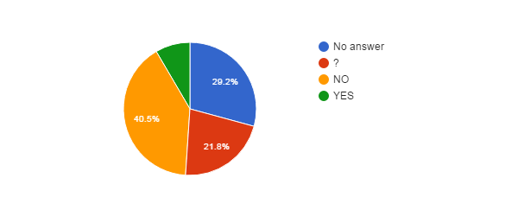

Fear for your Job ? (SpacePole)
Q17 | count(*)
No answer | 7
NO | 101
YES | 176
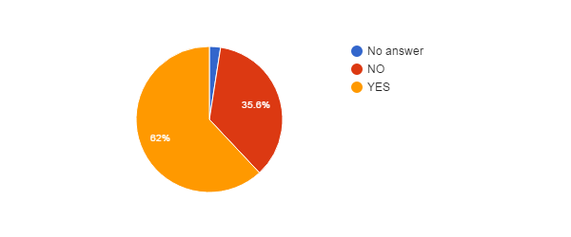

Fear for Job vs Position (SpacePole)
↓Q17\Q3→ | CON | MAN | OTH | STA
NoAnswer | 6 |  |  | 1
NO | 54 |  | 5 | 42
YES | 104 |  |  | 72

Fear for Job vs Age (SpacePole)
↓Q17\Q5→ | NoAnswer | 21­30 | 31­40 | 41­50 | 51­60 | 61­65 | >65
NoAnswer |  |  | 4 | 1 | 2
NO | 1 | 12 | 45 | 20 | 17 | 3 | 3
YES | 3 | 19 | 57 | 58 | 29 | 9 | 1

Fear for Job vs Career (SpacePole)
↓Q17\Q2→ | ? | Sci | Tech/Admin
NoAnswer |  | 6 | 1
NO | 1 | 56 | 44
YES | 9 | 92 | 75

Reform will improve some employment conditions ? (SpacePole)
Q18 | count(*)
? | 75
NO | 157
YES | 52
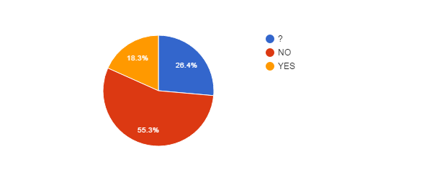

Reform will improve some employment conditions vs Position (SpacePole)
↓Q18\Q3→ | CON | MAN | OTH | STA
NoAnswer
? | 53 |  | 4 | 18
NO | 75 |  |  | 82
YES | 36 |  | 1 | 15

Reform will improve some employment conditions vs Age (SpacePole)
↓Q18\Q5→ | NoAnswer | 21­30 | 31­40 | 41­50 | 51­60 | 61­65 | >65
NoAnswer
? | 2 | 10 | 31 | 19 | 8 | 3 | 2
NO | 2 | 12 | 53 | 45 | 36 | 8 | 1
YES |  | 9 | 22 | 15 | 4 | 1 | 1

Reform will improve some employment conditions vs Career (SpacePole)
↓Q18\Q2→ | ? | Sci | Tech/Admin
NoAnswer
? | 4 | 49 | 22
NO | 6 | 72 | 79
YES |  | 33 | 19

Reform will deteriorate some employment conditions ? (SpacePole)
Q20 | count(*)
No answer | 1
? | 48
NO | 7
YES | 228

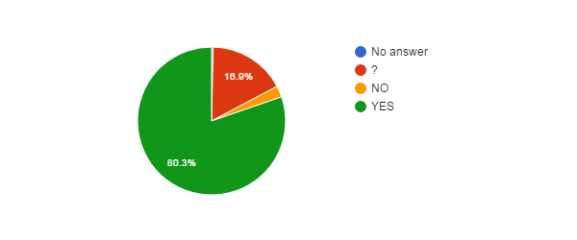

Reform will deteriorate some employment conditions vs Position (SpacePole)
↓Q20\Q3→ | CON | MAN | OTH | STA
NoAnswer | 1
? | 34 |  | 3 | 11
NO | 5 |  |  | 2
YES | 124 |  | 2 | 102

Reform will deteriorate some employment conditions vs Age (SpacePole)
↓Q20\Q5→ | NoAnswer | 21­30 | 31­40 | 41­50 | 51­60 | 61­65 | >65
NoAnswer |  | 1
? | 1 | 8 | 23 | 10 | 3 | 2 | 1
NO |  | 1 | 3 | 1 | 2
YES | 3 | 21 | 80 | 68 | 43 | 10 | 3

Reform will deteriorate some employment conditions vs Career (SpacePole)
↓Q20\Q2→ | ? | Sci | Tech/Admin
NoAnswer |  |  | 1
? | 1 | 30 | 17
NO |  | 3 | 4
YES | 9 | 121 | 98

Impact of BELSPO's reform on the FSIs (SpacePole)
Q22 | count(*)
No answer | 152
? | 64
NO | 10
YES+ | 13
YES­ | 45
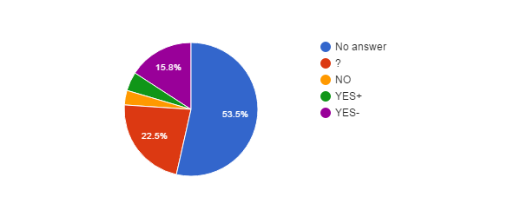

Impact of BELSPO's reform on the FSIs vs Career (SpacePole)
↓Q22\Q2→ | ? | Sci | Tech/Admin
NoAnswer | 6 | 92 | 54
? | 3 | 33 | 28
NO |  | 6 | 4
YES+ |  | 5 | 8
YES­ | 1 | 18 | 26

Impact of BELSPO's reform on the FSIs vs Position (SpacePole)
↓Q22\Q3→ | CON | MAN | OTH | STA
NoAnswer | 83 |  | 2 | 67
? | 42 |  | 2 | 20
NO | 7 |  |  | 3
YES+ | 9 |  |  | 4
YES­ | 23 |  | 1 | 21

Language (SpacePole)
Lang | count(*)
EN | 21
FR | 167
NL | 96
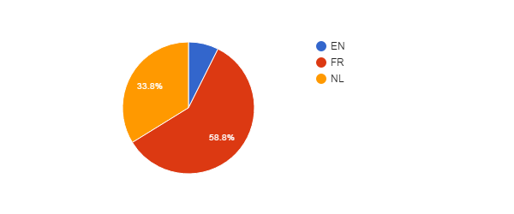

Language vs Age (SpacePole)
↓Lang\Q5→ | NoAnswer | 21­30 | 31­40 | 41­50 | 51­60 | 61­65 | >65
EN |  | 1 | 7 | 12 |  |  | 1
FR | 1 | 16 | 58 | 50 | 29 | 11 | 2
NL | 3 | 14 | 41 | 17 | 19 | 1 | 1

Language vs Position (SpacePole)
↓Lang\Q3→ | CON | MAN | OTH | STA
EN | 19 |  |  | 2
FR | 92 |  | 2 | 73
NL | 53 |  | 3 | 40

Which improvements do you expect ? (SpacePole)
#answers Q19 | 84
MealVouchers | 30
CompanyCar | 10
FreeHospInsurance | 34
BetterInstCulture | 37
2dPension | 52
BetterPromotions | 56
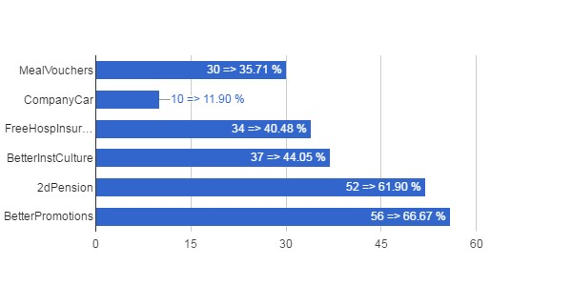

Which Improvements vs Career (SpacePole)
↓Q19\Q2→ | ? | Sci | Tech/Admin
MealVouchers |  | 16 | 14
CompanyCar |  | 4 | 6
FreeHospInsurance | 1 | 17 | 16
BetterInstCulture |  | 21 | 16
2dPension | 1 | 30 | 21
BetterPromotions | 1 | 37 | 18

Which Improvements vs Position (SpacePole)
↓Q19\Q3→ | CON | MAN | OTH | STA
MealVouchers | 18 |  | 1 | 11
CompanyCar | 4 |  | 1 | 5
FreeHospInsurance | 24 |  |  | 10
BetterInstCulture | 23 |  | 2 | 12
2dPension | 37 |  | 1 | 14
BetterPromotions | 41 |  | 2 | 13

Which Improvements vs Age (SpacePole)
↓Q19\Q5→ | NoAnswer | 21­30 | 31­40 | 41­50 | 51­60 | 61­65 | >65
MealVouchers | 2 | 6 | 12 | 6 | 2 | 1 | 1
CompanyCar |  | 3 | 3 | 4
FreeHospInsurance | 2 | 3 | 14 | 11 | 2 | 1 | 1
BetterInstCulture | 1 | 8 | 18 | 8 |  | 1 | 1
2dPension | 2 | 5 | 25 | 13 | 4 | 2 | 1
BetterPromotions | 1 | 8 | 27 | 15 | 3 | 1 | 1

Which deteriorations do you expect ? (SpacePole)
#answers Q21 | 240
JobInsecurity | 169
IncrPressureStress | 153
RedEfficiency | 124
IncomeLoss | 110
WorseWorkAtmos | 159
WorkAutonomyLoss | 135
SciFreedomLoss | 141
FSIAutonomyLoss | 148
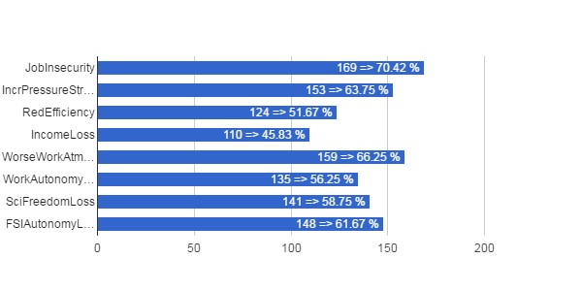

Which Deteriorations vs Career (SpacePole)
↓Q21\Q2→ | ? | Sci | Tech/Admin
JobInsecurity | 8 | 88 | 73
IncrPressureStress | 8 | 71 | 74
RedEfficiency | 7 | 59 | 58
IncomeLoss | 4 | 52 | 54
WorseWorkAtmos | 7 | 80 | 72
WorkAutonomyLoss | 6 | 70 | 59
SciFreedomLoss | 1 | 104 | 36
FSIAutonomyLoss | 6 | 82 | 60

Which Deteriorations vs Position (SpacePole)
↓Q21\Q3→ | CON | MAN | OTH | STA
JobInsecurity | 90 |  | 1 | 78
IncrPressureStress | 81 |  |  | 72
RedEfficiency | 63 |  |  | 61
IncomeLoss | 56 |  |  | 54
WorseWorkAtmos | 83 |  | 1 | 75
WorkAutonomyLoss | 68 |  | 1 | 66
SciFreedomLoss | 77 |  | 3 | 61
FSIAutonomyLoss | 72 |  | 2 | 74

Which Deteriorations vs Age (SpacePole)
↓Q21\Q5→ | NoAnswer | 21­30 | 31­40 | 41­50 | 51­60 | 61­65 | >65
JobInsecurity | 3 | 13 | 51 | 54 | 37 | 9 | 2
IncrPressureStress | 4 | 17 | 49 | 53 | 24 | 6
RedEfficiency | 4 | 9 | 37 | 44 | 23 | 6 | 1
IncomeLoss | 2 | 10 | 33 | 34 | 26 | 4 | 1
WorseWorkAtmos | 4 | 16 | 44 | 56 | 32 | 5 | 2
WorkAutonomyLoss |  | 12 | 44 | 41 | 31 | 4 | 3
SciFreedomLoss | 3 | 14 | 47 | 45 | 25 | 5 | 2
FSIAutonomyLoss | 3 | 11 | 47 | 51 | 28 | 6 | 2

